
Agate Framework
Administration Guide

Achieving Productivity and Quality
by
"Building with Parts"

Agate Partners
17270 Tilia Ridge
Eden Prairie, MN 55347

(952) 239-4125
Steve@Sandness.com
Copyright © 2009 Agate Partners. All Rights Reserved.
Table of Contents
- Overview 3
- “Building with Parts” 3
- Setting up a User 4
- Setting up a Program 4
- Maintenance Commands
5.1 Maintain Workstations 5
5.2 Maintain Users 6
5.3 Maintain User’s Global Properties 7
5.4 Maintain Users / Groups 8
5.4 Maintain User to Folder Relationships 9
5.5 Maintain Programs 10
5.6 Maintain Programs Rules 11
5.7 Maintain Commands 13
5.8 Maintain Folders 15
5.9 Maintain Printers 16
5.10 Maintain Agate Setup Information 17
6. Reports
6.1 List Users / Groups 18
6.2 List User’s Menu Tool Bar Usage 19
6.3. List Commands 20
6.4 List Folders 21
6.5 List User to Folder Relationships 22
6.6 List Programs 23
6.7 List Printers 24
6.8 List Agate Activity Log 25
7. Utilities
7.1 Execute SQL 26
7.2 Display text file 27
7.3 Compose and Send eMail 28
7.4 Update Help and Icon File Names 29
7.5 Make all users 'View Only' status 30
7.6 Restore all users to their 'Normal' status 31
8. Control
8.1 Table Maintenance Authorizations 32
8.2 Property Files 33
9. Framework Initialization
9.1 Starting Framework from a Script File 34
10. Messages
10.1 Maintain Message Numbers 35
10.2 Maintain Systems Id 36
11. Glossary 37

1. Overview
The Agate Framework supports rapid application development of java applications. The resulting solution is a high quality, professional result, even though it is quickly developed.
The Framework creates a consistent environment for developers to achieve high productivity by utilizing “re-use” of “software parts”. Young developers are exposed to the full power and potential of object technology.
2. “Building with Parts”
Developer Productivity
The Framework provides software parts for the creation of business solutions: data maintenance frames, business objects, reports, menus, processing procedures, and user prompts. An array of supporting parts and widgets are available for use within these major parts. Parts are extended using the object technology technique of sub-classing and overriding methods.
A class can access parameters at execution in a standard, some times hierarchical way, from these sources:
1. Program Definition
2. Command Definition
3. User Definition
4. User Global Properties
5. Program Rules
End User Productivity
The Framework presents a consistent user interface for all portions of an application. Extensive keyboard shortcuts, tool tip help, and html help aid the user experience.
An interactive report writer (refer to Users Guide) is available for users to create and run there own reports, for either ad hoc analysis or to extend the functionality of Framework built applications. These reports are saved in a user's 'My Reports' folder for easy, repetitive use. If a user written report needs to be made available for multiple user's to execute, it may be placed into a 'public' folder that is accessible to these users.
Archiving scanned documents and Framework generated reports (refer to Users Guide) is integrated into the Framework, creating an efficient user interface for displaying these documents from report lines that reference them.
Commands
Commands, built with the framework, are used to:
1. Set up users.
2. Set up programs.
3. Set up printers.
4. Reference framework and database properties. Some properties are
stored in property files.
5. Build and run reports interactively.
3. Setting up a User
1. If necessary, define a new user id and password using an operating system
utility.
2. Grant database privileges to the user id using a database utility.
3. Define the user to the Framework with 'Maintain users'.
4. Define the user's workstation with 'Maintain workstations'.
5. Initialize the user's global properties with
'Maintain a user's global properties'.
6. Assign the user either
a) to a group with 'Maintain groups' or
b) to a starting set of folders
with 'Maintain user to folder relationships'.
7. Create a C:\SKAMPtrk folder on user's workstation
8. Initialize the workstation property in the C:\SKAMPtrk\Java.ini property file
WorkstationName= (20 char. max.)

4. Setting up a Program
1. Define the program to the Framework with 'Maintain programs'.
2. Define at least one command with 'Maintain commands'.
3. Enter command(s) into folder(s) with 'Maintain folders'.
5. Maintenance Commands
Commands (built with Framework parts) are used to maintain data attributes needed for Framework execution.
5.1 Maintain Users
To log into an Agate Framework application, the user id must exist in this authorized users table.
A user can be authorized to display, add, change, or delete data.
User authorizations supersede command and program authorizations.
Each data table contains transaction time and user id columns. When data rows are inserted or updated, the row is time stamped with the current time and logged in user id. These columns support the framework's optimistic locking algorithm. With optimistic locking, data is not locked when displayed for change. This technique minimizes locking interference and deadlock.
DB2 uses the operating system list of valid users to authenticate a user's id and password. The user must also be granted privileges to access database resources, either individually or by making the user a member of a database group. Both these tasks are completed using operating system and database utility programs.
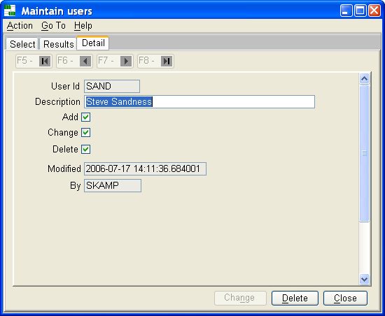
5.2 Maintain Workstations
Each workstation should be assigned a unique workstation name. This name is entered into this table and into the Java.ini properties file located in the C:\SKAMPtrk folder on the user's workstation.
When the user logs in, a check is made to verify that the workstation name in the user's Java.ini file matches an entry in the Agate workstation table.
Creating a unique workstation name for every workstation is not required, but is strongly recommended. The workstation name is included in the audit trail log of commands executed. A unique name for each workstation improves the value of this log for tracing and measuring event activity.
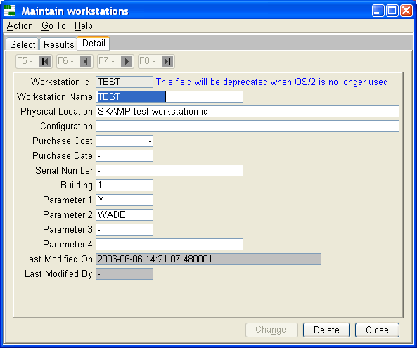

5.3 Maintain a User's Global Properties
A collection of properties is defined to customize Framework execution for each user.
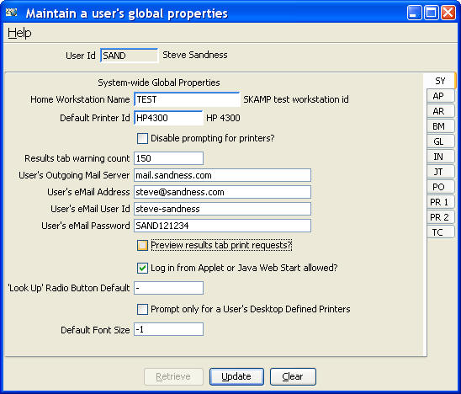
5.4 Maintain Groups
Users and printers can be assigned to a group.
Groups are an efficient way to specify authorizations, printers, and folder tree for a homogeneous set of users. When a user belongs to more than one group, the user’s menu tree will contain root folders for each group.
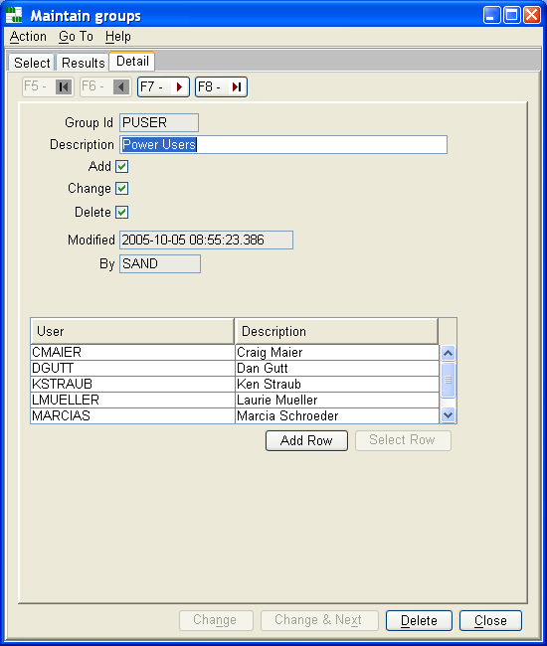
5.4 Maintain User to Folder Relationships
Each user or group must be associated to one or more folders.
These folder(s) become the root folder(s) for the menu tree for the user or group.
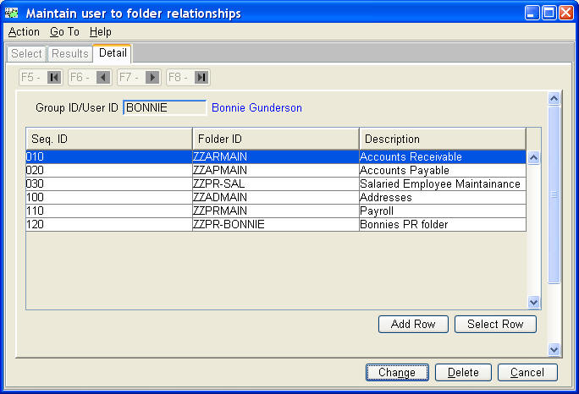

5.5 Maintain Programs
Every program executed from Agate's menus must be defined to the Framework with a unique program name.
A program can have some of its features disabled / enabled with this definition as well. Parameters can also be provided to further customize execution. HTML help and a unique icon aide the user experience.
Each program must have at least one command defined. When a new program definition is added, a command with the same name is also added. Use the 'Where Used' button to maintain commands where the program is referenced.
These commands are placed into folders. Folders can also contain other folders to enable building a folder tree. The root folder(s) are defined either to individual users, or a group of users, thus enabling a unique folder tree to be displayed to a user.
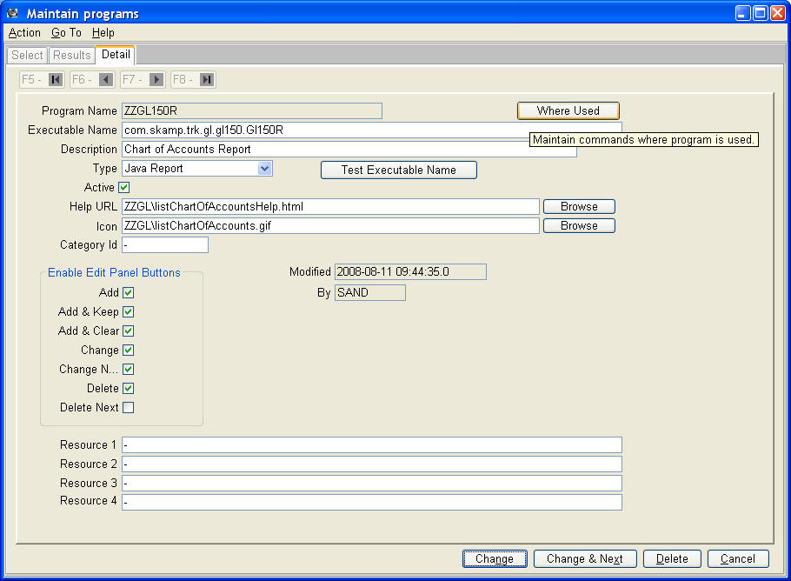
5.6 Maintain Programs Rules
A well designed program does not contain embedded business values as hard coded constants, but rather, retrieves them from the database.
'Maintain program rules - developer mode' allows a developer to customize a maintain screen for each program that needs additional database values as constants for its execution.
'Maintain program rules - user mode' renders a custom maintain screen for each program's required database values.
If an end user is to be able to change these values, the developer can indicate that the row(s) for a program are 'user maintainable'. A 'Maintain program rules' command for end users is available and can be placed into folders authorized to change these rules. One of these commands has been placed into Agate III's General Leger Maintenance Menu.
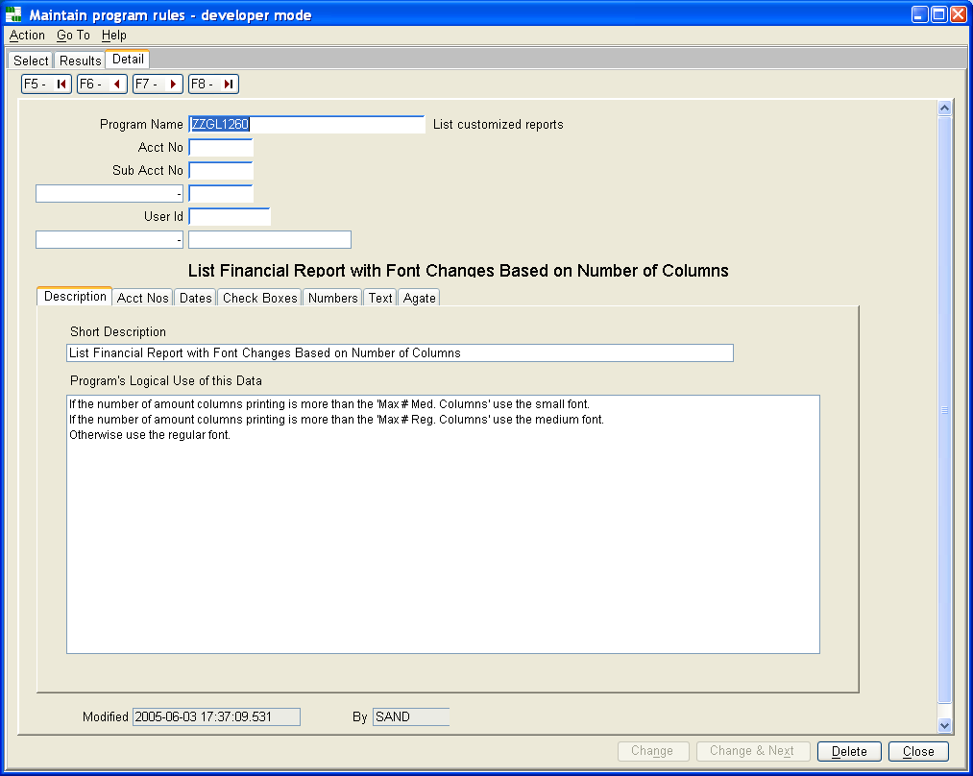
Developer Mode
The program rules table contains a collection of character strings, dates, checkboxes, and decimal columns. Each column has an associated 'label', character string column. In developer mode one can describe the use of one of these columns by entering a description into the column's associated 'label'.
In addition, a series of checkboxes can be used to indicate which of the program's tabs should be displayed when the program is executed in 'user mode'.
User Mode
In user mode, only those columns with non null 'labels' are displayed. The 'labels' themselves are non-editable.
In this mode, the rules program has the ‘look and feel’ of a typical Framework developed table maintenance command.
5.7 Maintain Commands
One command must be created for each program. Commands can modify the behavior of a program, using available option settings and parameters. Thus, multiple commands can be used to define different program behaviors and/or restrict features of a program.
For table maintenance programs, adding, changing or deleting rows can be disabled, the program can be started in add mode, or the program can be started in search mode. A table maintenance program, with all update options disabled, creates a view only program, a very good way to search, display and scroll result sets, print result sets, and display individual rows.
Command authorizations supersede program authorizations.
Commands are placed into folders. By restricting access to folders, different users will realize different behaviors and authorizations using the same program. Use the 'Where Used' button to maintain folders where the command is referenced, and the 'Program' button to change program information for the command.
Each time a command is executed an audit trail record is created, containing the command id, user id, workstation name, and current time stamp.
Panel 1 Tab
Edit panel buttons and search fields can be disabled.
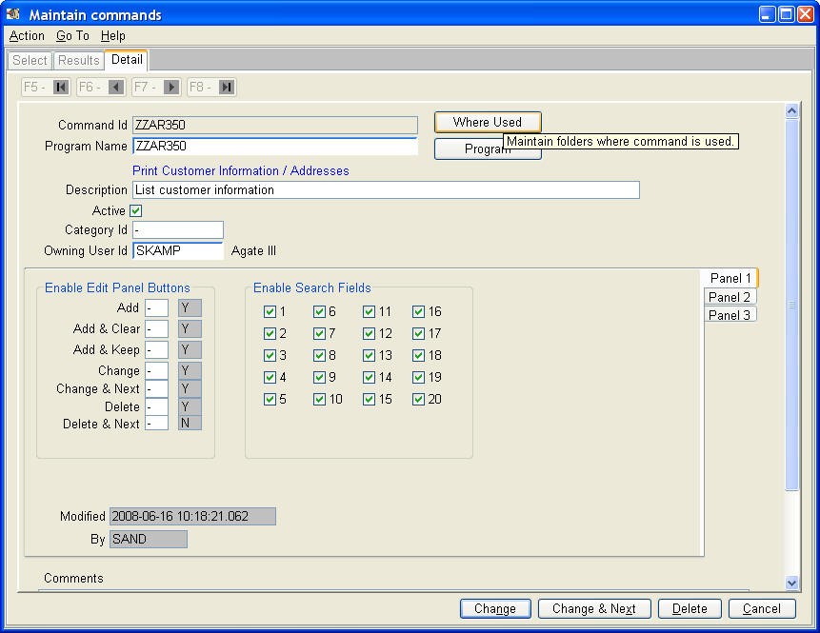
Panel 2 Tab
Framework options and user program options can be indicated by checking the ‘Enable Option’ checkboxes. Tool tip help describes the Framework’s usage of options 1-10. Options 11-15 are available for user written classes.
‘Printer Options’ can be entered for use by report writer classes. If a printer id is entered, the user is not prompted for selecting a printer and this id is used.
Parameters fields are available for user written classes.
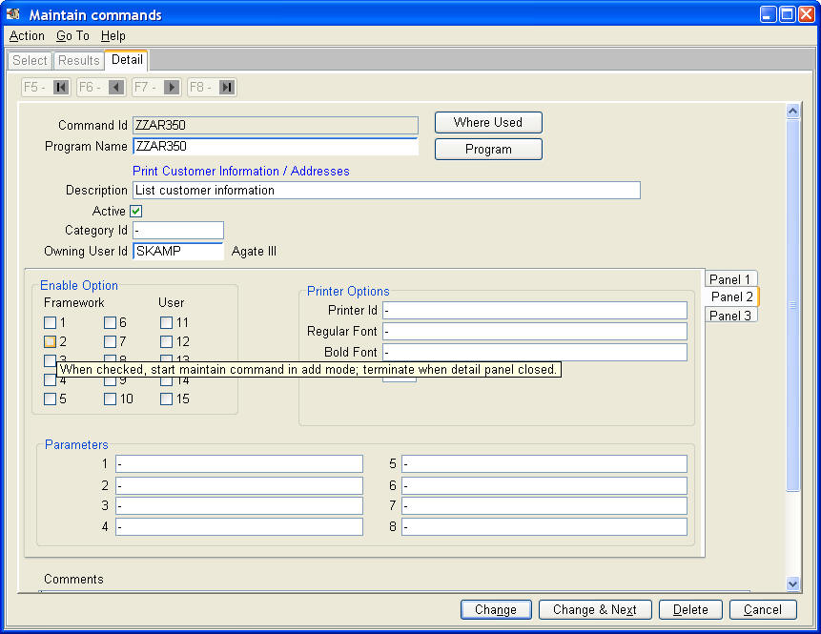

5.8 Maintain Folders
Folders are collections of commands and other folders.
The folder tree structure, as seen on the left side of the menu window (refer to Users Guide), is constructed for each user with these folders. Each user's starting folder or folders is based on entries in the 'user to folder relationship' table.
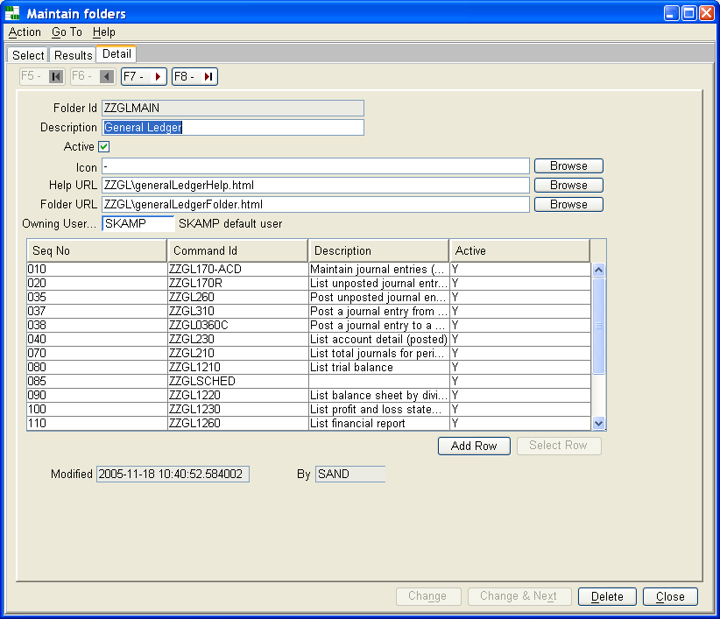

5.10 Maintain Printers
Each printer must be defined to the Framework.
When appropriate, a user will be prompted to select a printer from a list constructed of all 'PUBLIC' printers, all printers from groups the user is associated, and all printers specifically assigned to this user.
A default printer for a user is specified using 'Maintain a user's global properties'.
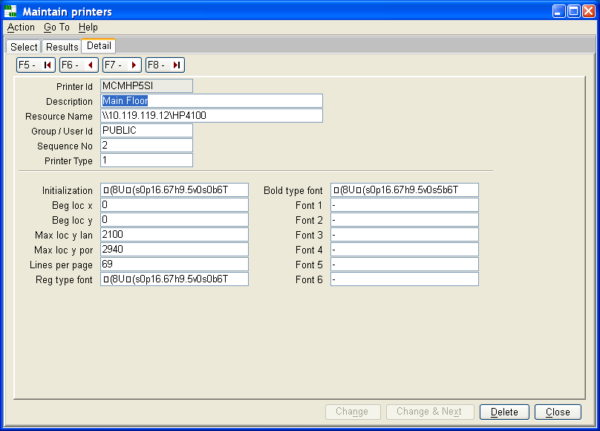
5.11 Maintain Agate Setup Information
Agate setup information contains global properties for the Framework.
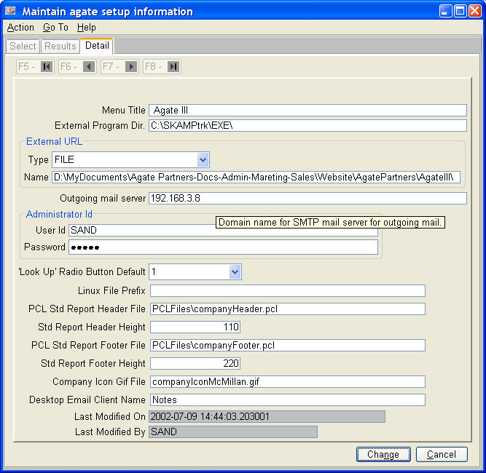
6. Reports
These Framework reports are more comprehensive than reports that can be printed from the results tab of the table maintenance commands.
6.1 List Users / Groups
Report lists user and group relationships with authorizations.
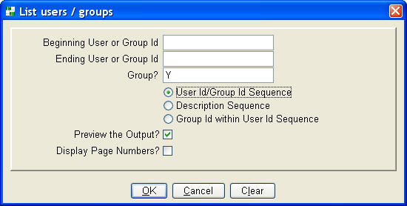
User Id / Group Id Sequence (listing only groups)
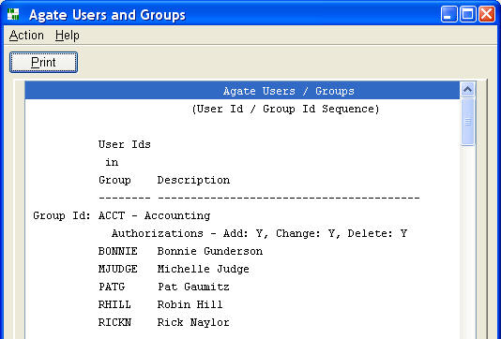
Group Id within User Id Sequence
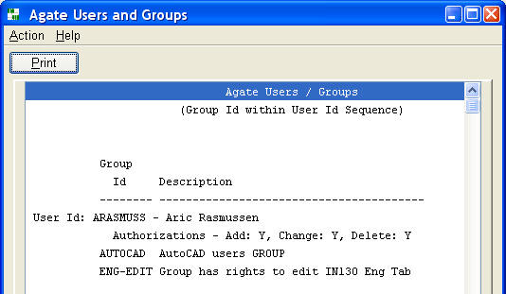
6.2 List User's Menu Tool Bar Usage
This report lists the commands users have placed on their menu's tool bar. It can be used to identify commands not having a unique icon.
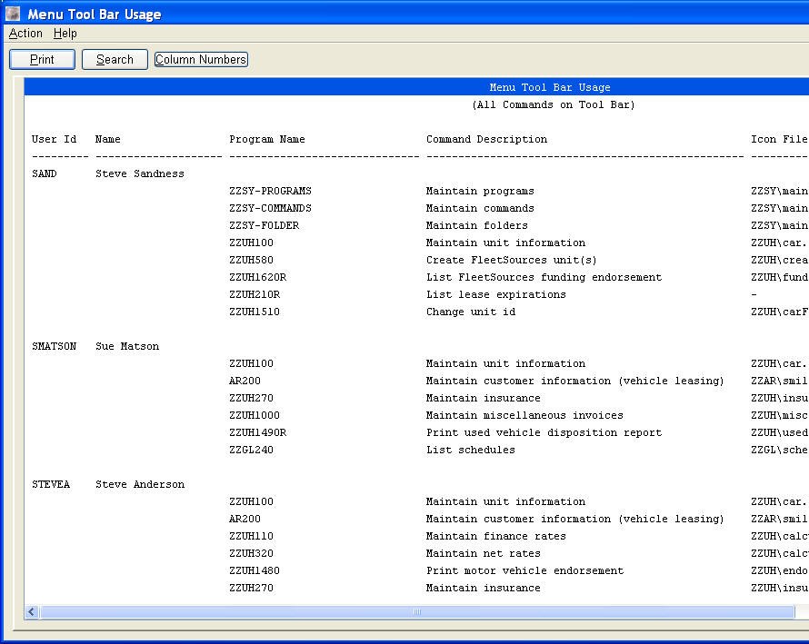

6.3 List Commands
Command id sequence shows command and program authorizations together.
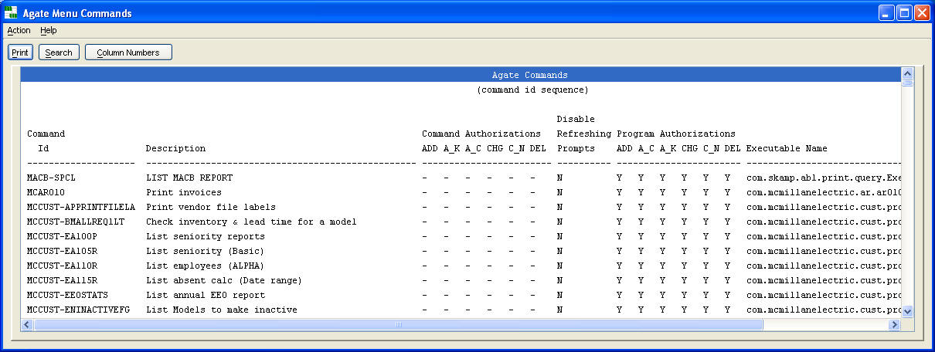
Program name sequence is a 'where used' list of all command ids for a program.
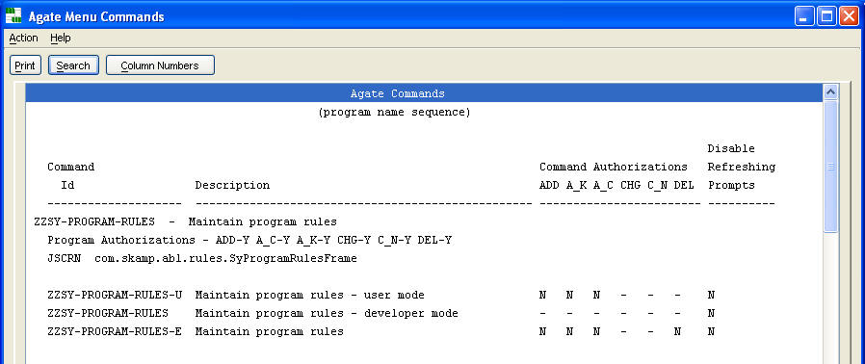
Executable name sequence lets you identify the command ids for a program when you know the class name.
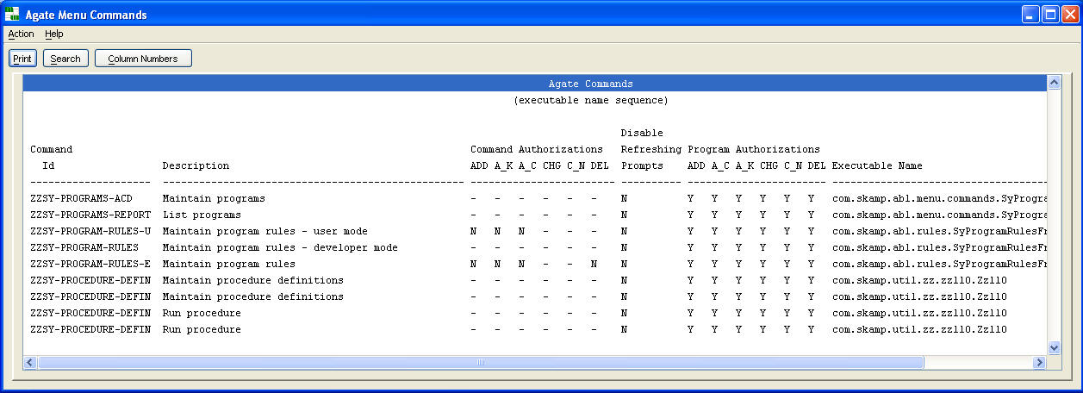
6.3 List Folders
Folder id sequence shows command and program authorizations together for each folder.
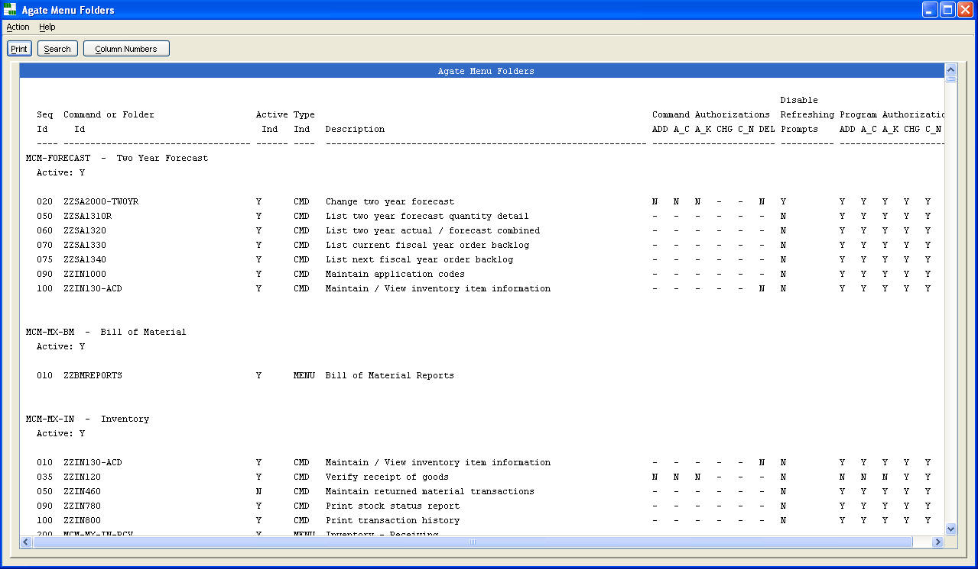
Command id sequence is a 'where used list' of folder ids for a command.
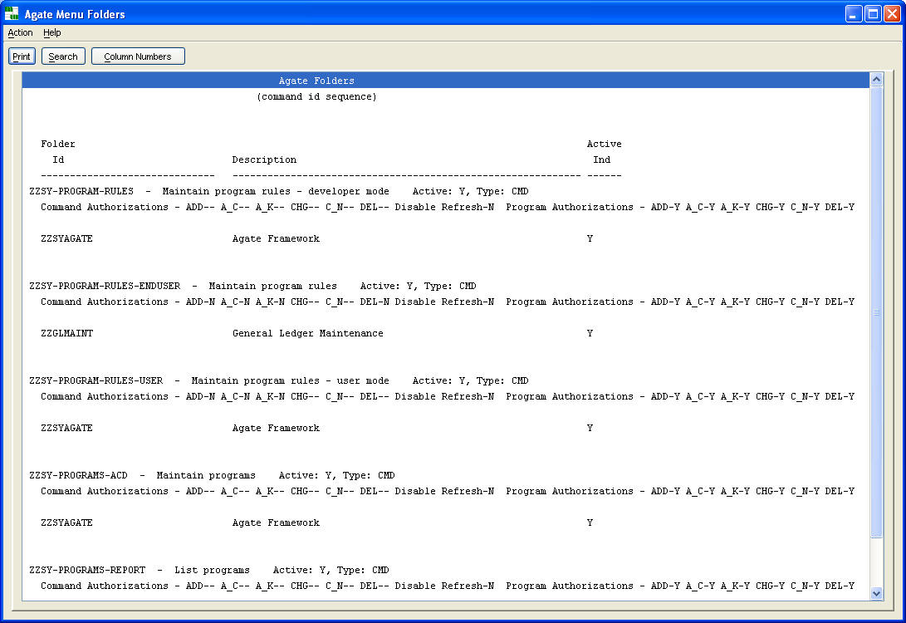
6.4 List User to Folder Relationships
This report lists the root folders for users and groups with their authorizations. A user can be a member of multiple groups as well as have root folders individually assigned by user id using 'maintain user to folder relationships'. The 'Source' column of the report indicates whether the root folder is assigned by user id or group id. The folders are ordered by the collated 'Sequence' column on the menu window, with duplicates eliminated.
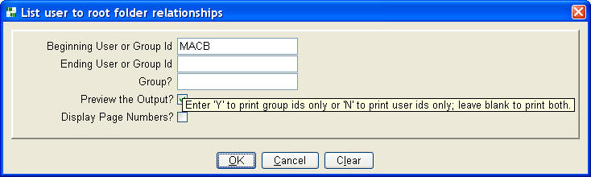
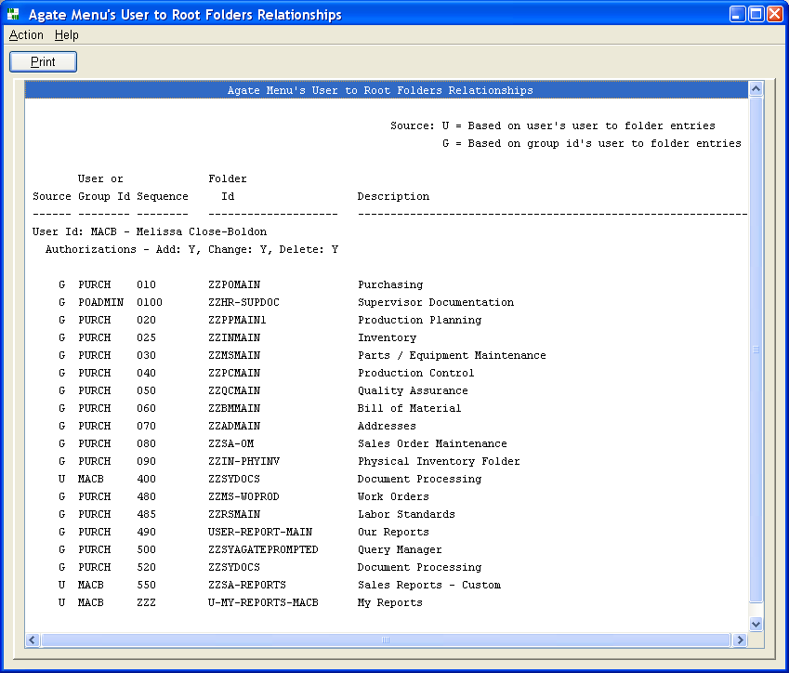
6.5 List Programs
This report is a cross reference of class names to program names.
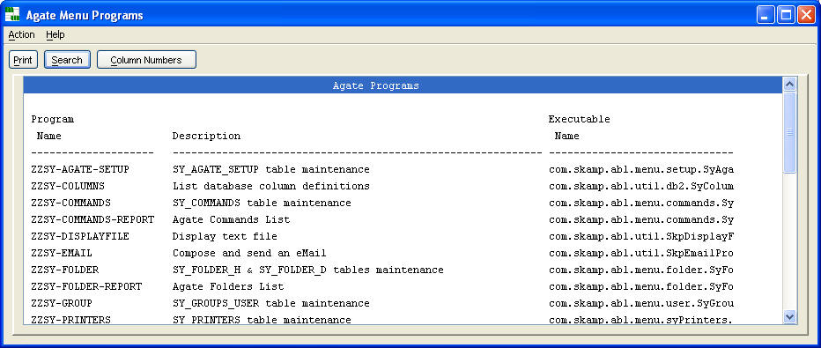

6.6 List Printers
This report lists attributes for Framework defined printers.
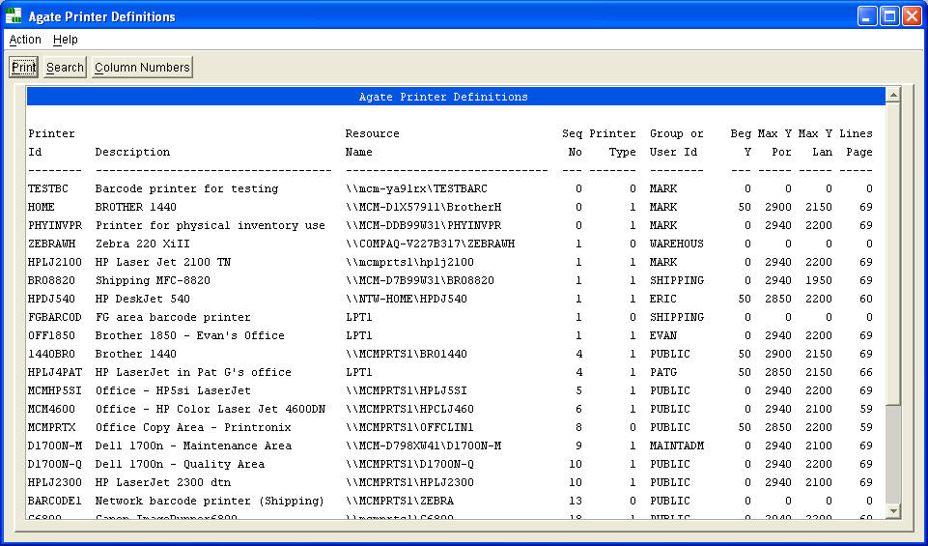

6.7 List Agate Activity Log
The activity log is an audit trail of commands executed, user log on's and log off's. User programs can add entries to the log by assigning message numbers and logging them as needed using Framework helper methods.
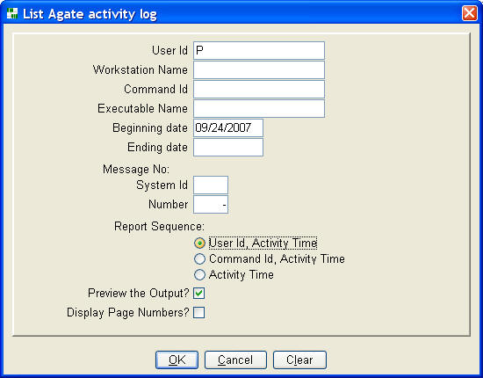
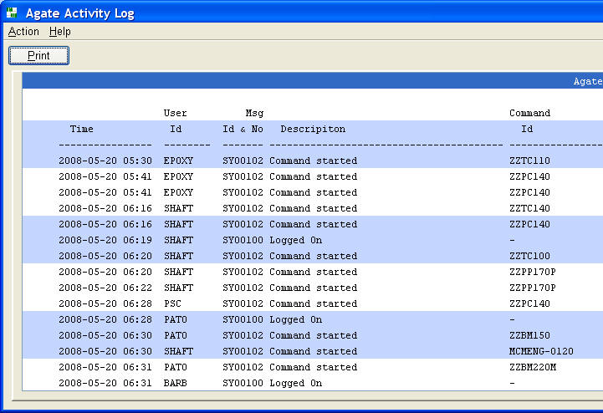
7. Utilities
7.1 Execute SQL
Any SQL statement can be executed using this command. It is a valuable aid for performing problem determination at a user's workstation, especially one not equipped to perform SQL statements any other way.
The command can be password protected to prevent erroneous use, when the command is placed into a folder accessible to an end user. To do so, create a command with option15 set off.
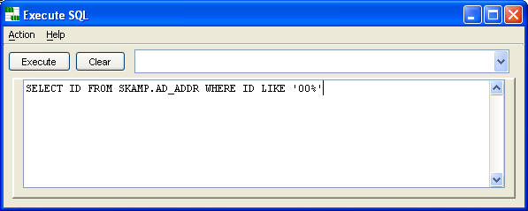

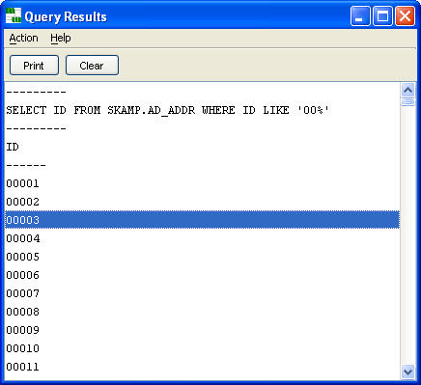
7.2 Display Text File
Any text file can be displayed in a scrollable list.
The command will recognize either the Windows or Linux technique for line endings.
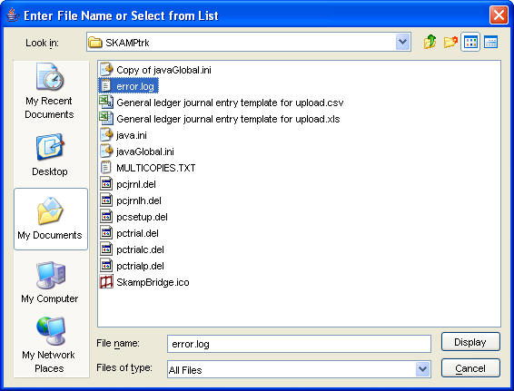
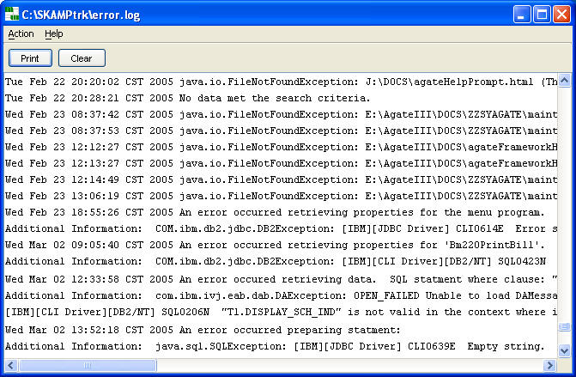
7.3 Compose and Send an eMail
Any report can be sent as an e-mail when a user is enabled to do so using the 'Maintain a user's global properties'. The report is placed into the text area of this dialogue. One can add annotations and comments before sending the e-mail.
One can also 'cut and paste' contents of the text area into other word processing documents, so that’s another use for this dialogue.
In addition, one can compose and send an e-mail using this command, which displays an empty, e-mail composition window.
User written programs can also link to this dialogue.
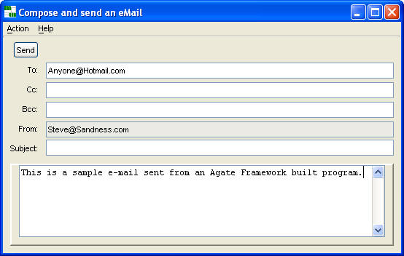
7.4 Update Help and Icon File Names
This command updates the help and icon file names in the SY_FOLDER_H and SY_PROGRAMS tables in this database from the database name entered in the following prompt. This command is used by Agate Partners to update HTML help references in a database.
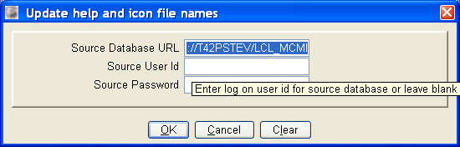

7.5 Make all users, except me and exceptions 'View Only' status
All users, except for up to four listed in the below prompt plus the logged in user, are changed to 'View Only' status.
This status change only occurs after a user has stopped and restarted Agate; thus users should be notified to do so after this command has been executed. This command can be used to allow users to continue to use Agate without making changes while one or a small set of users are allowed to continue making changes. This can be helpful when running a multi-command process without risking undesirable changes, such as a monthly billing process or a month end or year end General Ledger close.
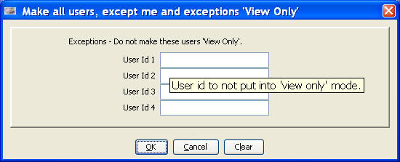
The command completes successfully by displaying the following message:
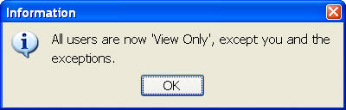

7.6 Restore all users to their 'Normal' status from 'View Only'
status
Users are restored to their previous status from 'View Only' status.
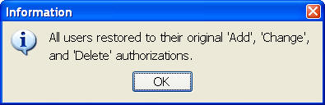
If Agate had not been placed into a 'View Only' status, the following error message is displayed.
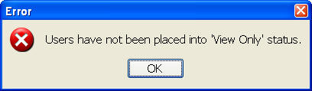

8. Control
8.1 Table Maintenance Authorizations
All table maintenance programs built with the Framework support Displaying, Adding, Changing and Deleting rows. For application design or user authorization reasons, some of these capabilities may need to be 'turned off'.
Each time a command is executed, a hierarchy of user, command and program is checked, in that order, to determine which of these capabilities the logged on user is authorized. If at any level, the feature is 'turned off', the user will not see the action buttons supporting the option.
Turning off add, change, and delete makes a maintenance program 'display only', a most effective way to present data to a user. It often eliminates the need for a variety of reports of the same data.
8.2 Property Files
The Framework has two property files, java.ini and javaGlobal.ini, located in the C:\SKAMPtrk folder on a user's workstation.
The files are concatenated together at execution with the javaGlobal.ini being read first. When the files contain duplicate entries, the first one found is used by the Framework.
Typically, an organization's installation of the Framework contains only one javaGlobal.ini file, which is copied to the workstation's C:\SKAMPtrk folder while starting the Framework using an operating system script file. This start up technique provides a method to maintain system-wide property values, such as the database name, in one easily maintained file. The java.ini property file is used for values unique to a workstation.
Here is a sample javaGlobal.ini file:
* Database to access
Database=jdbc:db2://T42PSTEV/LCL_MCMI
* JDBC driver to use
Driver=COM.ibm.db2.jdbc.net.DB2Driver
Here is a sample java.ini file:
* This workstation's name
WorkstationName=TEST
*OutputPathname=c:\skamptrk\debugMessages.txt
*DisplayURL=true
*Start this program at start up
*AutoStart1=com.skamp.trk.tc.tc100.Tc100
*Auto log on this user id, rather than prompting for
* user id and password
Userid=SAND
* Password for auto log on
Password=testing
*** disables checking user id and workstation id with
*** SY_USER and SY_WORKSTATION
*DisableValidate=true
Note: An asterisk (*) in column one lets a line to be used as a comment.
C:\SKAMPtrk can be changed to another folder by passing a /S: parameter to the AgateStart class when starting the Framework. This parameter option facilitates starting the Framework from a Linux or Citrix client. See the AgateStart class’s source code documentation for more information and other start up options.
9. Framework Initialization
9.1 Starting Framework from a Script File
The Framework can be started from a script file such as the following example for Windows. (This example has been copied from a .BAT file with word wrap enabled.)
set prodjarpath=AD1.6.0.3.JAR;AP1.6.0.4.JAR;AR1.6.0.11.JAR;BM1.4.1.5_6.JAR;EN1.6.0.0.JAR;GL1.6.0.5.jar;HR1.6.0.2.jar;INPT11.6.0.10.JAR;INPT21.6.0.4.JAR;JT1.6.0.2.JAR;LC1.4.1.11_6.JAR;MS1.6.0.3.JAR;PI1.4.1.1_6.JAR;PO1.6.0.7.JAR;PP1.6.0.2.jar;PR1.6.0.13.JAR;QC1.6.0.1.JAR;RGA1.4.1.15_6.JAR;RS1.6.0.1.JAR;SA1.6.0.8.JAR;ScSA1.4.1.14_6.JAR;TC1.6.0.2.JAR;UHB1.6.0.1.jar;UHM1.6.0.6.jar
set mcmpath=MCMENG1.6.0.3.JAR;MCMCR1.6.0.6.JAR;MCMSA1.6.0.3.JAR;
set waldpath=WALDCRP1.6.0.6.jar;
set walserpath=WAX1.6.0.1.jar;
set agatepath=..\..\Agate\Agate1.6.0.11.jar;..\..\Agate\AgateImage1.5.1.6.jar;..\..\API\activation.jar;..\..\API\mail.jar;..\..\DB2\db2java.zip;..\..\DB2\sqlj.zip;..\..\DB2\db2jcc.jar;..\..\API\IBMUtilities.jar;..\..\API\Calendar.jar;..\..\API\CommAPI.jar;..\..\API\jai_codec.jar;..\..\API\jai_core.jar;..\..\Agate\SY1.6.0.5.jar;..\..\API\AgateSpreadsheet.jar;..\..\API\AgateSpellChecker.jar;
set Path=C:\Program Files\Java\jre1.6.0_02\bin\;%Path%
java -version
start javaw -splash:SplashImage.gif -Xms128m -Xmx512m -cp %agatepath%;%prodjarpath%;%mcmpath%;%waldpath%;%walserpath% com.skamp.abl.menu.AgateStart
rem pause
@exits
Multiple jar files for applications developed with the Framework, and supporting utilities, are organized for ease of maintenance into appropriate folders. Numbers in the jar file names correlate to source code versions. Note the usage of the Java splash screen feature. The splash screen is displayed until the Framework is completely initialized.
10. Message Numbering
The Agate Framework supports a message logging mechanism. Messages are assigned numbers with a system id prefix. User programs can add entries to the Agate activity log by using Framework helper methods.
Use the 'Maintain system ids' command to add or modify system ids, and the 'Maintain message numbers' command to add or change message numbers.
The 'List Agate activity log' can be used to report usage of messages by user.
10.1 Maintain Message Numbers
Use this command to add or change message numbers.
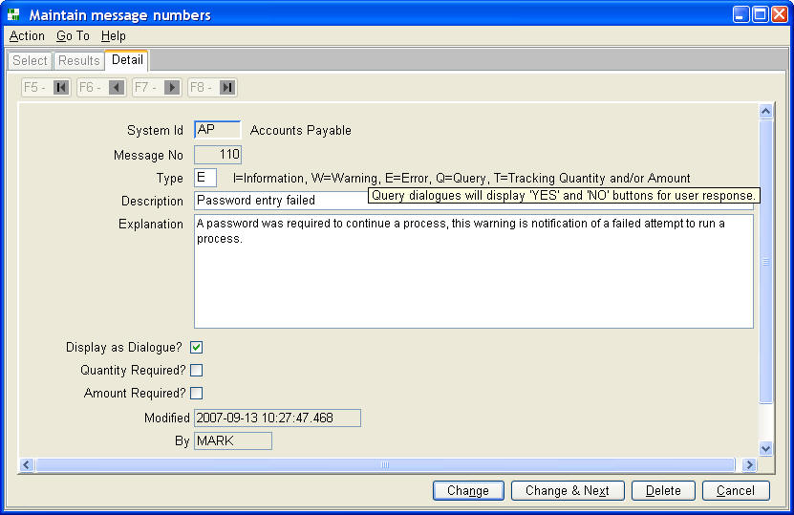
10.2 Maintain System Ids
Use this command to add or modify system ids.
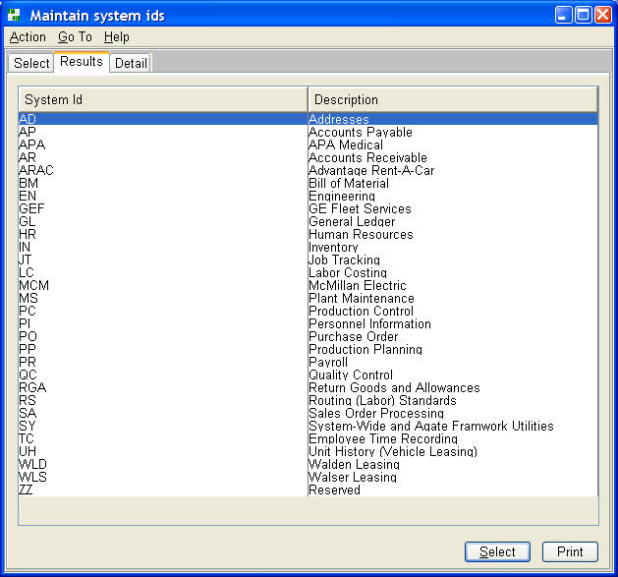
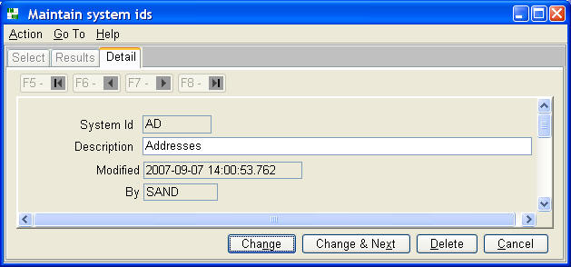
11. Glossary
The Agate III Users Guide contains a glossary for Agate III and the Framework.

