
Agate III
General Ledger Guide

“Built with Agate Framework”

Agate Partners
17270 Tilia Ridge
Eden Prairie, MN 55347

(952) 239-4125
Steve@Sandness.com
Copyright © 2009 Agate Partners. All Rights Reserved.
Table of Contents
- Introduction 4
- Overview 5
- Processing Commands 6
3.1 Maintain Unposted Journal Entries 6
3.2 List Unposted Journal Entries 9
3.3 Post Unposted Journal Entries 10
3.4 Post a Journal Entry from a Spreadsheet 11
3.5 Post a Journal Entry to a Closed, Prior Period 12
3.6 List Account Detail 13
3.7 List Total Journals 14
3.8 List Trial Balance 16
3.9 List Balance Sheet 18
3.10 List Profit and Loss Statement 21
3.11 List Financial Report 23
3.12 Close Current Period 26
3.13 List Chart of Accounts 27
- Scheduled Accounts 29
4.1 List Schedules 29
4.2 List Schedules – 1 to 15 Columns 33
4.3 Delete Balanced Entries from Schedules 36
- Bank Statement Reconciliation 37
5.1 Reconcile Bank Account 37
5.2 List Final Reconciliation, Mark Entries as ‘Done’ 41
6. Maintenance Commands 42
6.1 Change Journal Entries Allowed Indicator 43
6.2 Maintain Recurring Journal Entries 44
6.3 List Recurring Journal Entries 45
6.4 Copy Recurring Journal Entries to Unposted 46
6.5 Maintain Financial Report Definitions 47
6.6 List Financial Report Definitions 49
6.7 Re-sequence Financial Report Definition 52
6.8 Create New Report Definition from Current Report Id 53
6.9 Maintain Chart of Accounts 54
6.10 Maintain Sub Account Numbers 55
6.11 Maintain Account / Sub Account Restraints
by User, Group or Code 56
6.12 Maintain Sub Account Number’s Rollup Codes 57
6.13 Maintain Rollup Codes 58
6.14 Maintain Division Codes 59
6.15 Maintain Setup Information and User’s Properties 60
6.16 Maintain Period Ending Dates 62

Table of Contents (continued)
6. Maintenance Commands (continued)
6.17 Maintain Source Codes 63
6.18 Maintain Company Information 64
6.19 Fix Posted Journal Entries 65
6.20 Fix Scheduled Entries 66
6.21 Fix Reconciled Indicator in Posted Journal Entries 67
7. Glossary 68
1. Introduction
This manual is a compilation of Agate III’s menu window help frames for the General Ledger. It completely describes the General Ledger; however, you may find it more convenient to review this information while running Agate III, where you can use links to navigate through the help in an order convenient to you.
The commands in this manual are described in the same order as displayed in Agate III’s standard menu tree structure. Every installation has the option of re-arranging folders and commands, so your menu window may look differently.
General Ledger’s Standard Menu Tree Structure
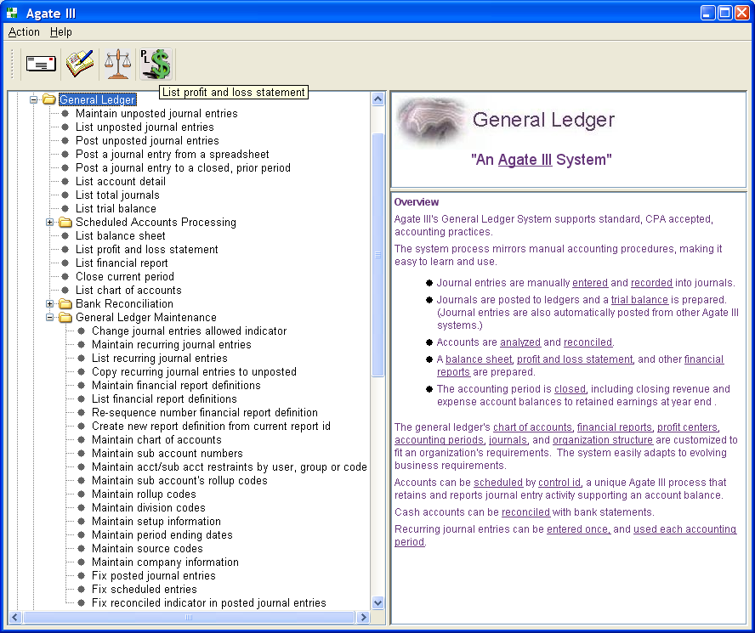
Agate III’s menu window is divided into three internal frames, a command tree on the left side, with two HTML (Hyper Text Markup Language) help frames on the right. Selecting a folder or command displays its associated help. Links can be used to drill down or to reference an associated command’s help. You can place often used commands on the toolbar by selecting one, right clicking, and clicking the ‘Add to Favorites’ menu action.
2. Overview
Agate III's General Ledger System supports standard, CPA accepted, accounting practices.
The system process mirrors manual accounting procedures, making it easy to learn and use.
- Journal entries are manually entered and recorded into journals.
- Journals are posted to ledgers and a trial balance is prepared. (Journal entries are also automatically posted from other Agate III systems.)
- Accounts are analyzed and reconciled.
- A balance sheet, profit and loss statement, and other financial reports are prepared.
- The accounting period is closed, including closing revenue and expense account balances to retained earnings at year end .
The general ledger's chart of accounts, financial reports, profit centers, accounting periods, journals, and organization structure are customized to fit an organization's requirements. The system easily adapts to evolving business requirements.
Accounts can be scheduled by control id, a unique Agate III process that retains and reports journal entry activity supporting an account balance.
Cash accounts can be reconciled with bank statements.
Recurring journal entries can be entered once, and used each accounting period.
3. Processing Commands
3.1 Maintain Unposted Journal Entries
Journal entries are entered in a header / detail format.
The journal entry header is coded with company number, period number, source code, reference, activity date and description. Checking 'Detail Line Description?' allows entering a unique description on each detail line, rather than one description on the header.
Each detail line is coded with account number, sub account number, and either a debit or credit amount. If checked in the user's general ledger global properties, a control id entry field is included in the detail dialogue.
Checking 'Auto. Reverse?' generates a reversing journal entry for the next accounting period when the current period is closed.
Check 'Statistical accounts only?' to enter non monetary values into accounts checked as such in the chart of accounts. These values can be used for calculations on financial reports.
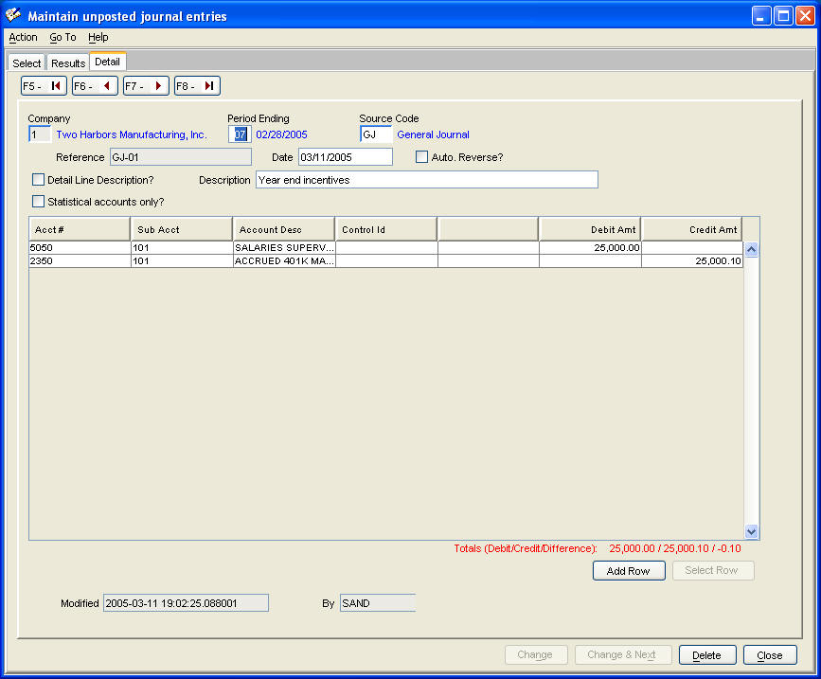

Pressing 'Add Row' or 'Select Row' displays the dialogue for adding, changing, or deleting account coding lines.
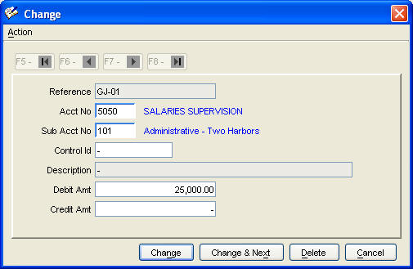
Entering Unposted Journal Entries Unique Characteristics
This command does not function like other header / detail entry commands that do not update the database with detail lines until you add or change the header. Since entering a long, complex journal entry can take some time, each account coding detail line is immediately updated to the database, thereby preventing any loss of your work if a computer failure occurs while keying an entry.
This does lead to the possibility of attempting to post an out of balance entry. The 'Post unposted entries' command detects out of balance entries and will not copy them to the posted journal entries table.
If one needs to interrupt adding a long, complex entry. The 'End Entry' button (see below) is available for this purpose, since the 'Add' button verifies that an entry is in balance.
Finally, while adding a new entry, you can not go back and change a detail line that has already been added. This is because the program needs a header added before detail lines can be changed. To do this, press 'End Entry'. Then do ‘Search’ to re-display the journal entry. You can now add, change, and delete coding lines to complete your entry.
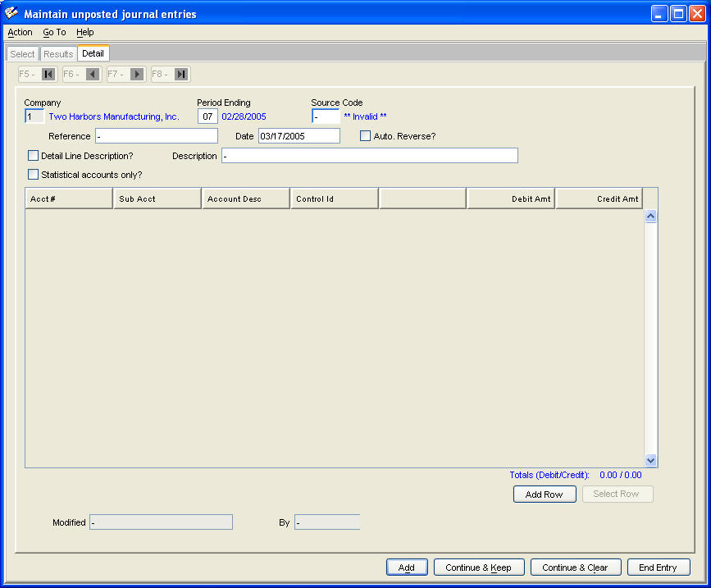
3.2 List Unposted Journal Entries
List unposted journal entries based on prompt values. Enter your user id to list only journal entries you have entered.
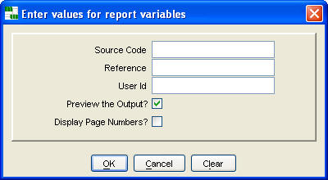
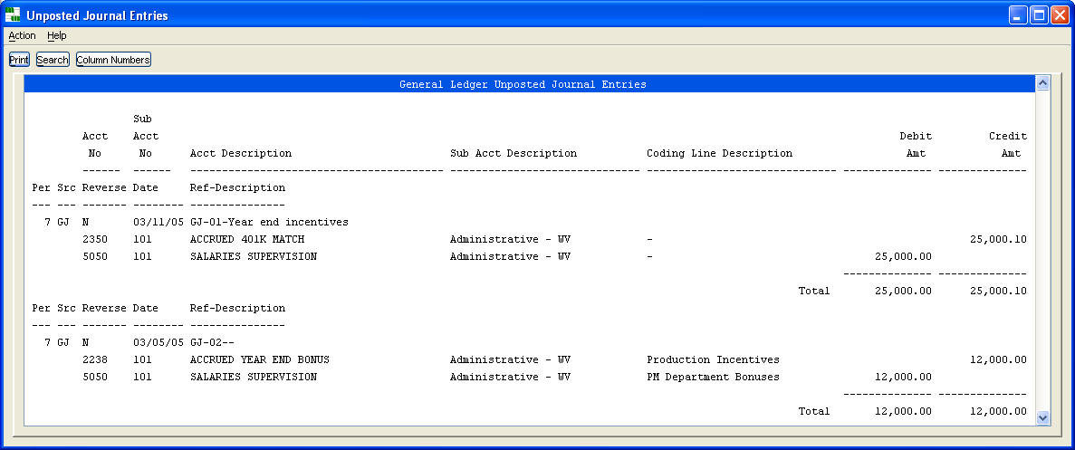
3.3 Post Unposted Journal Entries
Copy unposted entries to the posted entries table, after verifying they are in balance.
Enter your user id to post only journal entries you have entered. Leave the user id prompt blank to post all entries.
Checking 'Calculate Trial Balance?' includes these journal entries in the current period's ending balances, making running a trial balance unnecessary, before listing a balance sheet, profit and loss statement, or any of the financial reports.
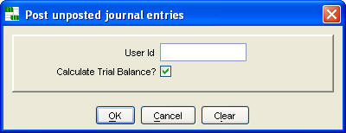

3.4 Post a Journal Entry from a Spreadsheet
1. Prompts for the file name of the spreadsheet journal entry to be posted
2. Copies the file (comma delimited format) into a work table
3. Validates that account numbers, etc, are correct
4. Displays an error report and terminates when errors are detected
5. Previews a posting report for your final review
6. Prompts whether to continue: "Ready to post?"
7. Posts the spreadsheet data as a journal entry
A template spreadsheet file, that you may copy for preparing your journal entries, is located at x:\Data\GeneralLedgerJournalEntryTemplate.xls, where ‘x’ is the network drive letter used for your Agate III installation.
Your spreadsheet must be saved in comma delimited format, i.e. one with a file suffix of ".csv".
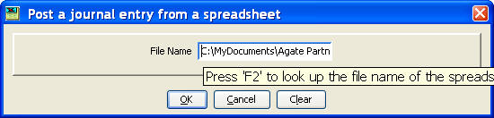
You can press 'F2' from within the File Name field in the above prompt to display the following file chooser dialogue to browse and locate your comma delimited, spreadsheet file.
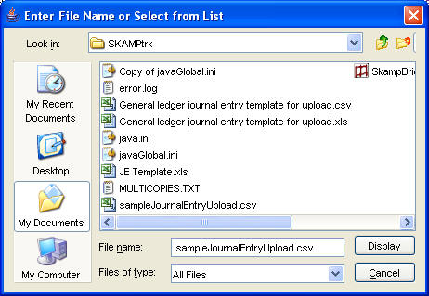

3.5 Post a Journal Entry to Closed, Prior Period
1. Prompts for user id posting prior period journal entry.
2. Enter or display journal entry to be posted
3. Validates that account numbers, etc, are correct
4. Displays an error report and terminates when errors are detected
5. Previews a posting report for your final review
6. Prompts whether to: "Continue posting prior period journal entry for prior period n?"
7. Posts the journal entry to prior period; rolls balances forward to current period.
8. Saves journal entry into appropriate history and schedule tables.
9. Before/after images of balance tables saved for audit trail.
Restrictions:
1. Only one one journal entry can be posted at a time.
2. Only one account / sub-account amount coding per journal entry.
3. Can only post to the last 11 prior periods.
3.6 List Account Detail
List posted journal entries based on prompt values.
Year to date journal entries are available only if indicated to be saved in the chart of accounts. Life to date journal entries are available only if indicated to be saved in setup information.
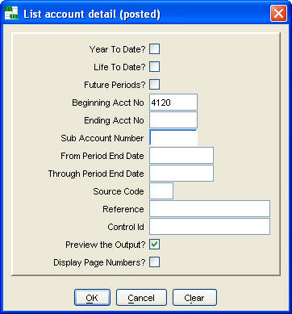

Account Detail Report
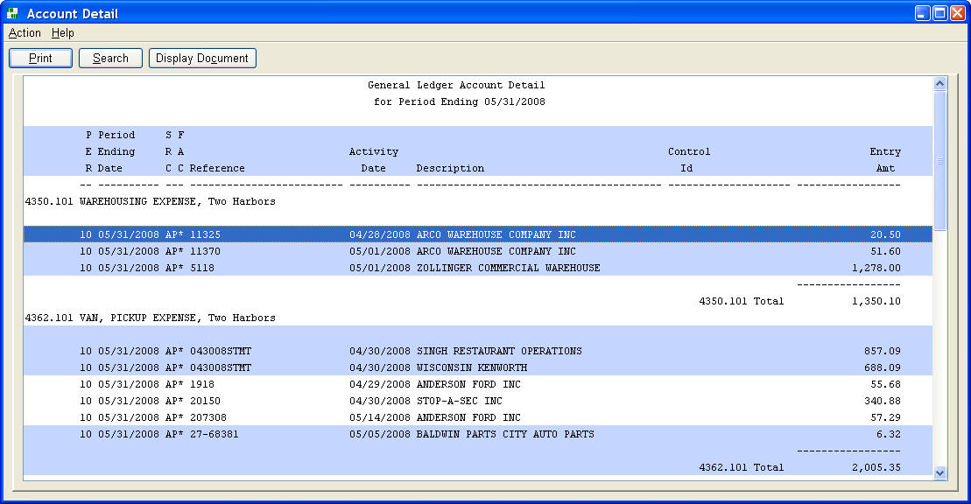
Note: An asterisk (*) in the FACsimile column indicates a supporting document image can be displayed by either double clicking the line or pressing the 'Display Document' button.

3.7 List Total Journals
List detail and/or summary total journals for current period based on prompt values. Journal entries are listed in reference order for each source code.
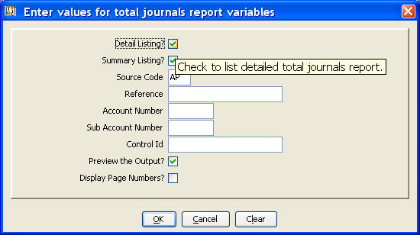
Total Journals Detail Report
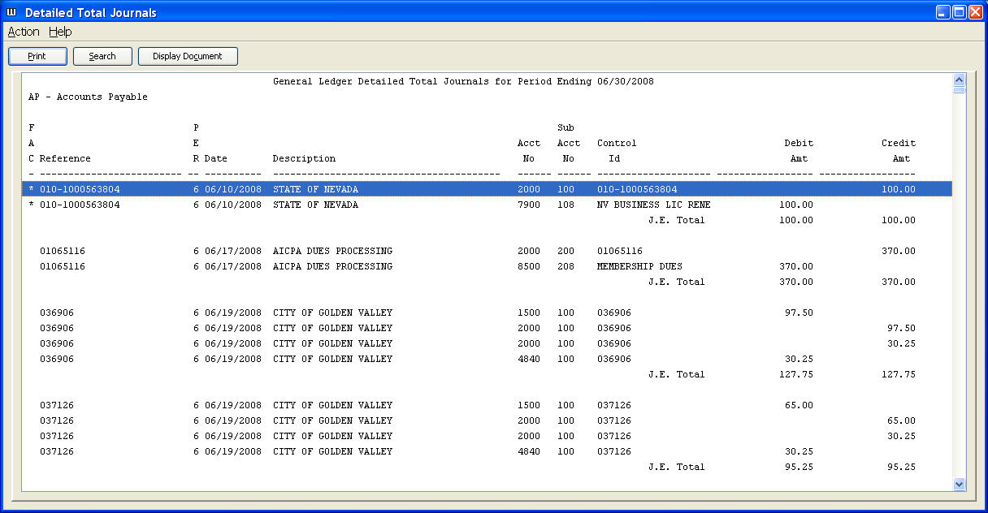
Note: An asterisk (*) in the FACsimile column indicates a supporting document image can be displayed by either double clicking the line or pressing the 'Display Document' button.

Total Journals Summary Report
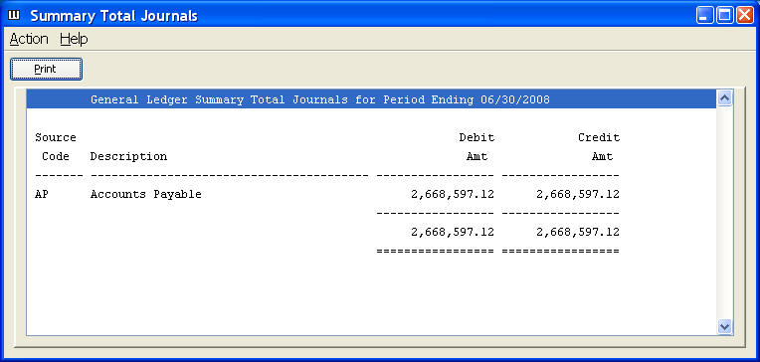

3.8 List Trial Balance
Calculate ending balances for current period, and list detail and/or summary trial balances based on prompt values.
You must calculate ending balances before listing a balance sheet, profit and loss statement, or financial report, if journal entries have been posted since the last calculation.
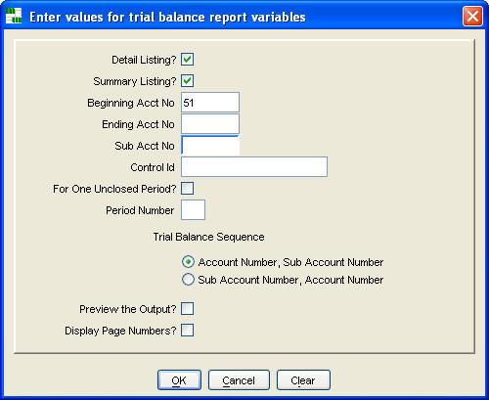
Trial Balance Detail Report
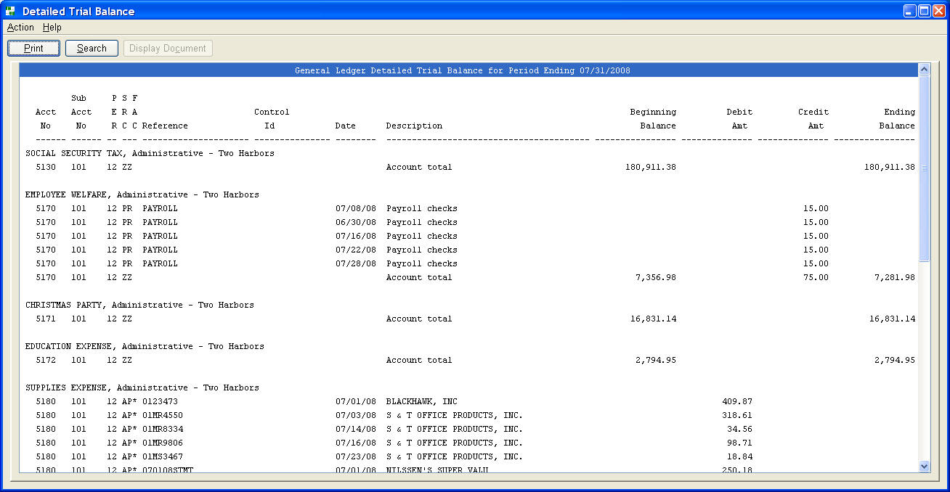
Note: An asterisk (*) in the FACsimile column indicates a supporting document image can be displayed by either double clicking the line or pressing the 'Display Document' button. The 'Search' button can be used to search forward or backwards through the report.

Trial Balance Summary Report
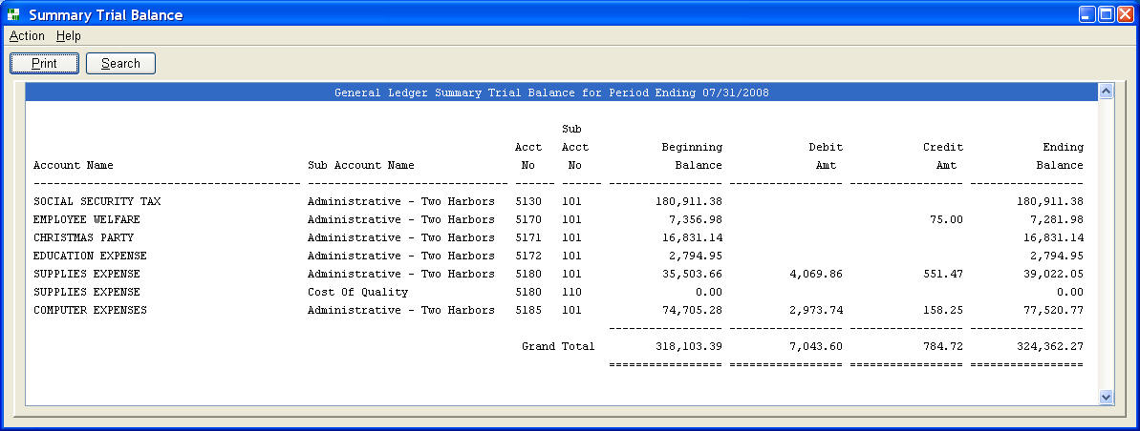
3.9 List Balance Sheet
List balance sheet based on prompt values.
- 'Compare prior periods' -- Compares current year to last year.
- 'Print Percents' -- Include a percent column, based on 100% amount specified in report definition
- 'Indent' -- Number of characters to indent left margin
- 'Display Date Printed' -- Include a date, time, and page number footer line
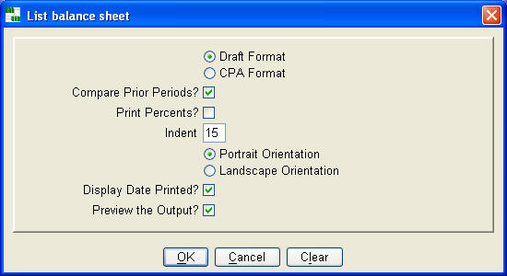
CPA Format
The CPA format is prepared using financial report definition 'ZZGBS'. Drill down to journal entry detail supporting an amount by either double clicking the line or pressing the 'Display Detail' button.
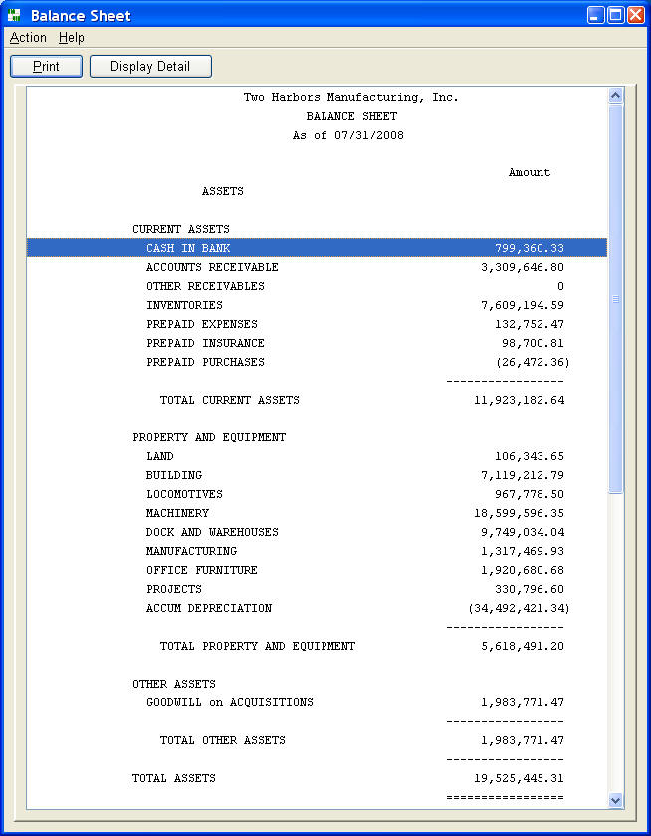
Draft Format
The draft format lists and totals all accounts in the ranges of assets, and liabilities / equities, as defined in setup information. Use it to verify that the CPA format is accurate, i.e. no accounts have been left out of its report definition.
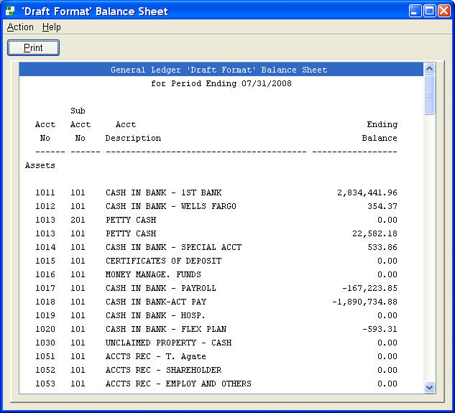
3.10 List Profit and Loss Statement
List profit and loss statement based on prompt values.
- 'List Percents?' -- Include a percent column, based on 100% amount specified in report definition
- 'Indent' -- Number of characters to indent left margin
- 'Display Date Printed?' -- Include a date, time, and page number footer line
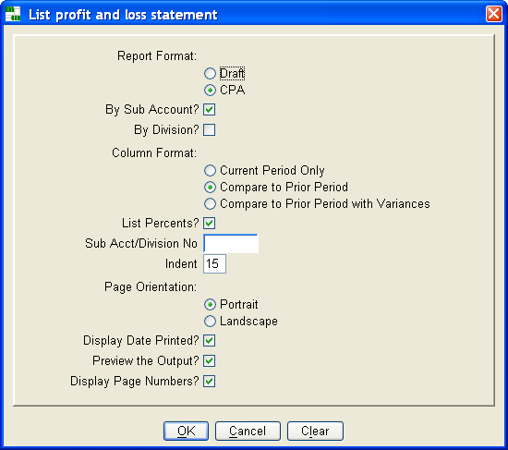
CPA Format
The CPA format is prepared using financial report definition 'ZZGPL'. Drill down to journal entry detail supporting a current period amount by either double clicking the line or pressing the 'Display Detail' button.
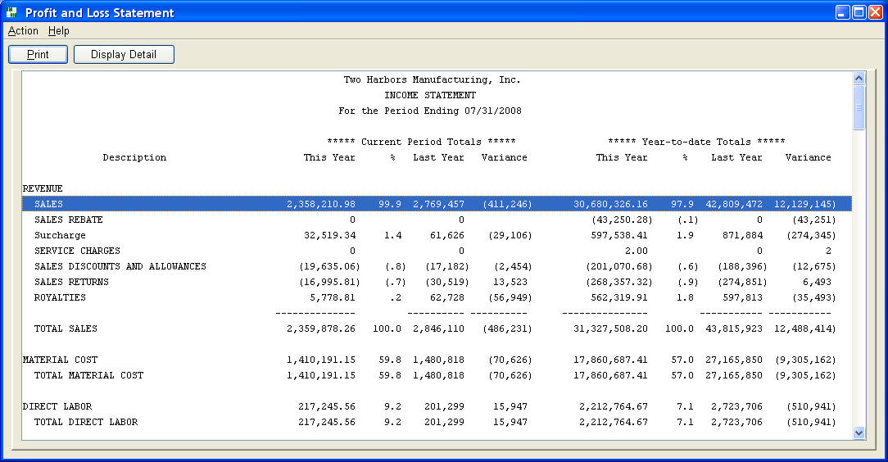
Draft Format
The draft format lists and totals all revenue and expense accounts, as defined in setup information. Use it to verify that the CPA format is accurate, i.e. no accounts have been left out of its report definition.
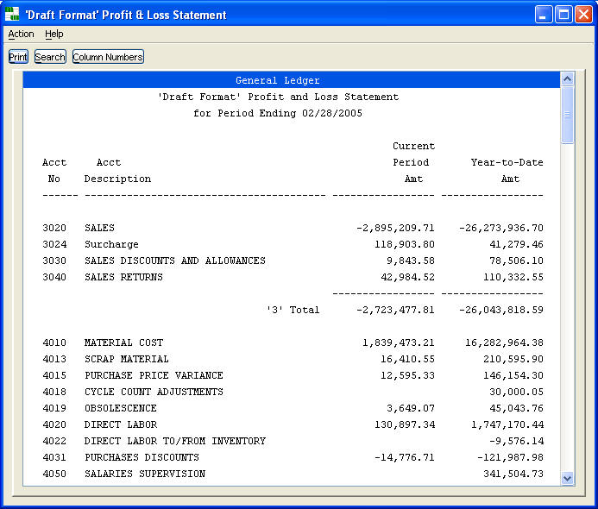
3.11 List Financial Report
List financial report based on report definition and prompt values.
- 'List Percents?' -- Include a percent column, based on 100% amount specified in report definition
- 'Display Page Numbers?' -- Include a date, time, and page number footer line
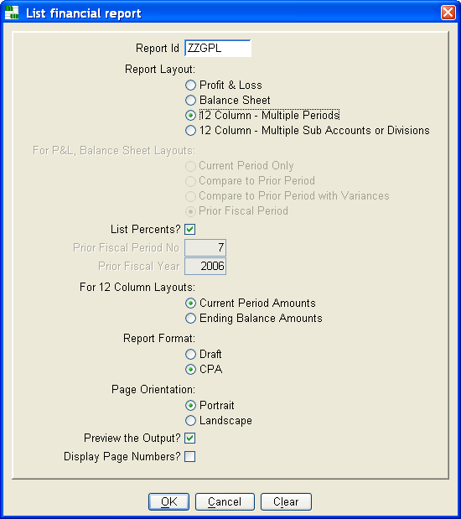

When you select one of the 12 column report layout types, the following additional prompts display for further defining your report contents and layout.
Twelve Column Layout Prompt – Multiple Periods
Enter period number and column heading for 1 to 12 columns, a grand total heading, and a title.
- Last Twelve Periods -- Use to print current year periods or prior year period numbers greater than current period
- Prior Year Periods -- Use to print prior year periods
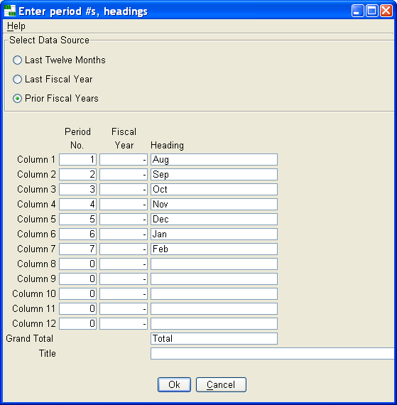
Draft Format Prompt
This prompt allows entering a range of accounts and list of sub-accounts to limit the number of accounts listed. This draft report provides an excellent spread sheet layout of account history, which may be further analyzed using the print prompt dialogue's ‘Open in Spreadsheet Program’ option.
You may also list sub-totals by account number by checking ‘SubTotals by Acct No?’.
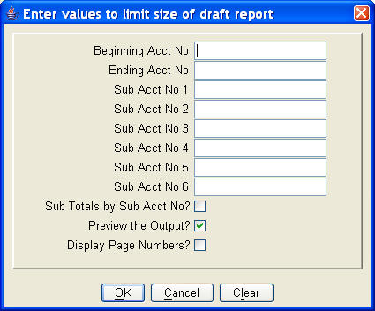
Twelve Column Layout Prompt – Multiple Sub Accounts or Divisions
Enter sub account numbers or division codes for 1 to 12 columns, a grand total heading, and a title.
- P & L Formats or Ending Balance Amts from the first prompt can be designated
- Reports can be printed for current period or any prior closed period.
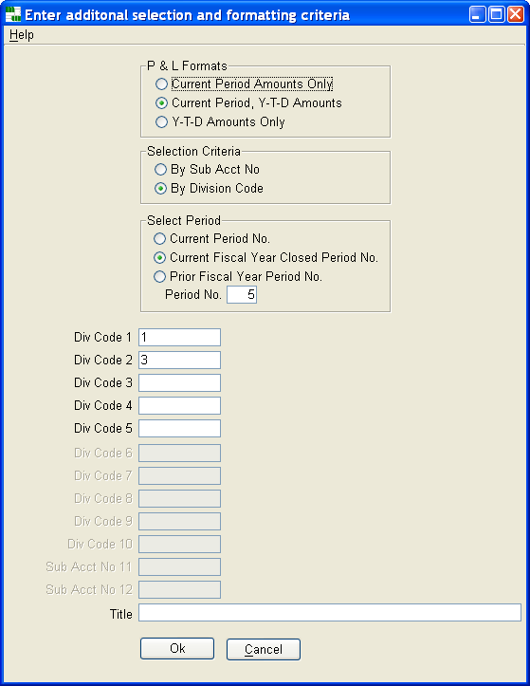
Twelve Column Layout Report Example in CPA Report Format
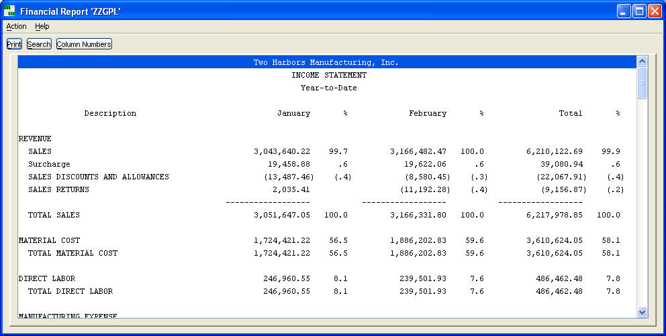
3.12 Close Current Period
Prompt displays period number and ending date of period to be closed.
Press 'Yes' to continue closing.
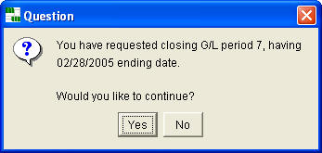
Close Processing Steps
- Calculates trial balance, insuring ending balances include all posted journal entries.
- Ending account balances are set as next period's beginning balances.
- Journal entries are copied to year to date and schedule history tables.
- Ending balances are saved in current year table for comparison period reporting.
- Period number is incremented
- Ending date, for the period number lagging three periods, is incremented one year.
- Unchecks 'Copied this period?' for all recurring journal entries.
- Auto-reversing journal entries are made for next period.
- Year end processing: Close revenue and expense account balances to retained earnings.
- Year end processing: Copy year to date journal history to life to date journal history.
- Year end processing: Copy current year period ending balances to life to date balances history.
NOTE: Always make a database backup before running this command. It would be impossible to recover the database to a "normal state" should this command abend, and the database's rollback logic also fails.
3.13 List Chart of Accounts
Lists valid account numbers, sub account numbers, and division codes, in either account number or description sequence, based on prompt values.
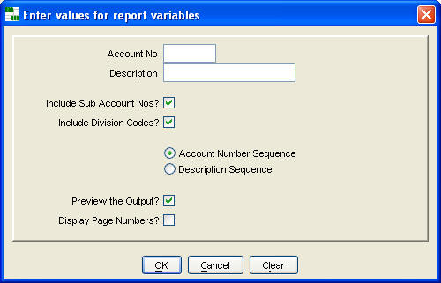
The 'Change' button is is enabled on any line eligible to maintained directly from the previewed report. Pressing the 'Change' button or double clicking the report line will link you to the table maintenance window for that report line. In the example below, the 'Change' button will link you to chart of accounts maintenance for account number 1011.
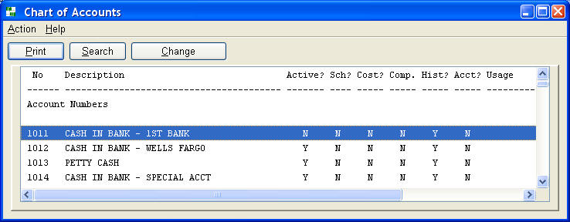

Sub Account Numbers Section
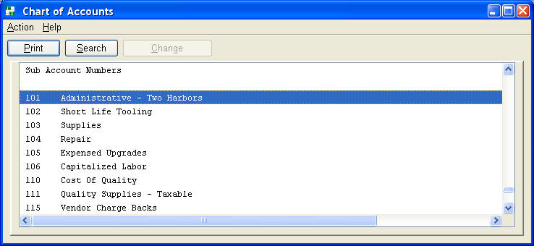
Division Codes Section
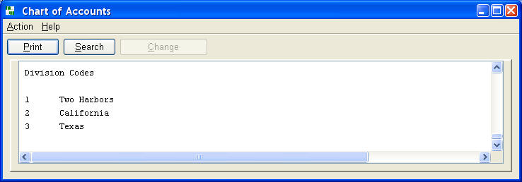

4. Scheduled Accounts
A control id field is added to scheduled account journal entries. Scheduled account journal entries are retained, until the journal entries for a control id balance; i.e. total to zero.
Scheduling summary, detail, aging, and 1 to 15 column reports, that support an account's current balance, can be run at any time.
This feature is especially useful for balance sheet accounts. It often eliminates developing an automated subsidiary system, and it eliminates searching through a multitude of period ending reports to identify journal entries supporting an account's current balance.
Scheduling is useful for equipment, note, leasing, payable, and clearing accounts. It can eliminate the need to create individual account numbers to separate sets of activity. Instead, each set is assigned a unique control id, for a loan, piece of equipment, project, lease, etc.
4.1 List Schedules
List up to six schedules reports based on prompt values: summary, detail, aging summary, detail and summary aging by control id.
The date prompts create three selection options:
- If all three dates are null, journal entries are selected through the current period.
- If 'Period Ending Date' is entered, journal entries are selected through that period ending date.
- If 'Beginning Date' and 'Ending Date are entered, journal entries are selected for that range of activity dates.
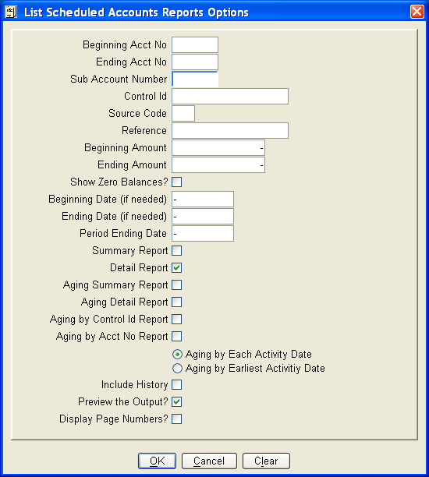
For large reports, this command may process for a time before displaying the report. The procedure execution window below provides feedback that processing is proceeding successfully.
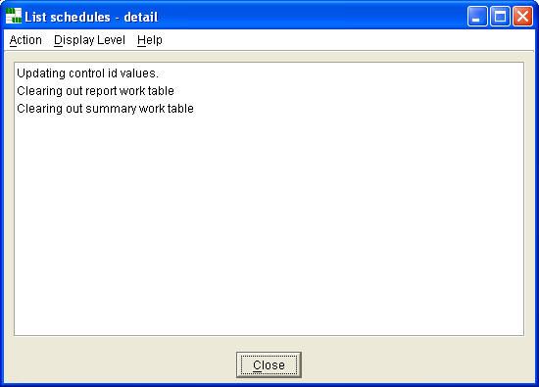

Summary by Control Id Report
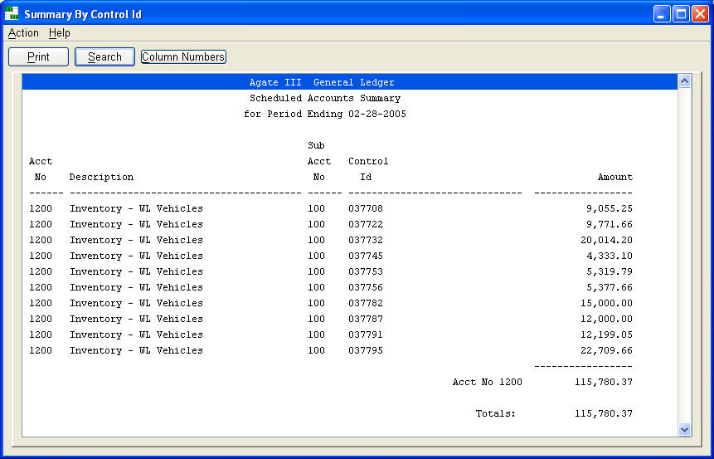
Detail Report
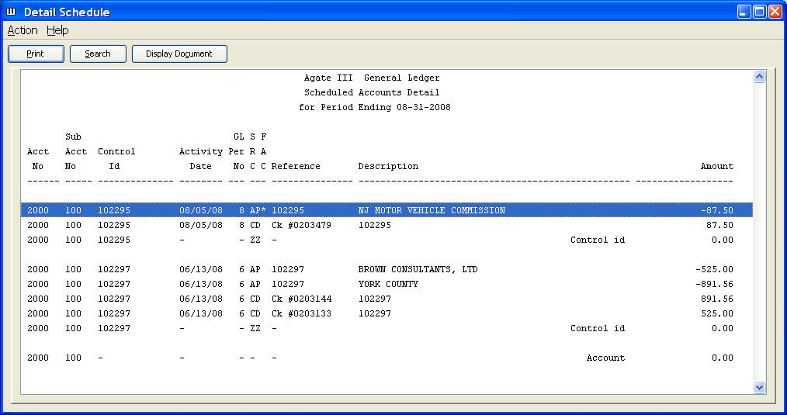
Note: An asterisk (*) in the FACsimile column indicates a supporting document image can be displayed by either double clicking the line or pressing the 'Display Document' button.

Aging Detail Report
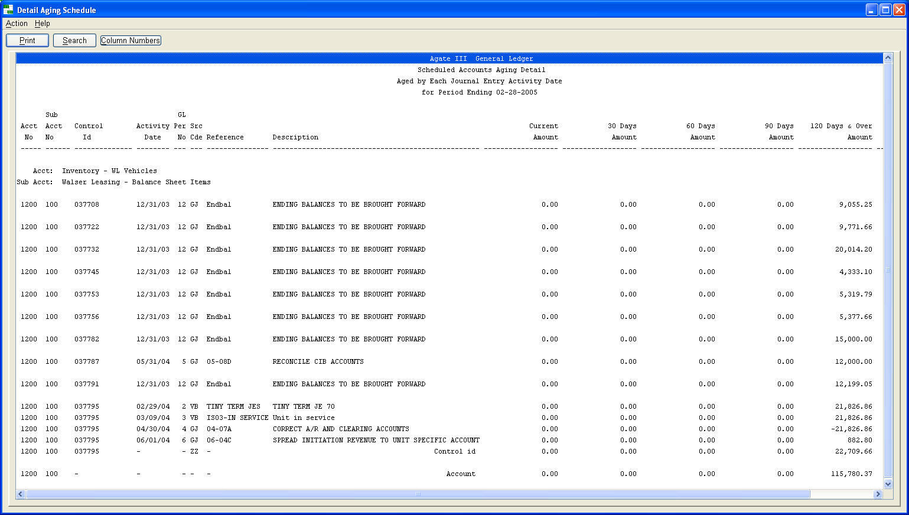
Aging Summary by Control Id
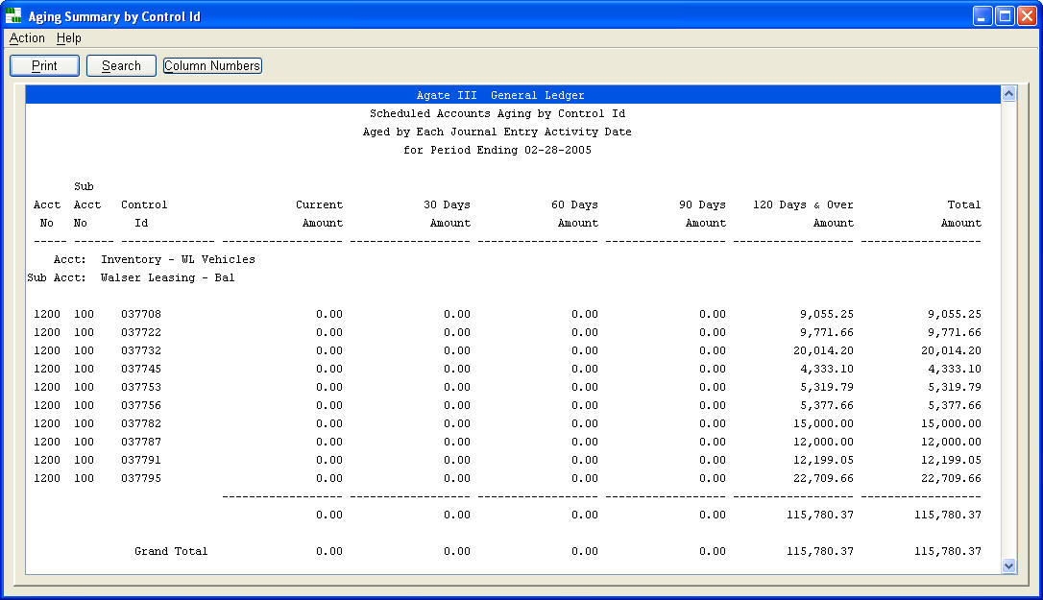
Aging Summary by Account Number
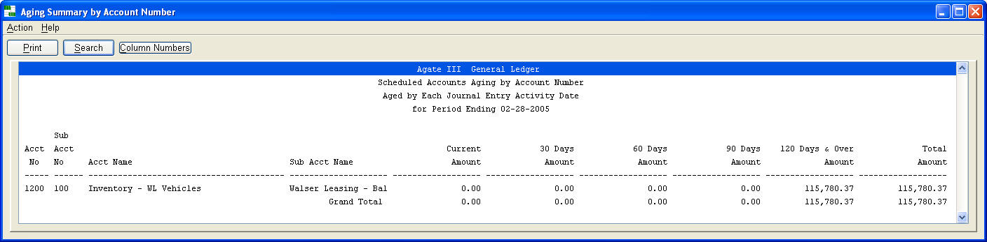

4.2 List Schedules - 1 to 15 Columns
Scheduled accounts can be listed in detail or summarized by control id for up to fifteen accounts based on prompt values.
The date prompts create three selection options:
- If all three dates are null, detail is listed through the current period.
- If 'Period Ending Date' is entered, detail is listed through that period ending date.
- If 'Beginning Date' and 'Ending Date are entered, detail is listed for that range of activity dates.
- If 'Only if Activity Earlier Date' entered, detail is listed only if the activity date is less than or equal to this date.
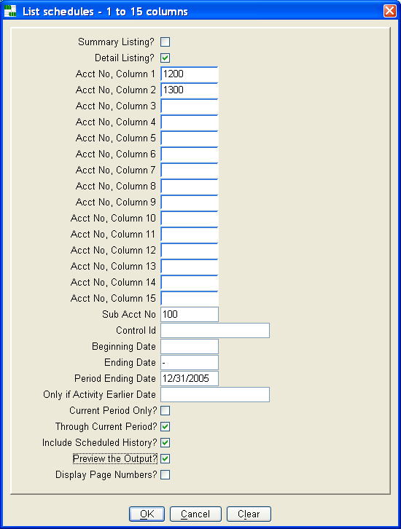
For large reports, this command may process for a time before displaying the report. The procedure execution window below provides feedback that processing is proceeding successfully.
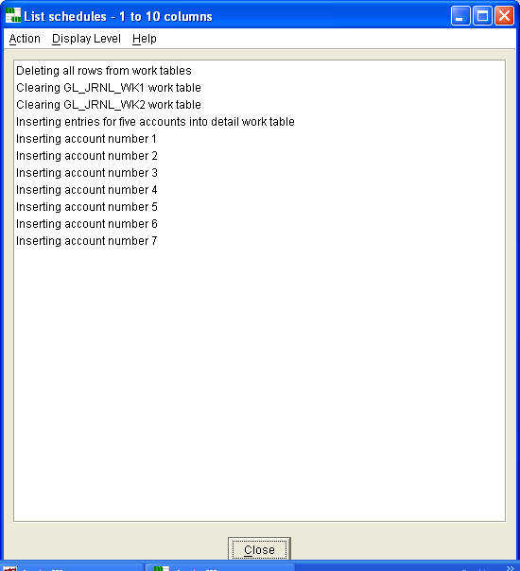
Detail Report
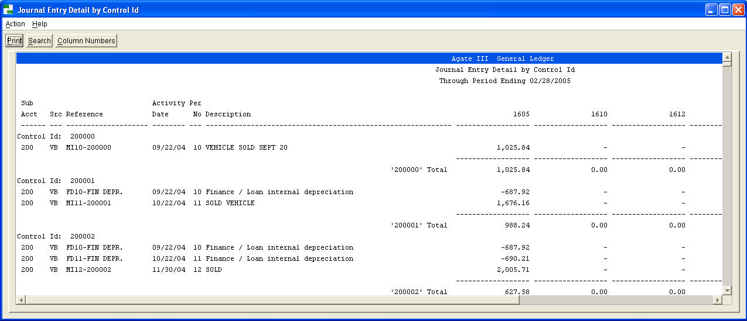
Summary Report
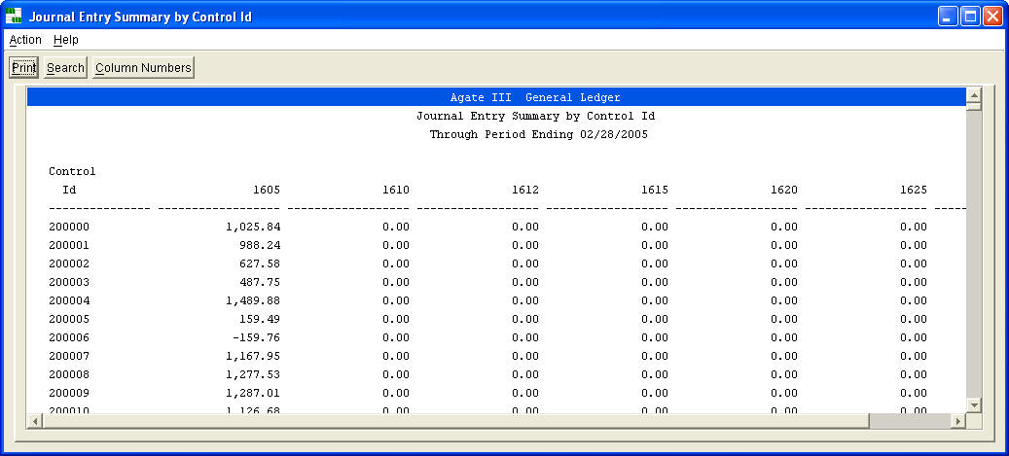

4.3 Delete Balanced Entries from Schedules
Deletes journal entries that balance by control id from the schedules history table through the entered period ending date.
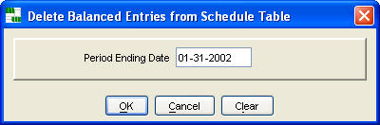
You should keep balanced entries for as long as you desire to create schedule reports for closed periods, to support balances in a closed period financial statement.
5. Bank Statement Reconciliation
Agate III provides two methods for reconciling a bank statement. The Accounts Payable system contains a check reconciliation process that is very effective, if most statement activity is checks. However, more and more organizations utilize ACH (automated clearing house) transfers, rather than checks for payment processing, making this check reconciliation process inefficient.
Agate III's General Ledger reconciliation process is more effective for these organizations. Account's Payable journal entries are posted in check detail, rather than summarized. For ACH activity, journal entries are made manually or posted from spreadsheets, using data often provided by the bank in computer readable format. Journal entry detail, rather than Accounts Payable check detail, is then reconciled with the bank statement.
5.1 Reconcile Bank Account
Reconcile a bank statement for the entered bank id.
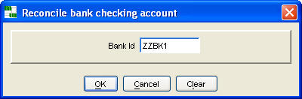
Setting Period Ending Date
To start a reconciliation for a period, use the menu action 'Set maximum G/L period ending date for je's to include in reconciliation' to set the period ending date; then stop and re-start this command.
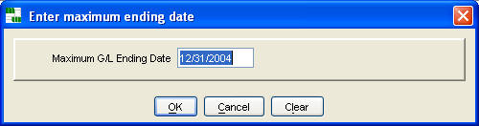
Reconciling Entries
You can reconcile either individual entries by checking the 'Reconciled?' check box or you reconcile a range of items using the menu action 'Reconcile/Unreconcile a group of journal entries'. The windows for these two options are displayed below. An efficient process is to mark all entries 'reconciled' for a period, and then 'unreconcile' those few entries not clearing the bank for the accounting period.
Reconcile/Unreconcile a Range of Items
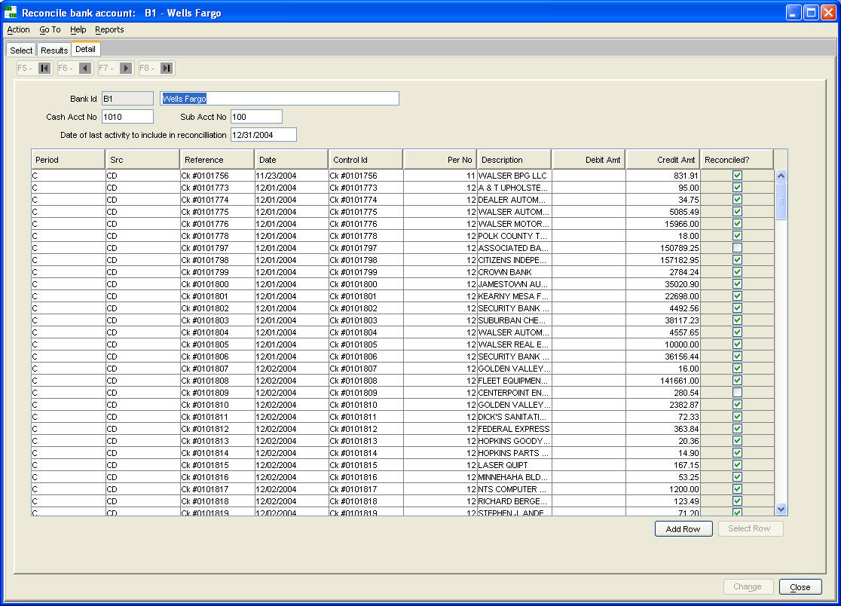
You may either check items in above window or select a row and display the following dialogue.
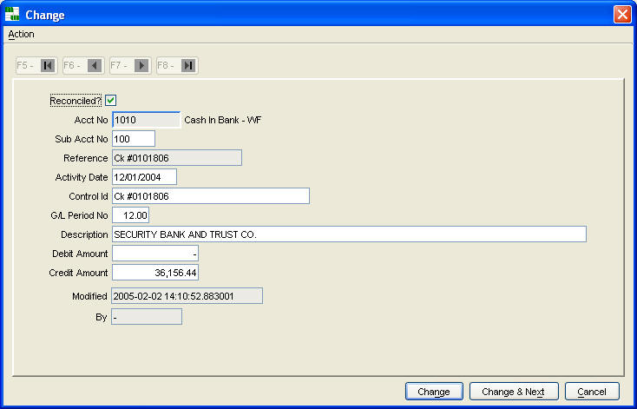
Reconcile/Unreconcile a Range of Items
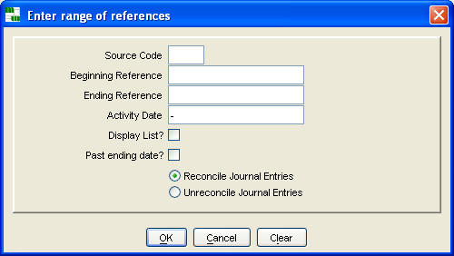
Reports
Use menu actions to either 'List reconciled or unreconciled entries' or to 'List preliminary reconciliation' reports.
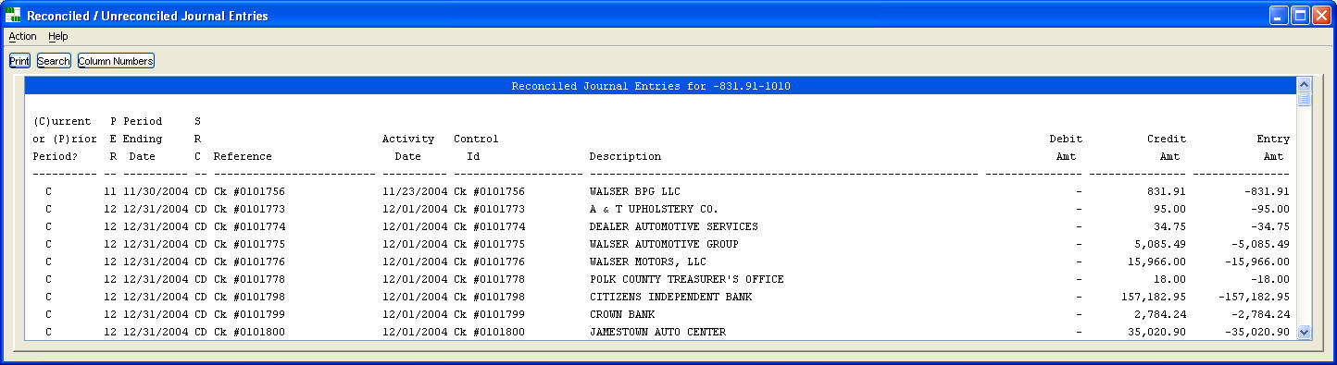
Preliminary Reconciliation Summary
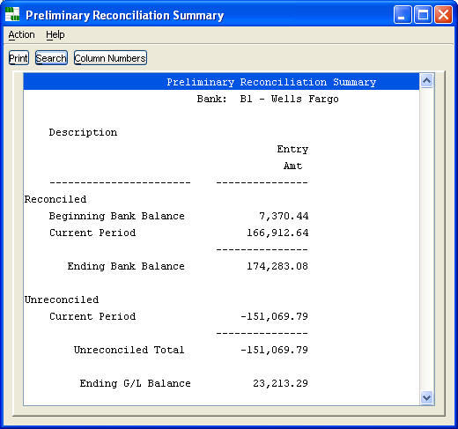
Starting Up Reconciliation
When using bank reconciliation for the first time, use 'Maintain bank definitions' (Accounts Payable Maintenance Folder) to enter the beginning bank balance, and use 'Fix reconciled indicator in posted journal entries' to mark as 'done', i.e. completed with the reconciliation process, all journal entries before the first bank statement being reconciled.
5.2 List Final Reconciliation Summary - Mark Entries as 'Done'
List final reconciliation reports in either detail or summary formats. After closing the report windows you are prompted whether you wish to mark entries as 'Done', which finishes the reconciliation process and sets the beginning bank balance for the next reconciliation equal to the ending bank balance on these reports.
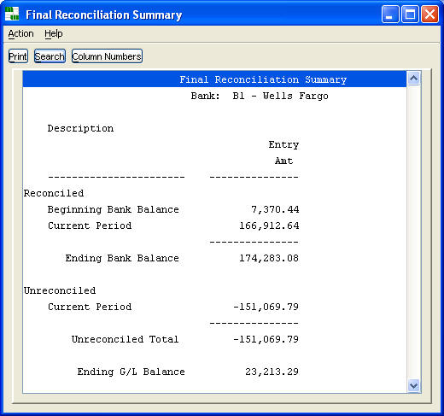
Ok to Continue Prompt
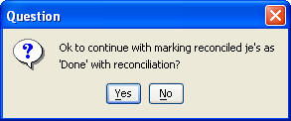

6. Maintenance Commands
Controlling Journal Entry by Period
In larger organizations, this command is helpful for having better control over which accounting periods are ‘open’ for journal entries.
- Change journal entries allowed indicator
Configuring the General Ledger
General Ledger control tables are modified using these commands.
- Maintain chart of accounts
- Maintain sub account numbers
- Maintain financial report definitions
- Maintain acct/sub acct restraints by user, group or code
- Maintain sub account’s rollup codes
- Maintain rollup codes
- Maintain division codes
- Maintain period ending dates
- Maintain source codes
- Maintain setup information
- Maintain company information
Recurring Journal Entries
Recurring journal entry commands save entering the same or similar journal entries each accounting period.
- Maintain recurring journal entries
- List recurring journal entries
- Copy recurring journal entries to unposted
Fixing Problems
Situations arise from time to time requiring a way to modify posted entries.
- Fix posted journal entries
- Fix scheduled entries
- Fix reconciled indicator in posted journal entries
6.1 Change Journal Entries Allowed Indicator
When multiple staff post journal entries, miscommunication may occur over which accounting period to use. This command gives the lead accounting person absolute control over which accounting periods are ‘open’ for journal entries. This is especially helpful coordinating the beginning of an accounting period, while the prior period has not been closed, yet should no longer receive journal entries while month end reconciliation is completed. This command can also be used to prevent accidentally posting an entry to a future period, or prior closed period.
The command works at the division code level, providing flexibility to organizations with different processing schedules by division.
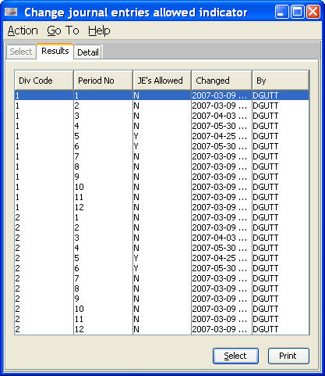
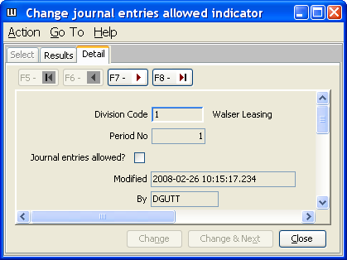
6.2 Maintain Recurring Journal Entries
Recurring journal entries saves re-keying the same journal entry each accounting period. The category id groups entries into sets that are copied at the same time during the accounting cycle. Checking 'hold' prevents an entry from being copied.
You can also set up skeletons for entries that are used repetitively. After copying these entries, you complete them with 'Maintain unposted journal entries'.
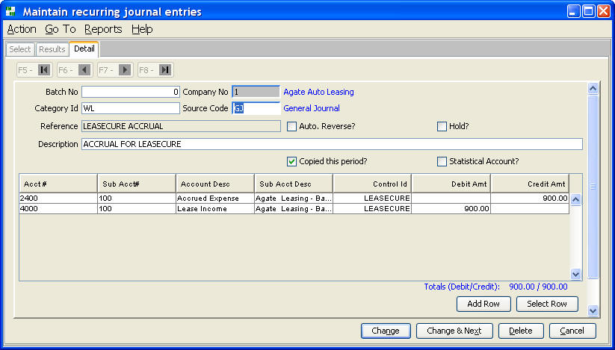
6.3 List Recurring Journal Entries
List recurring journal entries based on prompt values.
Checkboxes 'Hold' and 'Copied this period' on the maintain command have a value of either 'Y' or 'N' in the database. This prompt uses character input, rather than a checkbox for these fields, so you can retrieve checked, unchecked, or both for the report by entering either 'Y', 'N' or blank.
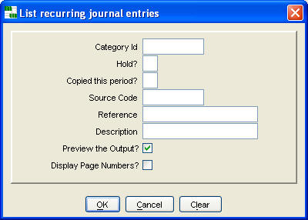
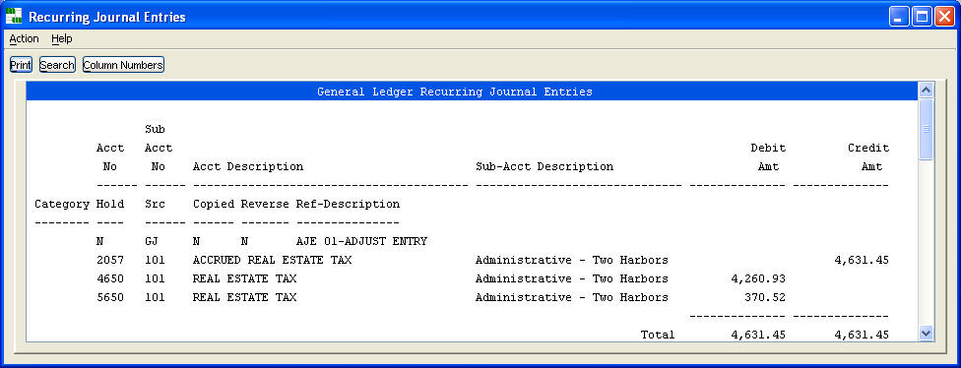
6.4 Copy Recurring Journal Entries
Copy recurring journal entries to the unposted journal entry table based on prompt values.
'Copied this period' is checked for those selected and copied, so they will not be copied again this period. Of course, you can uncheck this field with the maintain command if you need to copy them again.
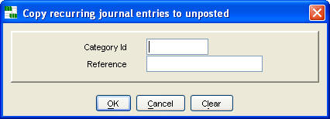
6.5 Maintain Financial Report Definitions
A report definition can be created and used by 'List financial report' to print most any financial report that you can envision, either in balance sheet, profit and loss, or 1 to 12 column format.
Report id's 'ZZGPL' and 'ZZGBS' are Agate III's profit and loss statement and balance sheet definitions, that are used with the 'List profit and loss statement' and 'List balance sheet' commands, respectively.
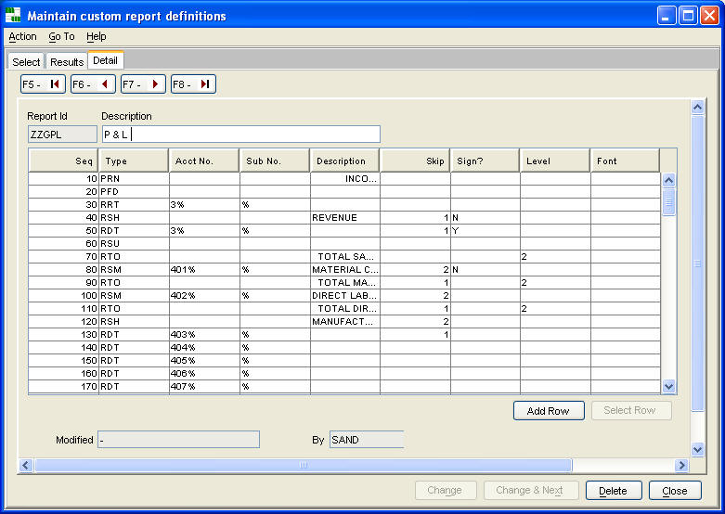
Pressing 'Add Row' or 'Select Row' displays the following detail dialogue, for adding, changing, or deleting line definitions.
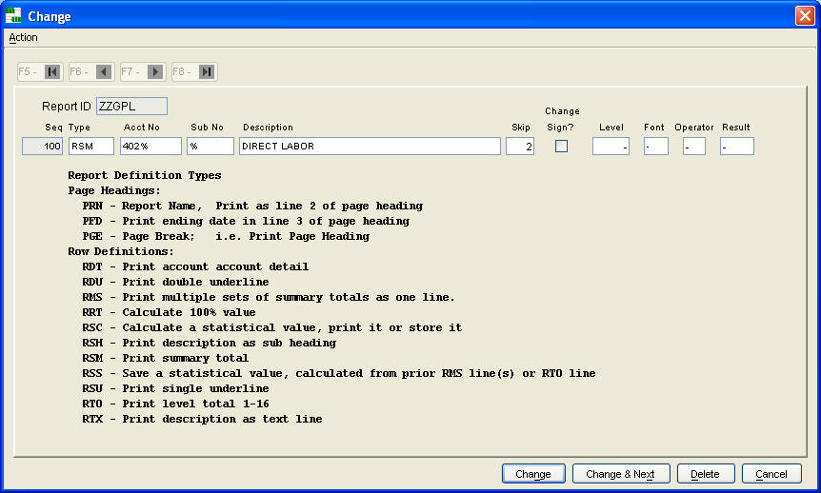
See 'List financial report definitions' for an example that uses many of the above 'Line Type' codes.
Statistical Calculations
Statistical numbers can be calculated and printed.
1. Use 'RSS' to save a statistical number calculated from either a prior 'RMS' line
or RTO line.
- Enter a statistical number into the 'Acct No' field.
2. Use 'RSC' to either calculate a new statistical value from existing ones or to print one.
- Enter two statistical numbers into 'Acct No' and 'Sub No' fields. Enter one of the following operators into 'Operator' field: + = Add, - = Subtract, * = Multiply, / = Divide, and % = Percent
- Enter either a new statistical number into the 'Result' field, or enter 'P' to print the result.
Note: 0 can be entered into 'Sub No' with a + operator to print an existing value.

6.6 List Financial Report Definitions
The profit and loss statement definition on pages 50-51 shows some typical uses of 'Line Type' codes.
Some highlights of this definition:
- Multiple RRT lines are used to calculate a 100% amount.
- Database wild cards are used in the acct no/sub acct no fields to define account selection criteria for RDT, RSM, RMS, and RRT lines.
- Twelve total levels are available. After a total prints, it is reset to zero. Thus, to print a cumulative income amount, one must always use a higher level number, as you proceed down the report.
- Accounts can be listed in any order. Note the 38 series of accounts printed at the bottom of the report.
- RSM summarizes accounts for the the Acct No/Sub Acct No qualifier, printing one line on the report, using the description entered.
- Not shown in this example is the RMS line type. Multiple RMS lines aggregate to one total that is printed with the description of the last RMS line. This provides a way to aggregate a total for out of sequence account numbers.
- RDT, RSM, & RMS lines do not print if all columns have a zero amount.
- RSH, RSU, & RTO do not print, if inclusive RDT, RSM or RMS lines have zero amounts.
- The 'Skip' lines after printing value stays in effect until a subsequent line has a non-null value.
- The change 'Sign?" value stays in effect until a subsequent line has a non-null value.
Profit and Loss Statement Definition
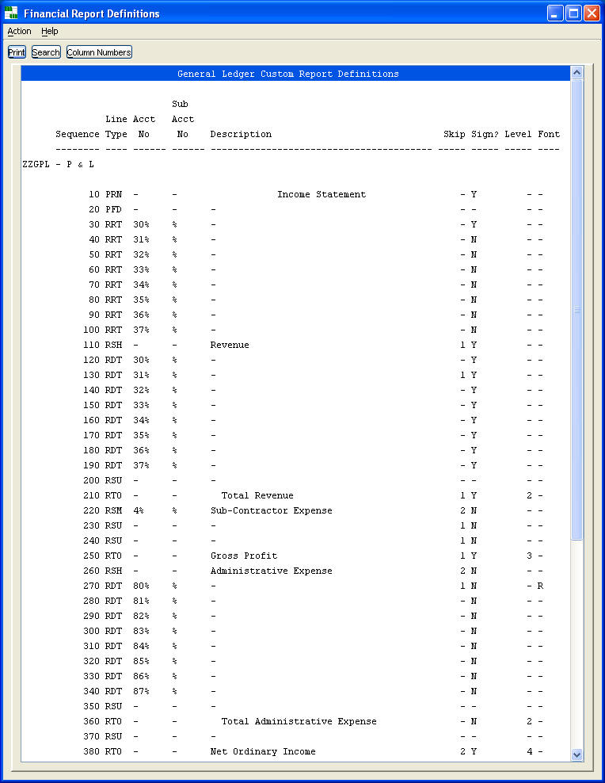
Profit and Loss Statement Definition (continued)
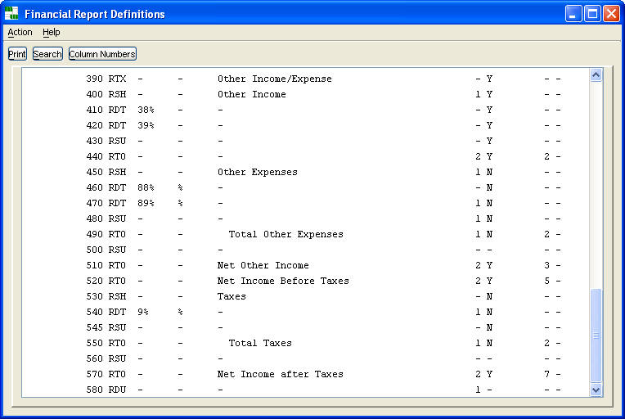
The 'Maintain financial report definitions' detail dialogue contains a complete list of 'Line Type' codes.
6.7 Re-sequence Financial Report Definition
Report definition lines are ordered by a sequence number. This command re-numbers the lines in increments of ten, leaving gaps for adding lines.
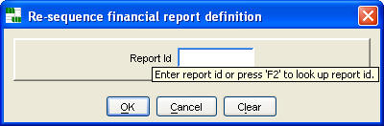
6.8 Create New Financial Report Definition from Current Report Id
The easiest way to create a new report definition is to modify an existing one. Copy an existing definition using this command. Modify the copied definition, using 'Maintain custom report definitions'.
Enter a new, unique report id, and a report id from which to create this new id. F2 is enabled to look up a report id.
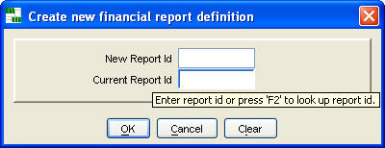
6.9 Maintain Chart of Accounts
The chart of accounts is Agate III's list of valid account numbers.
A well organized chart groups similar accounts in number ranges. It is best to have account numbers the same length for effective database wild carding. A typical chart design reserves the first digit of a number for major categories, such as assets, liabilities, equity, sales, expenses, and the second (and sometimes third digit) for sub categories and the next two to four digits for each account. You should leave gaps in your numbering system for future requirements.
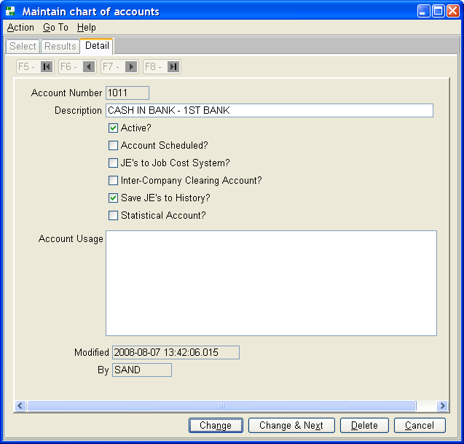
6.10 Maintain Sub Account Numbers
Sub account numbers associate account activity to business units, such as departments, branch offices, geographical locations, etc.
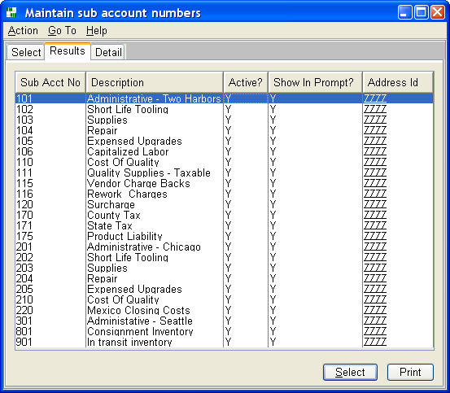
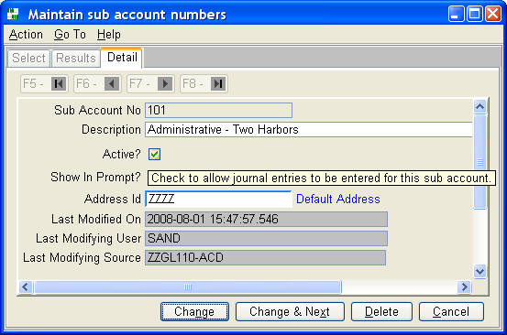
6.11 Maintain account / sub account restraints by user, group or code
One can restrict access to sets of account numbers and sub account numbers by user id, group id, or a unique code on standard General Ledger reports.
When specified by user id, that user will be restricted to accessing only the specified sets of account / sub account data. When specified by group id, every user who is a member of that group will be restricted to accessing the specified sets of data.
A unique code can be specified when creating a new command for one of the standard General Ledger reports; this unique code is entered as Parameter 8 in the command definition. This new command will then list only the subset of data as specified for the unique code.
Multiple rows with the same user id, group id, or unique code may be entered to define multiple ranges of account numbers and sub account numbers. If both a beginning and ending number is entered, the user will be able to access the accounts and sub accounts within the range. If only a portion of the beginning number is entered, all account or sub account numbers that begin with that portion will be accessible.
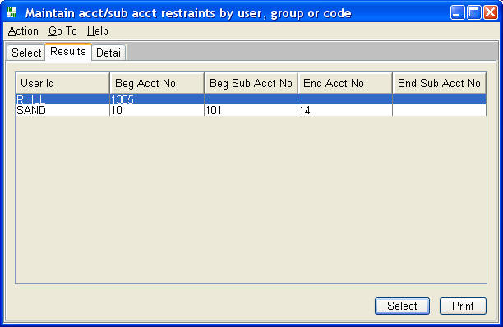
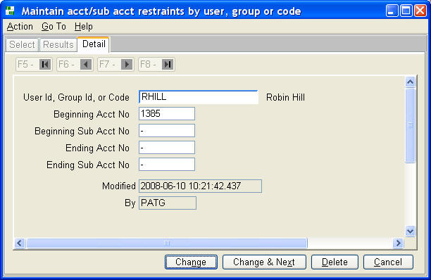
6.12 Maintain Sub Account’s Rollup Codes
Each sub account can be assigned five roll up codes. Financial statements can be created by roll up code. Valid roll up codes are defined using 'Maintain roll up codes'.
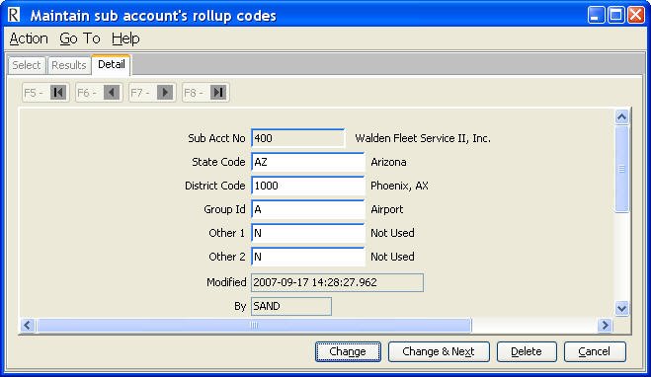
6.13 Maintain Rollup Codes
Specify valid rollup codes for each rollup level id. The description for each roll up level id is entered using program rules.
Each sub account can be assigned five roll up codes using 'Maintain sub account number's roll up codes'.
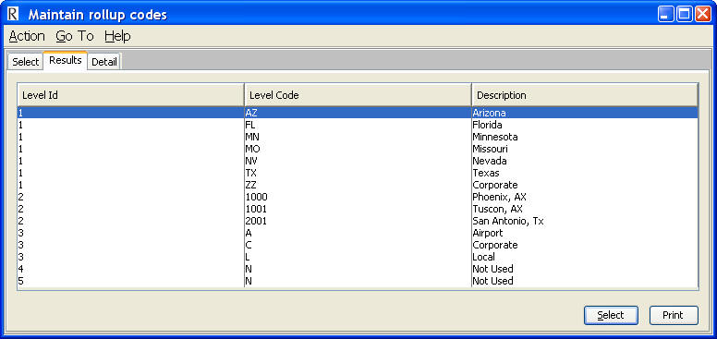
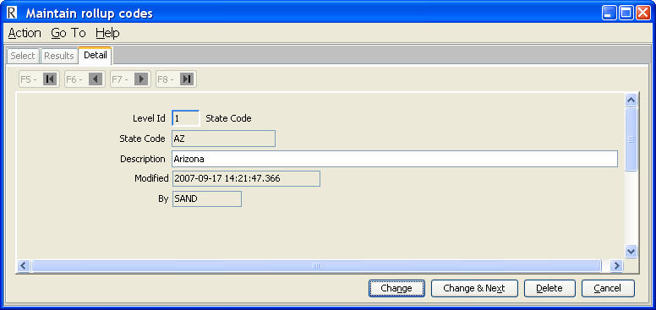
6.14 Maintain Division Codes
Define the description, balance sheet sub account number, and address id for each division code.
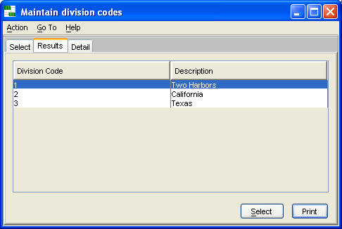
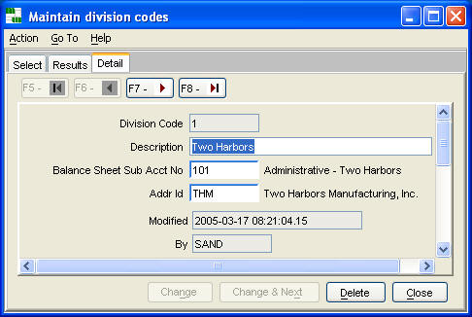
6.15 Maintain Setup Information and User’s Properties
Setup information is a set of global properties for controlling the execution of the general ledger system.
Each user has additional properties for controlling the system.
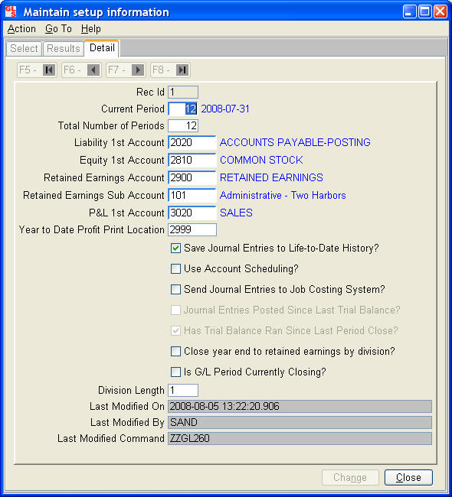
User's General Ledger Properties
Each user has a set of general ledger properties for customizing execution of commands.
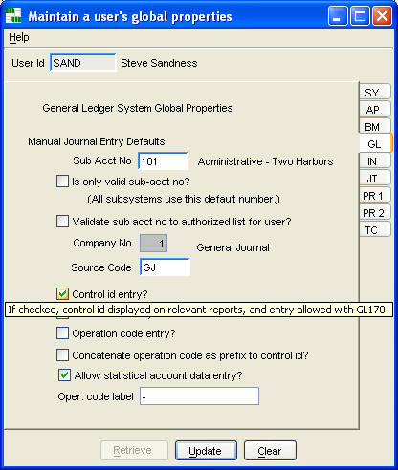
These properties are maintained by your Agate III system administrator using 'Maintain a user's global properties' command.
6.16 Maintain Period Ending Dates
Specify the ending dates for each period number, for the maximum number of periods in setup information. When closing the current period, the ending date is incremented one year, for the period number lagging three periods.
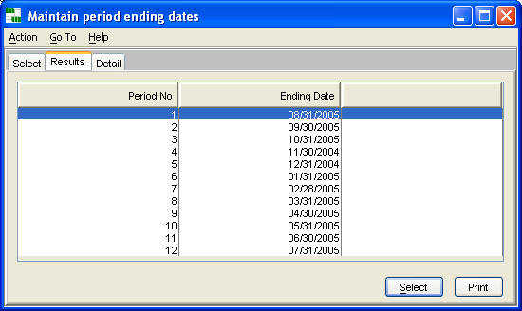
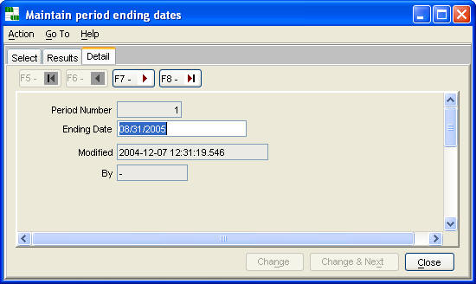
6.17 Maintain Source Codes
Source codes associate account activity to documents, business processes, etc.
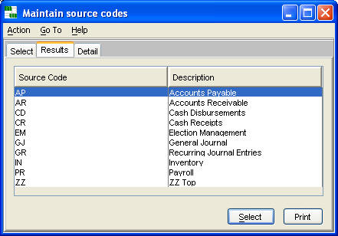
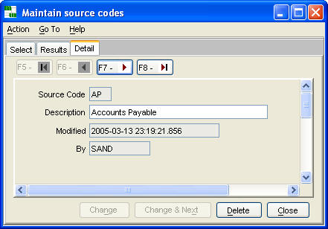
6.18 Maintain Company Information
Use this command to change the company's description and year to date profit line description, which is used when printing a balance sheet.
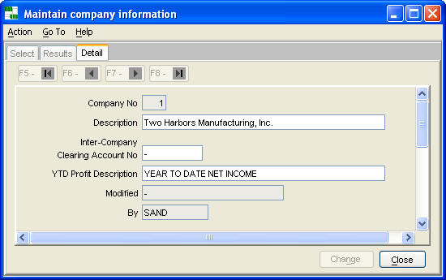
6.19 Fix Posted Journal Entries
Changing a posted journal entry should be done with great care, and be the 'last resort' in dealing with an issue, as it violates accepted accounting practices. However, it is the only way to correct an inaccurately entered control id. Changing amounts can put the system 'out of balance', so this should be done only by users with a detailed understanding of the general ledger's data structure and processes.
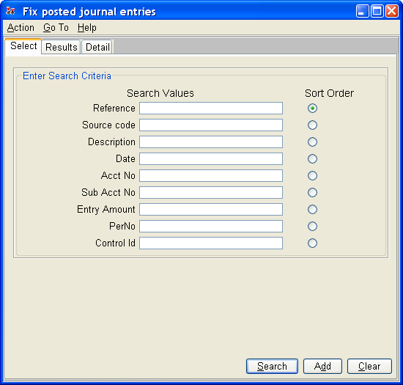
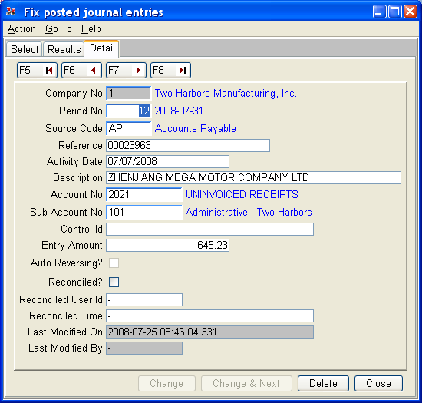
6.20 Fix Scheduled Entries
When a period is closed, scheduled account journal entries are copied to a schedule history table, to be retained until they balance by control id. Use this command to make changes to this table, making sure to maintain the balance integrity of the schedule detail total for the account to the account's ending balance.
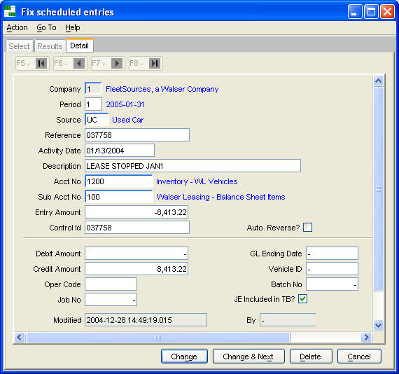
6.21 Fix Reconciled Indicator in Posted Journal Entries
This command is used primarily to mark journal entries 'Done' for periods prior to the first one being reconciled. This is done one time, when starting up the reconciliation process for an account. The command displays a list of journal entries to be changed, and prompts whether to continue. Use 'Reconcile bank account' to set the bank id affected by this command.
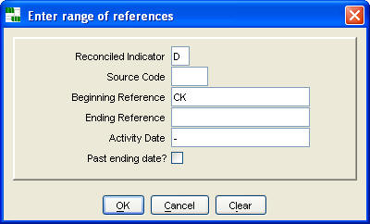
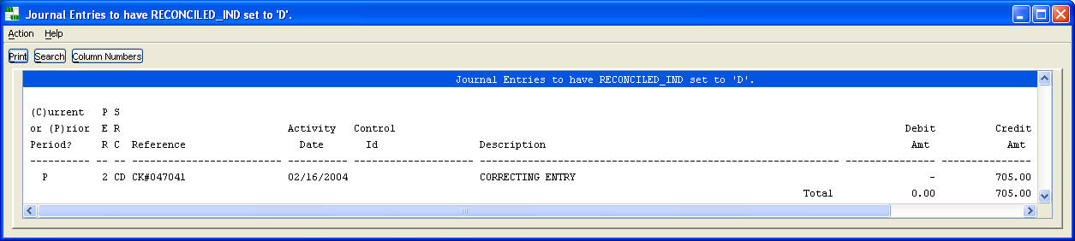
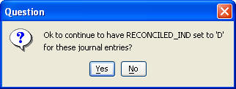
7. Glossary
The Agate III Users Guide contains a glossary for Agate III and Agate Framework.

