
Agate III
Users Guide

“Built with Agate Framework”

Agate Partners
17270 Tilia Ridge
Eden Prairie, MN 55347

(952) 239-4125
Steve@Sandness.com
Copyright © 2009 Agate Partners. All Rights Reserved.
Table of Contents
- Introduction 3
- Starting Agate III 3
- Menu Window 4
3.1 Overview 4
3.2 Agate III’s Highest Level Help Page 5
3.3 Table Maintenance Window 6
3.4 Report Preview Window 10
3.5 Menu Window’s User Settable Options 12
4. Query Manager
4.1 Overview 14
4.2 Maintain my or 'public' Queries 14
4.3 Define/Edit Button 16
4.4 Filter Tables Dialogue 17
4.5 Tables Selection Dialogue 18
4.6 Connecting Columns Dialogue 19
4.7 Report Columns Dialogue 20
4.8 Report Sequence Dialogue 21
4.9 Data Selection Dialogue 22
4.10 Report Format Dialogue 24
5. Integrated Document Archiving
5.1 Overview 27
5.2 Change / View Documents 27
5.3 Associate Document to Agate Ids 29
5.4 List Document Groups 32
5.5 Maintain Document Types 33
5.6 Maintain Filing Labels 34
5.7 Maintain Search Values
for Agate Generated Documents 35
5.8 Maintain Document Groups 36
8. Glossary 37

1. Introduction
This manual is a compilation of Agate III’s menu window help frames describing 1) features available throughout Agate III, 2) Query Manager, an interactive report writer, and 3) Agate III’s integrated document archiving. You may find it more convenient to review this information while running Agate III, where you can use links to navigate through the help in an order convenient for you.
2. Starting Agate III
Agate III is started by running an operating system script file referenced by a shortcut installed on your desktop by your systems administrator.

A splash screen and logon window display after successful Agate III initialization. Enter your user id, password, and click the ‘Ok’ button or press the ‘Enter’ key.
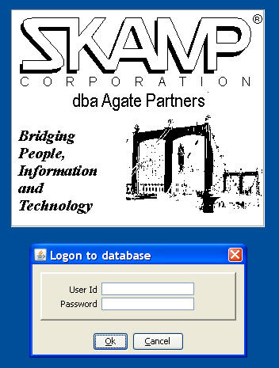
Your systems administrator can place your user id and password into your property file; then you will not have to enter them each time you start Agate III.
3. Menu Window
3.1 Overview
A menu window displays after entering a valid user id and password.
The menu window is divided into three internal frames, a command tree on the left side, with two HTML help frames on the right. Selecting a folder or command displays its associated help.
Links in the help information can be used to drill down or to reference an associated command’s help. To return from linked information, right click and select ‘Previous Help’.
Often used commands can be added to the tool bar for faster access than navigating the folder tree. Do this by right clicking a command line in the menu tree and selecting ‘Add to Favorites’ menu action. To remove from the tool bar, right click the tool bar icon and select ‘Remove from Favorites’ menu action.
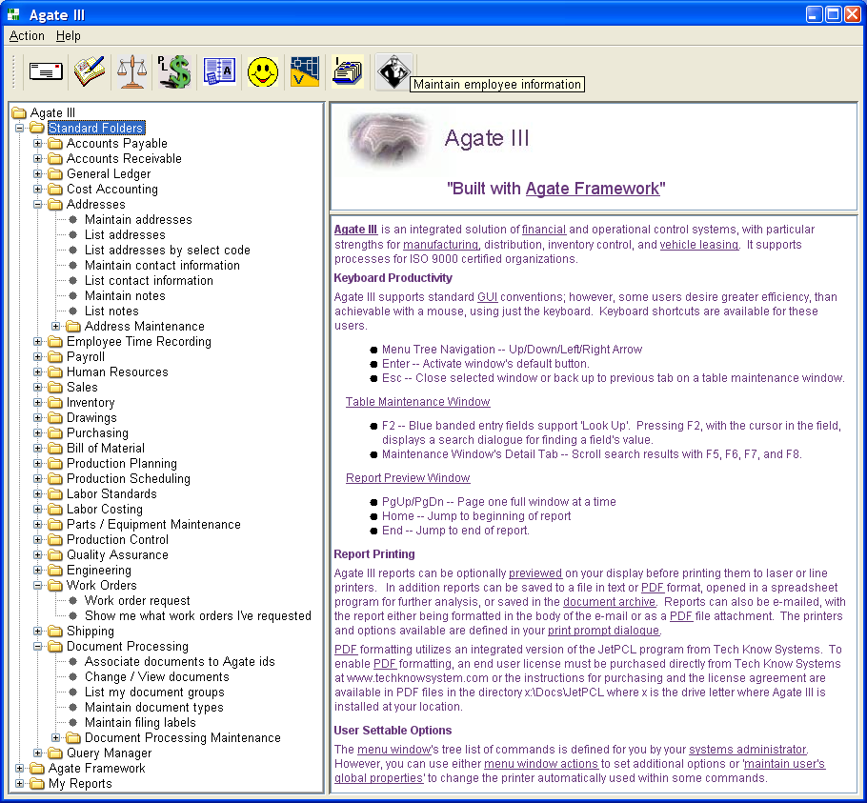
The menu window’s tree of commands is defined for you by your systems administrator.
3.2 Agate III’s Highest Level Help Page
Agate III is an integrated solution of financial and operational control systems, with particular strengths for manufacturing, distribution, inventory control, and vehicle leasing. It supports processes for ISO 9000 certified organizations.
Keyboard Productivity
Agate III supports standard GUI conventions; however, some users desire greater efficiency, than achievable with a mouse, using just the keyboard. Keyboard shortcuts are available for these users.
- Menu Tree Navigation -- Up/Down/Left/Right Arrow
- Enter -- Activate window's default button.
- Esc -- Close selected window or back up to previous tab on a table maintenance window.
Table Maintenance Window
- F2 -- Blue banded entry fields support 'Look Up'. Pressing F2, with the cursor in the field, displays a search dialogue for finding a field's value.
- Maintenance Window's Detail Tab -- Scroll search results with F5, F6, F7, and F8.
Report Preview Window
- PgUp/PgDn -- Page one full window at a time
- Home -- Jump to beginning of report
- End -- Jump to end of report.
Report Printing
Agate III reports can be optionally previewed on your display before printing them to laser or line printers. In addition reports can be saved to a file in text or PDF format, opened in a spreadsheet program for further analysis, or saved in the document archive. Reports can also be e-mailed, with the report either being formatted in the body of the e-mail or as a PDF file attachment. The printers and options available are defined in your print prompt dialogue.
PDF formatting utilizes an integrated version of the JetPCL program from Tech Know Systems. To enable PDF formatting, an end user license must be purchased directly from Tech Know Systems at www.techknowsystem.com or the instructions for purchasing and the license agreement are available in PDF files in the directory x:\Docs\JetPCL where x is the drive letter where Agate III is installed at your location.
User Settable Options
The menu window's tree list of commands is defined for you by your systems administrator. However, you can use either menu window actions to set additional options or 'maintain user's global properties' to change the printer automatically used within some commands.
3.3 Table Maintenance Window
Agate III supports SQL table maintenance using four types of windows: single table maintenance, one to many table maintenance, complex list table maintenance, or custom panel maintenance. All maintenance windows have a consistent 'look and feel'.
'Maintain chart of accounts' is an example of single table maintenance window; 'Maintain unposted journal entries' is a one to many maintenance window; 'Maintain multi-level bill of material' is a complex list table maintenance; and 'Maintain a user's global properties - user' is a custom panel maintenance window.
One to Many Maintenance Window
Single and one to many maintenance windows contain three tabs: 'Select', 'Results', and 'Detail'. When a maintenance window opens, the 'Select' tab is displayed with the cursor positioned in the first search field.
You can enter one or more search keys to retrieve a list of qualifying rows using the 'Search' button. You may also select the sequence for the rows to be displayed using the 'Sort Order' radio buttons.
The default button is always highlighted with a blue edge. In this case it is the 'Search' button, so pressing the enter key initiates a 'Search' action. One should find little need for using a mouse when doing routine tasks with maintenance windows.
Use the 'Add' button to go to the 'Detail' tab to add a new header row and detail row(s).
If only one row meets the search criteria, that row is displayed on the 'Detail' tab; otherwise a list of rows is displayed on the 'Results' tab.
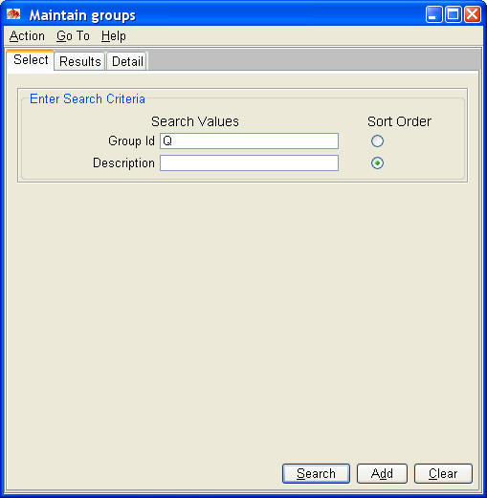
On the 'Results' tab, highlight the row of interest and use the 'Select' button to display the 'Detail' tab for that row. You may also double click the row to go to the 'Detail' tab..
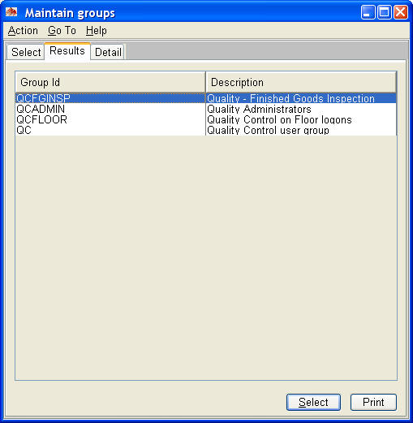
On the 'Detail' tab, you can change header fields or select one of the existing detail rows to display with the 'Select Row' button. Use the F5,F6, F7, and F8 function keys to navigate forward or backward through the rows of the 'Results' tab.
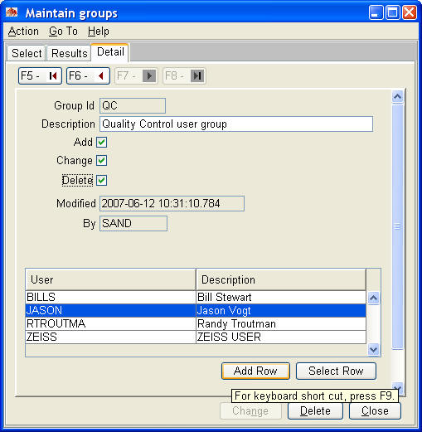
The 'Add Row' button displays a dialogue for adding a new row.
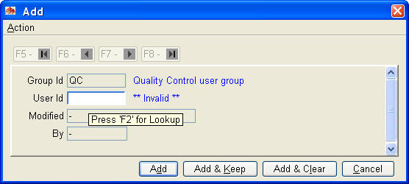
Note the blue banding on the 'User Id' field. This indicates the field is supported by a look up action for finding valid values using function key 2 (F2). Note also the tooltip help. Tooltip help displays whenever you hover the cursor over a field, and is used extensively throughout Agate III.
Pressing F2 displays the following 'Look Up' dialogue. Indicate whether to search by 'User Id' or 'Description' and enter a search value. Pressing the 'Search' button displays a list of qualifying rows for your selection. Make your selection and press 'Ok'; the selected value is automatically placed into the field.
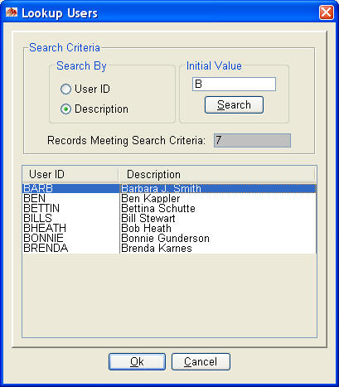
After completing all the fields on the add dialogue, press the 'Add' button to close the dialogue. Note, this does not add the row to the database. That happens when you press the 'Add' or 'Change' button on the 'Detail' tab, causing the header row and detail row(s) to be updated as one logical unit of work, thus insuring the integrity of the database.
Printing the Results Tab
The 'Results' tab may be printed using the 'Print' button. Before pressing the button, you may rearrange the columns by dragging the column description. Note below how the description column has been moved to the left as the results were displayed in that sort order.
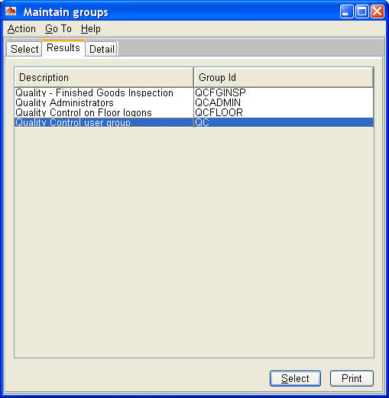
The report displays in a preview window for your review before printing. 'Results' tabs with many columns will often have there data truncated making reading it difficult; previewing a report is a good way to read and review the results tab more easily.
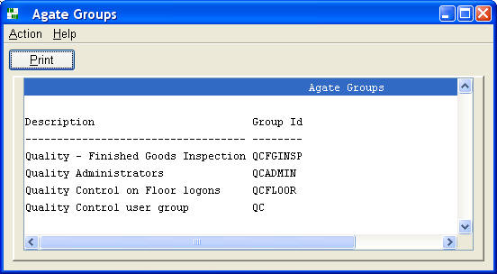
3.4 Report Preview Window
Agate III supports previewing a report before either routing to a printer, formatting to a PDF file, opening in a spreadsheet program, or emailing, by using the 'Print' button to display the print prompt dialogue.
The 'Display Document' button is enabled whenever a line is selected that is supported by an archived document. Double clicking the line or pressing the 'Display Document' button displays the archived document. Most reports that contain lines with supporting archived documents will have a column, such as the following example's FACsimile column, that contains an asterisk (*) whenever that line is supported by an archived document. This saves highlighting the line to determine whether it is supported by an archived document.
The 'Search' button, when present, displays a prompt dialogue for searching forward or backward through the report based on column value(s). Enter a portion of a column value(s) to find the first report line containing those value(s).
Instead of a 'Display Document' button, a previewed reports may have a 'Change' button. Use this button to link to a table maintenance window to change values for the highlighted row. The values on the report will not change until you re-run the report. See 'List chart of accounts' for an example of this button.
Previewed Report Example
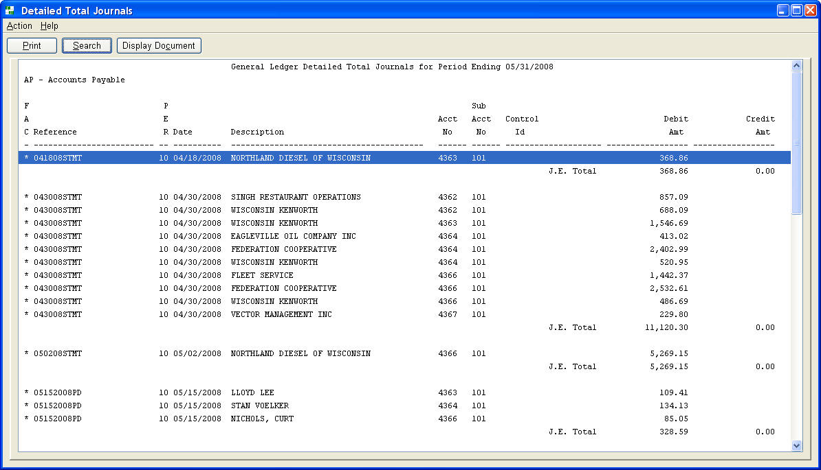
Print Prompt Dialogue
When requesting to print a report, a print prompt uniquely defined for you displays the printers and other options that are available for selection, including the archiving option if specified by 'Maintain search values for Agate generated reports'.
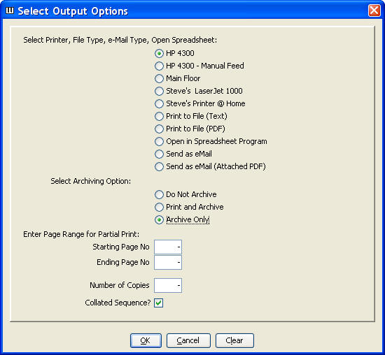
See your system administrator if you believe you should be authorized use of other available printers or report formatting options.
3.5 Menu Window’s User Settable Options
Selecting Action-->Options displays the following user settable options:
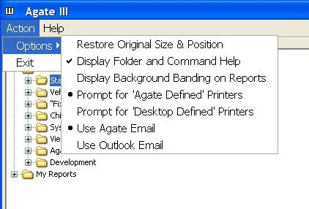
Restore Original Size & Position
Resets the menu window to its original size and position on your screen.
Display Folder and Command Help
Checking this menu action displays folder and command help in the right two windows of the menu.
Display Background Banding on Reports
Checking this menu action displays alternating blue and white background bands in the report preview window, aiding reading across wide reports.
Previewed Report with Banding Enabled
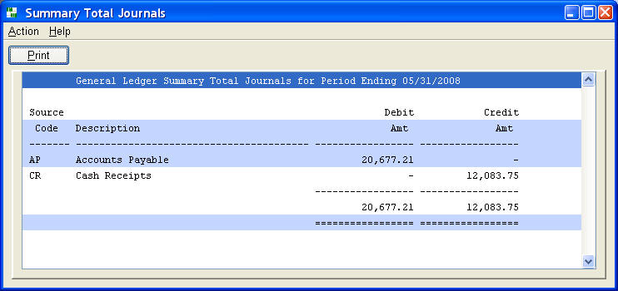
Prompt for 'Agate Defined Printers' or 'Desktop Defined Printers'
You may use either the Agate print prompt dialogue set up for you by your systems administrator or the desktop printers as defined within your desktop operating system.
Use Agate Email or 'Desktop' Email
You may use either the Agate email dialogue or the desktop email client defined in your operation system. Your systems administrator renames 'Desktop' to Outlook, Notes, or whatever other email client you use.
4.0 Query Manager
4.1 Overview
The Query Manager is a tool for interactively defining and running reports.
You use 'Maintain my or 'public' queries' command to define a new report, edit an existing report, or run a report.
Once a report is saved, a command to run the report is created in your 'My Reports' folder. You must restart Agate to refresh your menus, whenever you add a new report or change the name of an existing report.
If you make a report 'public', it will be available for others to add to their 'My Reports' folder using 'Maintain 'My Reports' or 'public' folders' command. Your system administrator may have created additional 'public' folders. Your 'public' report's commands may be placed in those folders as well.
4.2 Maintain my or 'public' Queries
Use this command to define and run your own reports. The 'Define/Edit' button guides you through a series of dialogues to define a report. When the report definition is saved, a command is created in your 'My Reports' folder. You must stop and re-start Agate for new commands to appear in your 'My Reports' folder. You can run the report using this command, rather than using the 'Run' button on the detail tab of this command. The 'Format' button displays the Format Dialogue, which is iteratively used to 'fine tune' the report layout.
Reports can be made available to other users by making them 'public'. You can add 'public' reports to your 'My Reports' folder using 'Maintain 'My Reports' or 'public' folders'.
Your system administrator may create 'public' folders and place them in appropriate locations in the Agate folder tree structure. These 'public' folders may then be used to distribute queries you develop to users who do not create their own reports. Use 'Maintain 'My Reports' or 'public' folders' to add a report you've defined and made 'public' to these 'public' folders.
You may modify the generated SQL by 'checking' the 'Modify manually?' checkbox on the detail tab. However, subsequently re-running the 'Define/Edit' action will overwrite the modified SQL statement. You will need to modify the generated SQL to construct 'union all' statements or to create a more complex 'where' clause than provided by the dialogues. If you need to modify the SQL, make sure you have the columns defined as you desire, because you cannot add or delete columns to the generated SQL. If you do, you create a mismatch with the generated column format definition, causing an execution error running the report.
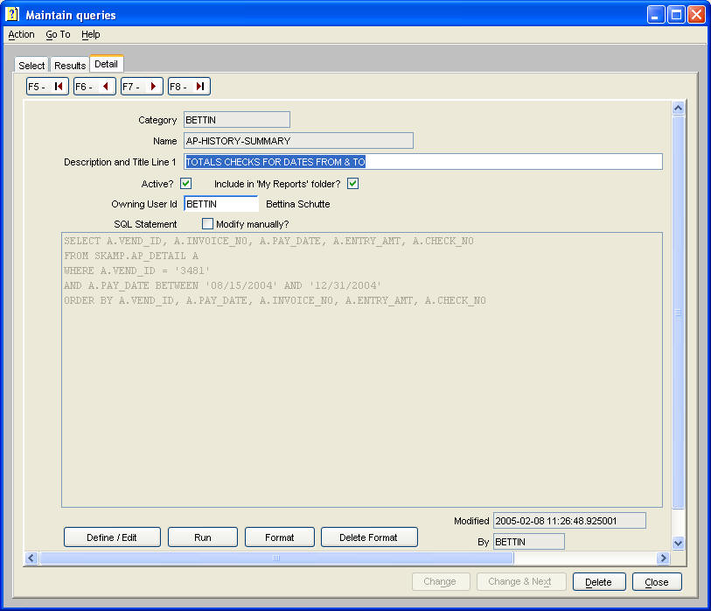
4.3 Define/Edit Button
The 'Define/Edit' button guides you through the following series of dialogues:
1. Filter Tables Dialogue
2. Table Selection Dialogue
3. Connecting Column Dialogue
4. Report Columns Dialogue
5. Report Sequence Dialogue
6. Data Selection Dialogue
7. Report Format Dialogue
4.4 Filter Tables Dialogue
The filters dialogue is used to limit the list of tables shown in the following tables dialogue. All Agate tables are part of the 'SKAMP' database schema. (Agate Partners was formerly SKAMP Corporation.) Checking the exclude 'work tables', 'transaction tables', and/or 'views' will limit the list of tables to Agate master, transaction, history and control tables.
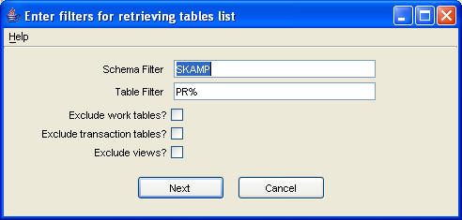

4.5 Tables Selection Dialogue
Select a table to include in the report; then either double click or press the right arrow button to add to the 'Tables for Report' list. When 'Tables for Report' list is complete, press 'Next' to continue the report definition.
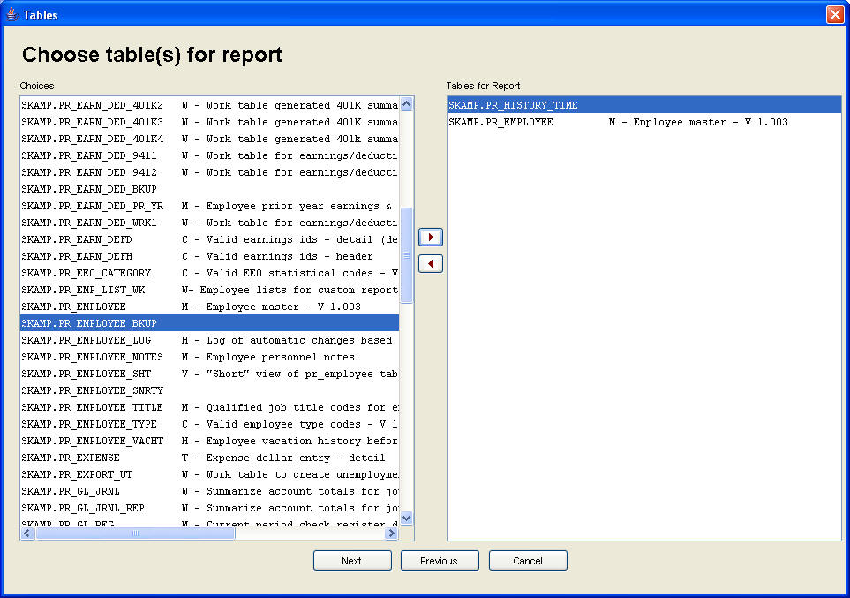
4.6 Connecting Columns Dialogue
If you select more than one table for your report, you are prompted to select the columns that connect the tables as paired sets. If necessary, you may select multiple sets of columns that connect two tables.
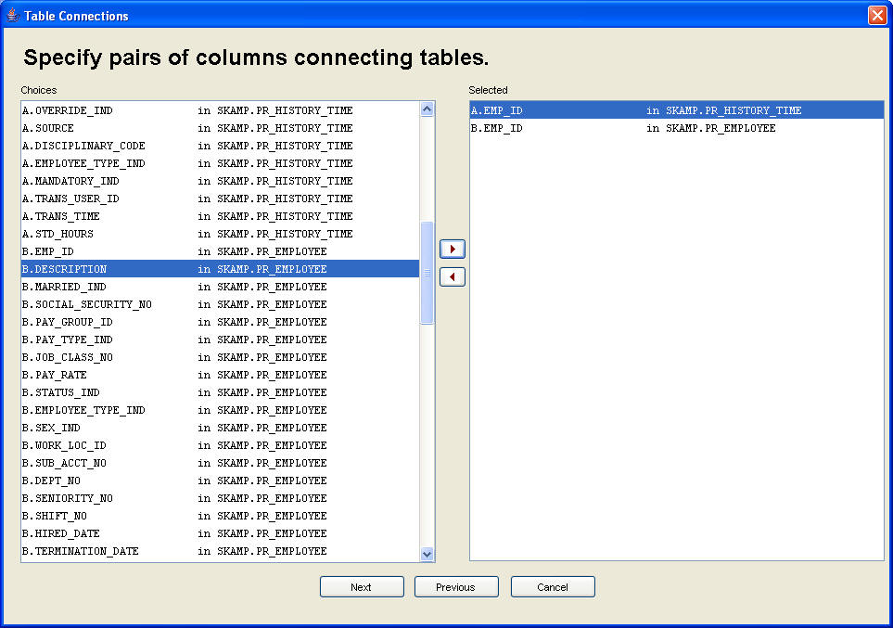

4.7 Report Columns Dialogue
Select the columns you want to include in the report in left to right order in which you want the columns displayed on the report. If the report has multiple level breaks, the columns creating these breaks must occur in a left to right order on the report.
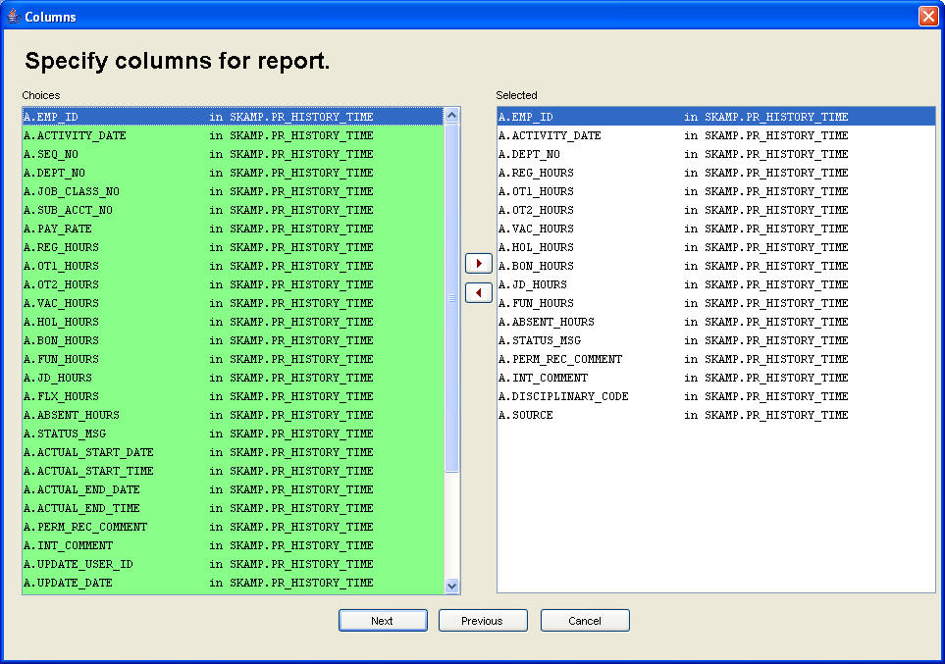
4.8 Report Sequence Dialogue
Select columns for sorting the rows on the report. When sorting on multiple columns, select the columns in major to minor order.
Currently, this dialogue only supports an ascending sort. If you need to create a descending sort, after defining the report with these prompts, check 'Modify manually?' and add the 'DESC' clause as needed to columns in the 'ORDER BY' clause.
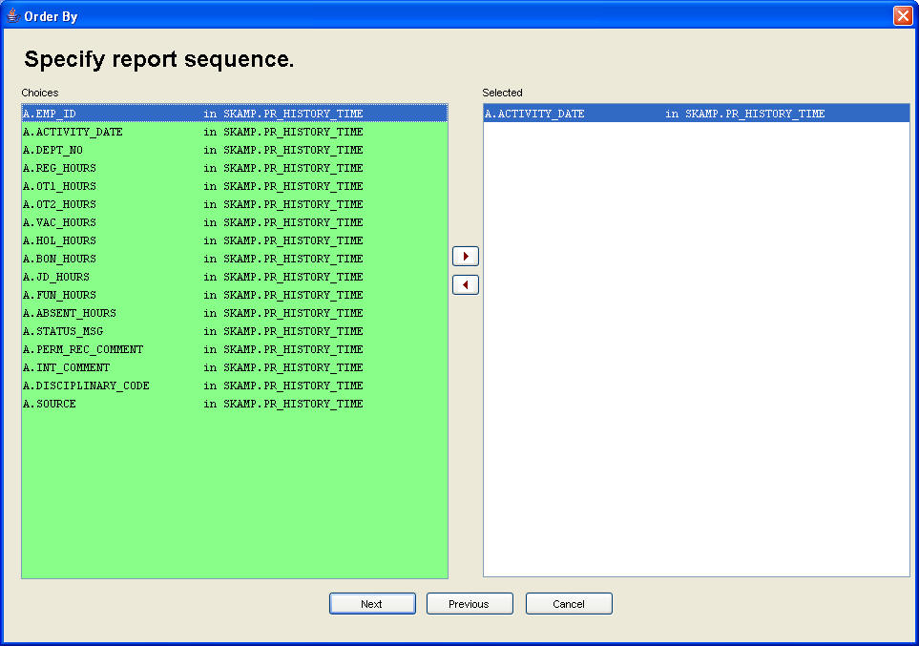

4.9 Data Selection Dialogue
Select columns used to qualify data for the report.
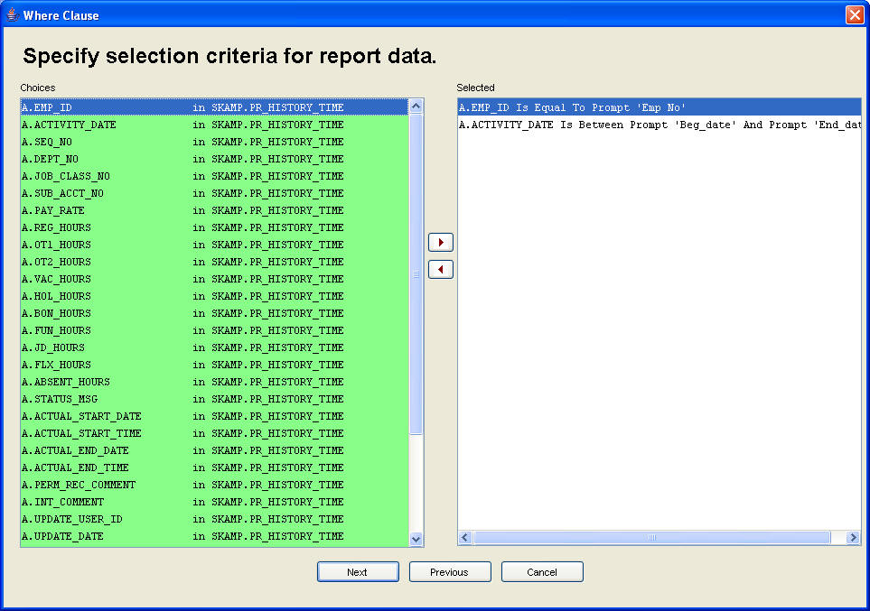Upon selecting a column you will be prompted with the following dialogue to specify the qualifying condition(s) for selecting rows for the report. Instead of specifying constant values, you may check 'Prompt User?' and enter a prompt name. When the report is executed, the user will be prompted to provide a value for each prompt name.
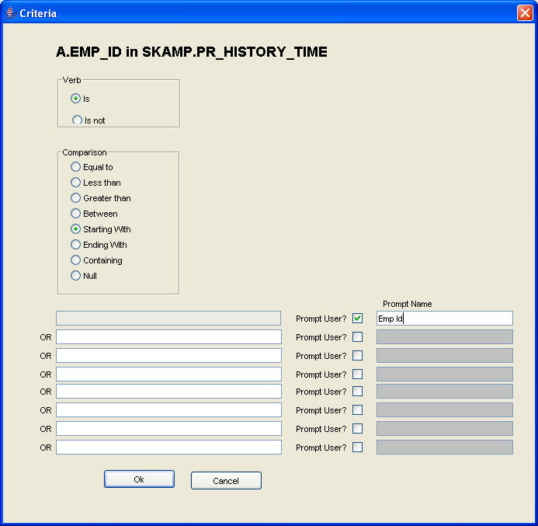
When you specify multiple selection criteria columns, you will be prompted to specify whether to 'And' or 'Or' the selection criteria. Specifying more than two selection criteria with both 'And' and 'Or' conditions may not generate the SQL statement you desire. You may have to check 'Manually modify?' and modify the generated SQL with left and right parenthesis as needed to achieve your desired result.
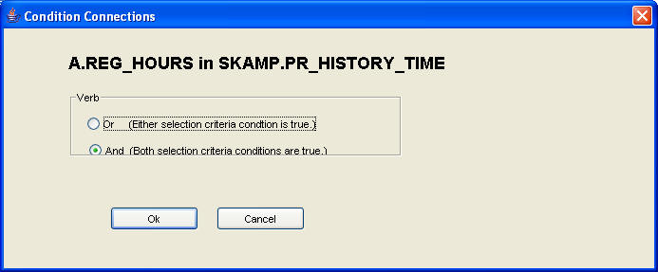
4.10 Report Format Dialogue
The database column names are the default report column headings; these can be modified to more meaningful descriptions.
Check the columns you want to total or to cause level breaks. Level breaks occur left to right on the report.
The default width specified for a column is the database size of the column. These can be increased or decreased. For long text fields, you can check 'Wrap?' to print the column data on multiple lines after decreasing the column's width.
The default indent (spacing before each column) can be increased.
The default format pattern specified for decimal and date fields can be changed. MM = numeric month, MMM = month abbreviation, MMMM = month's full name.
You may check omit to not print a column selected for the report.
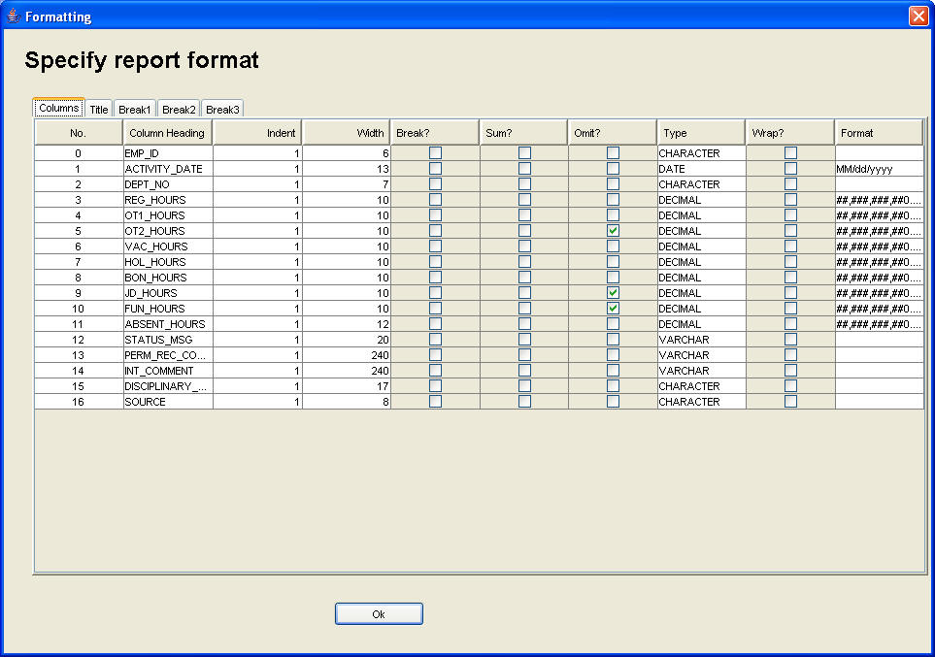
You can specify multiple title and final total lines on the ‘Title’ tab. Column data can be included in these lines by using &nnn notation, where nnn is the column number. At program execution, column data will replace these column numbers. You may check 'Omit?' on the Columns tab to exclude these columns from printing on the report.
Prompt values can also be included in these lines by using ^nnn notation, where nnn is the prompt number. Prompts are numbered from 0 to n.
You can check and uncheck other options indicated to control report printing, as well as control blank line spacing and page breaking.
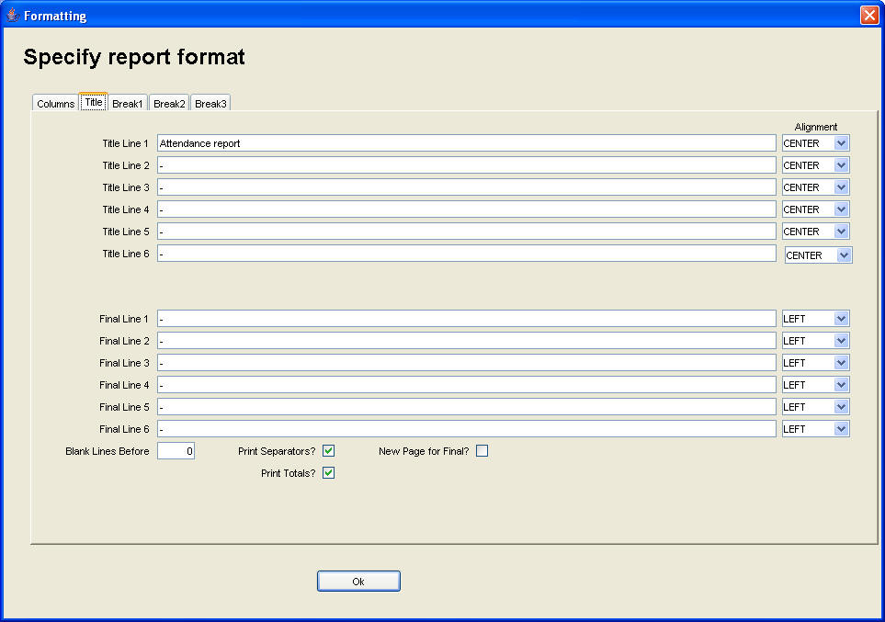
You can specify multiple heading and footing total lines for each of three level breaks on the appropriate ‘Breaks’ tab. Column data can be included in these lines by using &nnn notation, where nnn is the column number. At program execution, column data will replace these column numbers. You may check 'Omit?' on the Columns tab to exclude these columns from printing on the report. Prompt values can be included in these lines by using ^nnn notation, where nnn is the prompt number. Prompts are numbered from 0 to n.
You can check and uncheck other options indicated to control report printing, as well as control blank line spacing and page breaking.
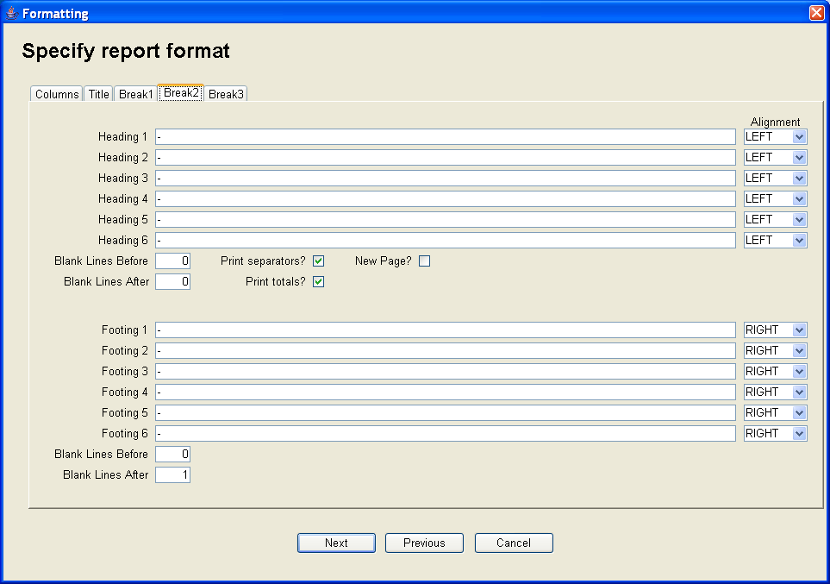
5. Integrated Document Archiving
5.1 Overview
Agate III supports archiving scanned document images into the database and displaying these archived documents from related report print lines.
Use 'Change / View documents' to either modify search fields entered with 'Associate documents to Agate ids' (or another command such as Accounts Payables' 'Enter and maintain unposted invoices') or to search and display a previously archived document. Use 'List my document groups' to see which groups you are authorized to view.
Document type codes and filing labels are used to create classification codes for searching and retrieving documents using 'Maintain document types' or 'Maintain filing labels'.
5.2 Change / View Documents
The document archive is searched using this command. Enter all or a portion or any search key to retrieve a set of documents meeting this criteria by pressing the 'Search' button. The user can only retrieve documents for authorized group ids.
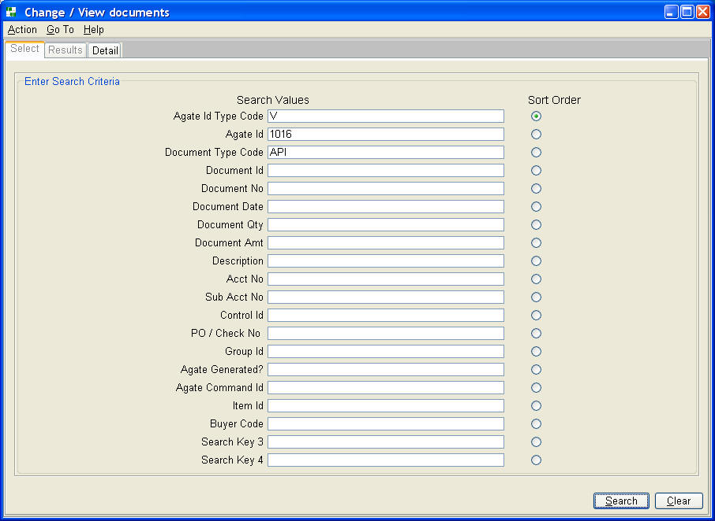
The results tab lists all documents meeting the search criteria. Select one to display the detail record.
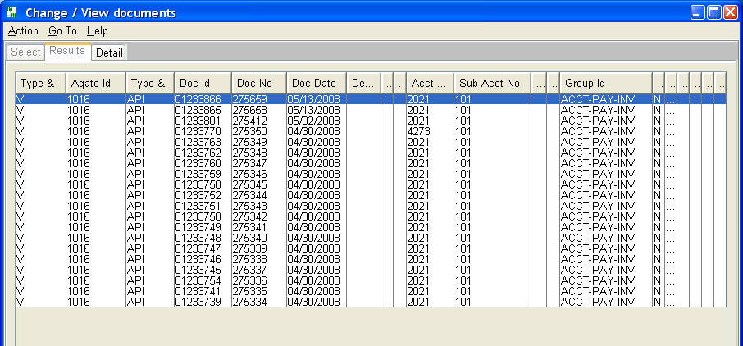
Use the 'Display Document' button to display the document image for this row. If the user is authorized, search parameters can be changed with this command.
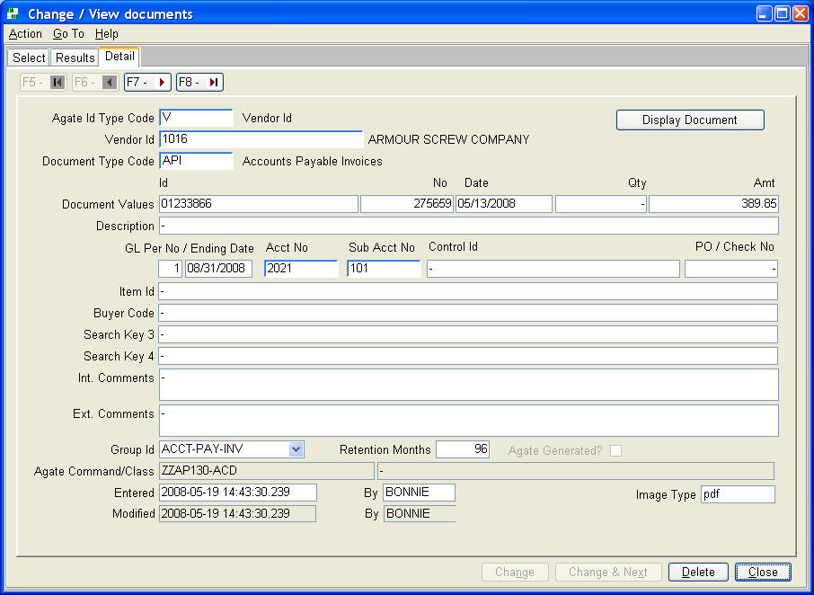
5.3 Associate Document to Agate Ids
Use this command to associate scanned document images to agate ids, document type codes, and other search values. Start by placing all the scanned document images to be achieved into a folder with no other files. The command starts by prompting the user for the default values to be assigned to each scanned document image.
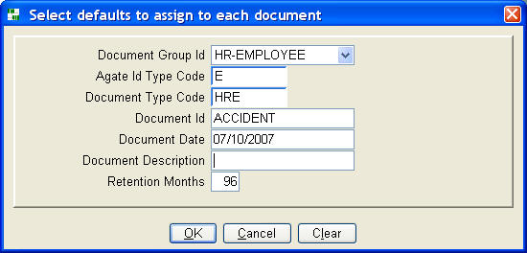
Next the user is presented a dialogue where one highlights the first document image in the folder of documents to be archived. Press the 'Display' button to continue.
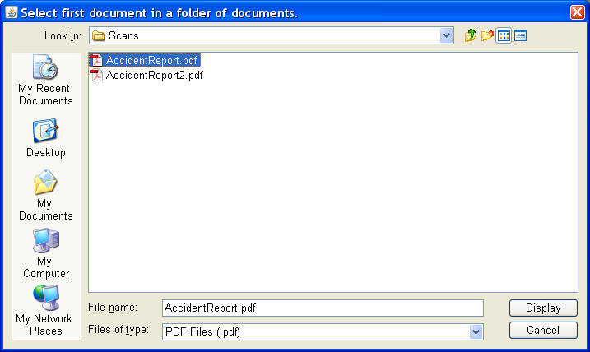
The command builds a row in a work table for each document image and displays a list of these rows.
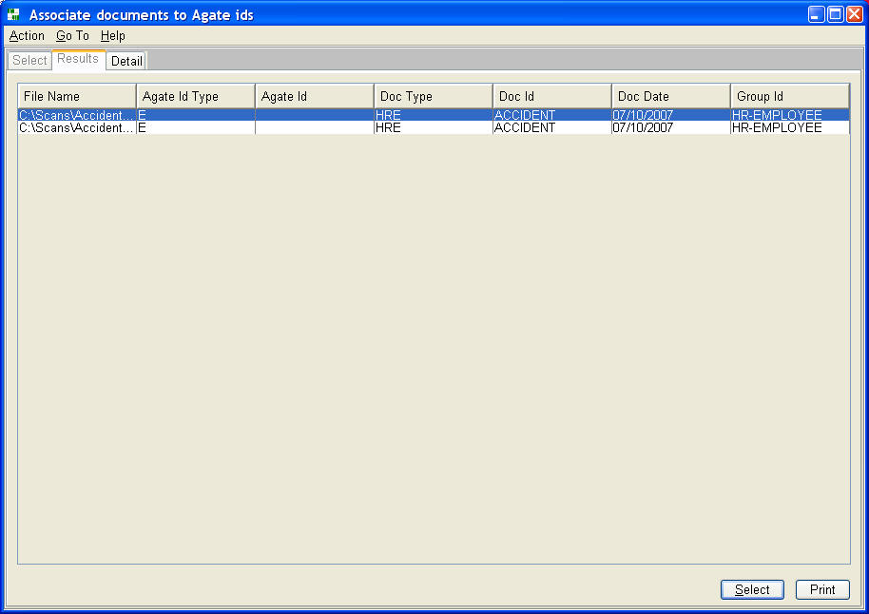
Select the first row and go to the detail tab by pressing the 'Select' button. On the detail tab one can change default values or add further search values.
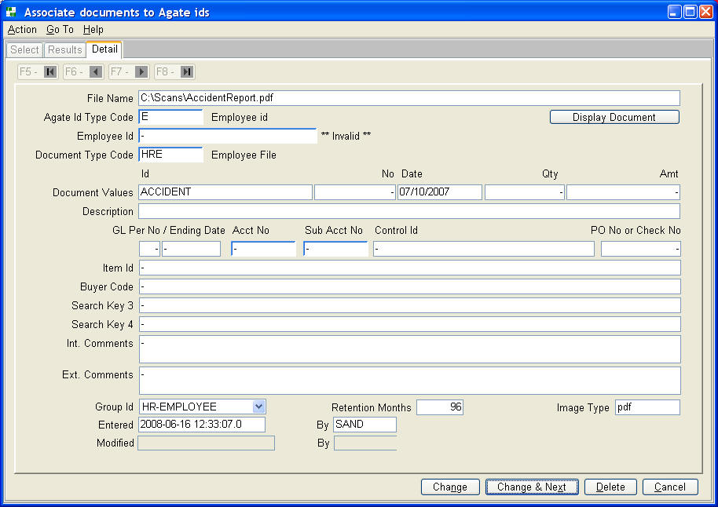
After adding or changing search values, use the 'Change and Next' button to go to the next row. Note that the file name is displayed on the detail tab for verification. One can also display the document image with the 'Display Document' button to further verify that you are coding values to the correct document image.
After you close this panel one is prompted to post the documents to the archive. Respond 'Yes' to do so or 'No' if you want to further change search values or add more scanned images to the work table before posting.
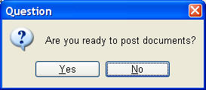
5.4 List Document Groups
Document group ids can be listed in either group id or user id sequence to aid managing access to the document archive. The 'list my document groups' version of the report lists the group ids accessible by the logged on user.
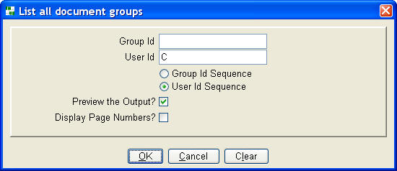
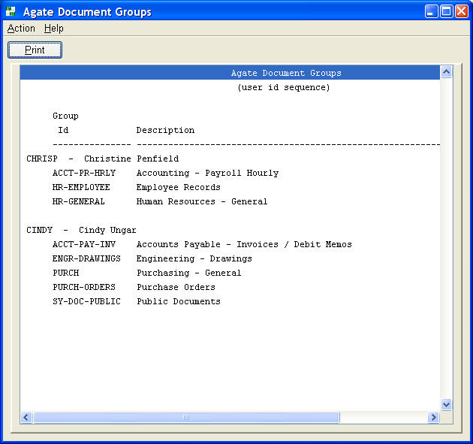
5.5 Maintain Document Types
One document type code is assigned to each archived document. It can be used as a search key. The checkboxes in the panel define what other search fields are required entries when associating fields to an image.
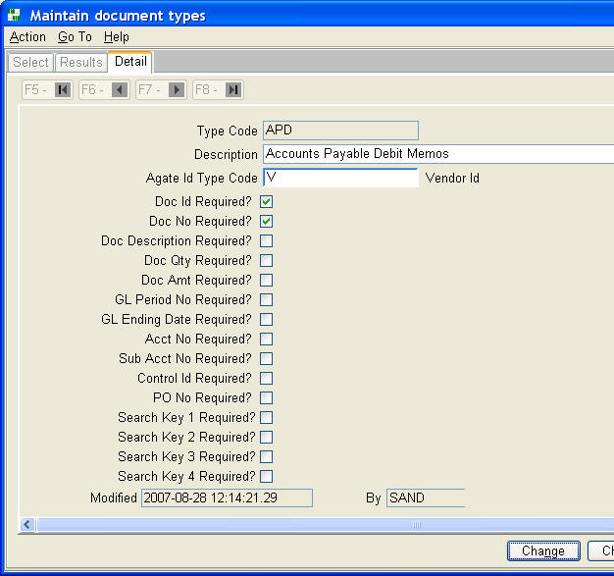
5.6 Maintain Filing Labels
Filing labels can be used to archive an 'F' Agate type id document while entering a filing label into the Agate id field. Filing labels can either be 'PUBLIC' and available to all users or entered with one's user id, making them only available to you.
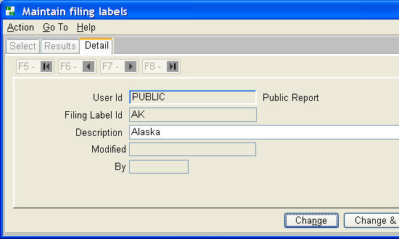
5.7 Maintain Search Values for Agate Generated Documents
Assign search values to an Agate Framework report. A user then is given the option to archive this report from the print prompt dialogue.
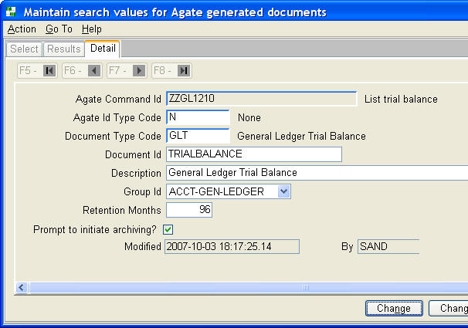

5.8 Maintain Document Groups
One document group id is assigned to each archived document. Documents can be retrieved and displayed only by users associated to the group.
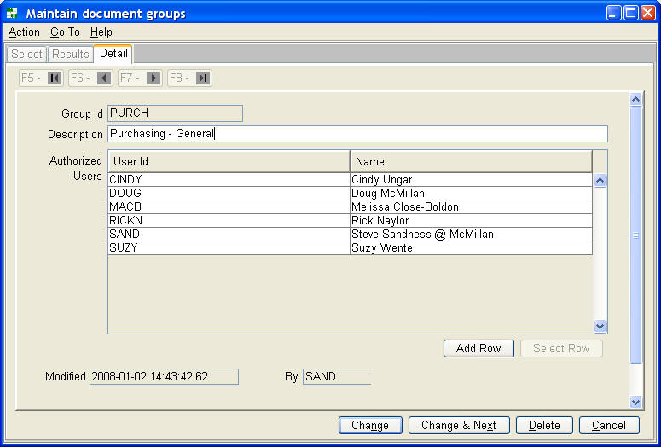

7. Glossary
Abend
A premature termination of a program caused by a software logic error or hardware problem.
The database software will rollback partial table updates when this occurs, unless it is part of the software problem, or its rollback data logs are corrupted due to hardware or software problems.
Account Number
A 1-6 digit number for each general ledger account.
Even though it is numeric, it is stored as a character type in the database, so one can use a portion of the number in a prompt, for the purpose of creating partial reports with database wild cards.
Activity Date
The activity date indicates when a journal entry's business activity occurred. It is not the date entered into the general ledger. This date has no relationship whatsoever with a period's ending date.
Address Id
A 1-6 alphanumeric value, which is one half of the 'address Id, sub id' primary key for Agate III's address table.
Company Number
A one to three digit number.
Agate III's General Ledger database architecture supports multiple companies. However, the programming is not complete for inter-company clearing and closing entries. Therefore, the system currently supports only one company, with the system automatically assigning company number 1 to all journal entries.
Control Id
A 1-20 character text value for scheduled account journal entries.
Journal entries are retained by control id until they balance, i.e. total to zero, providing a mechanism to list multi-period journal entry detail that supports an account balance.
Customer Id
A 1-6 character identifier for each Agate III customer.
Database Wild Cards
For character columns, the SQL 'LIKE' clause can be used with wild card characters '%' and '_'.
Most of Agate III's character prompts allow for partial field entry. Agate III appends these prompts with a '%', and generates a database selection using a 'LIKE' clause, retrieving all data starting with the characters entered.
When a user enters a % followed by characters in a prompt, the database selection retrieves all data where these characters occur anywhere in the field.
Refer to a SQL reference manual for more detailed description of database wild card capabilities.
Division Code
A 1-4 character code, whose length is defined in setup information.
Financial statements can be printed by division code. If division codes are utilized, the first portion of each sub account number equals a division code, thereby providing a two level rollup capability for financial statements.
DBMS - DataBase Management System
Software that controls the organization, storage, retrieval, security and integrity of data in a database. It accepts requests from the application and instructs the operating system to transfer the appropriate data. The major DBMS vendors are Oracle, IBM, Microsoft and Sybase. MySQL is a very popular open source product.
Employee Id
A 1-6 character identifier for each Agate III employee.
GUI - Graphical User Interface
Pronounced gooey. A visual computer environment that uses graphical images such as icons, menus, text fields, buttons, check boxes, radio buttons, and dialog boxes to ease the interface between the user and the computer. The user can use a mouse, keyboard, thumbpad, or other device to manipulate an icon, button, scroll bar, check box, or other graphical item to activate a routine or program feature.
HTML - Hyper Text Markup Language
The authoring language used to create documents on the World Wide Web. HTML defines the structure and layout of a Web document by using a variety of tags and attributes. Tags are also used to specify hypertext links. These allow Web developers to direct users to other Web pages with only a click of the mouse on either an image or word(s).
ISO 9000
ISO 9000 gives the requirements for quality management systems. ISO 9000 certification is now firmly established as the globally implemented standard for providing assurance about the ability to satisfy quality requirements and to enhance customer satisfaction in supplier-customer relationships.
Item Id
A 1-20 character identifier for each Agate III inventory item.
Java
The Java programming language lets you write powerful, enterprise-worthy programs that run in the browser, from the desktop, on a server, or on a consumer device. Java programs are run on -- interpreted by -- another program called the Java Virtual Machine (Java VM). Rather than running directly on the native operating system, the program is interpreted by the Java VM for the native operating system. This means that any computer system with the Java VM installed can run a Java program regardless of the computer system on which the application was originally developed.
Line Type
A three character code describing the functionality of a financial report definition line.
Link
A link is a reference to another HTML document. You are taken to the other document when you click on one.
null
A SQL database column can have a null value, i.e. no value, not even zero or blank. Agate III indicates a column is null by displaying a dash '-' character in the first position of a field on a table maintenance window or report.
Object-Relational Database
An object-relational database is a database similar to a relational database, but with an object-oriented database model. Objects, classes and inheritance are directly supported in database schemas and in the query language. In addition, it supports extension of the data model with custom data-types and methods.
PDF - Portable Document Format
Portable Document Format or PDF is a file format created by Adobe Systems, Inc. and is highly portable across computer platforms. PDF documents have a .pdf file extension (myfile.pdf). Adobe Acrobat Reader is a freely distributed software program from Adobe Systems, Inc. used to view PDF files.
Period Number
A one to three digit accounting period number.
The maximum number of accounting periods is defined in setup information. Each period number has a corresponding ending date, allowing for any duration of an accounting period.
Reference
A journal entry's multi-line account number / sub account number coding is related together by this 1-20 character text value.
Although not required to be unique, the total journal's detail list sub-totals by this field, making it worthwhile to achieve as much uniqueness as possible for an accounting period.
For manual journal entries, using a reference of XX-nnn where nnn is an increasing number each period and XX is the source code, is one technique for creating unique references. Other Agate III systems use similar techniques or dates for their automatically generated journal entries.
Relational Database
A database that maintains a set of separate, related tables, but combines data elements from the tables for queries and reports when required. Most every business database management system, including Oracle, DB2, SQL Server, MySQL, etc., is a relational DBMS.
Schema
Pronounced skee-ma, the structure of a database. The schema defines the tables, the columns in each table, and the relationships between columns and tables.
Server
A computer or device on a network that manages network resources. For example, a file server is a computer and storage device dedicated to storing files. Any user on the network can store files on the server. A print server is a computer that manages one or more printers, and a network server is a computer that manages network traffic. A database server is a computer system that processes database queries.
Source Code
A two character, alphanumeric code classifying journal entries by origin of entry.
SQL - Structured Query Language
SQL is a standardized query language for requesting information from a relational database. A relational database contains tables of data organized into rows and columns. Each table is similar in concept to a spreadsheet.
Statistical Number
Up to 100 calculated values can be printed on a financial report. Calculated values are stored by number, 1-100.
Sub Address Id
A 1-6 character identifier, the minor key portion of the primary key for Agate III's address table.
Sub Account Number
A 1-6 digit number for each general ledger profit center or expense center.
The number can be split into a major and minor key, with the major key equal to the division code. The number of characters used for division code is defined in setup information. Financial statements can be printed by sub account number, division code, or company number.
System Administrator
Each Agate III installation has at least one user who is authorized to set up users, user properties, folders and folder trees, workstations, and printers using Agate Framework commands. Your installation may be utilizing Agate Partners' staff to perform these tasks.
Tooltip
A Tooltip is a small text box that appears when the mouse pointer is hovered over a screen object. The box disappears when the mouse pointer is moved away from the object or after a specified period of time, usually a few seconds.
Tree - Graphical User Interface (GUI) Tree
A graphical user interface (GUI) tree is used for displaying a list of commands in the left frame of the menu window. Each folder is a node of the tree that can be expanded or collapsed.
User Id
Every user is assigned a unique id by the Agate system administrator. This id can not exceed eight characters.
If you are not prompted to enter a user id when you start Agate III, your administrator has included your user id in your workstation's javal.ini property file. You can use the 'About this program' help menu action to see your user id.
