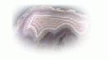

Agate Partners

An Overview

“Bridging People, Information and Technology”

- Introduction 2
- History 2
- Products 2
3.1 Agate III 2
3.2 Agate III for Manufacturing and Distribution 3
3.3 Agate III for Vehicle Leasing 4
3.4 Integrated Document Image Archiving 5
3.5 Agate Framework 6
- Examples 7
4.1 General Ledger 7
4.2 Accounts Payable 10
4.3 Accounts Receivable 11
4.4 Addresses 12
4.5 Inventory 13
4.6 Sales Order Processing 14
4.7 ‘N’ Level Bill of Material 15

Agate Partners
17270 Tilia Ridge
Eden Prairie, MN 55347

(952) 239-4125
Steve@Sandness.com

1. Introduction
This is an overview of Agate Partners’ history, mission, and products. Go to our website, http://www.sandness.com/AgatePartners/index.html, for more detailed information.
2. History
Agate Partners (formerly SKAMP Corporation) was founded in 1977 by Steve Sandness to provide software services to small to medium size (SMB) businesses. Steve brought large organization technical and managerial leadership skills to this new venture. Today Agate Partners continues the tradition of providing large scale solution solving skills and technology to SMB businesses.
With experience as an IBM Systems Engineer and Director of Systems Development for National Car Rental, Steve led SKAMP with the mission of providing software services to businesses acquiring their first computer. SKAMP grew and prospered for twenty-three years, and SKAMPtrak, a set of systems for small to mid-size businesses, was created and evolved through three major architectures.
SKAMP's products, assets, and employees were acquired by a Pennsylvania company in August, 2000. SKAMP's products were to be integrated into the acquiring company's portfolio. However, a reversion clause in the acquisition agreement returned ownership of all software products to SKAMP, with the rights to the name SKAMP remaining with the acquiring company.
We needed a new name. Agate Partners is a dba (doing busy as) for SKAMP Corporation. Partnering has always been a core foundation of SKAMP. We decided it should be reflected in our new name.
Why Agate? Agate Partners is committed to exploiting the power and productivity of object-oriented design and programming. Object technology solutions can be visualized as software objects containing other software objects, creating layered software components or 'parts'. The layered, hardened beauty of an agate rock bests visualizes the layered, hardened, beauty of our products.
3. Products
3.1 Agate III
Agate III is the name for our systems that can be installed individually or combined together, creating fully integrated solutions. An individual system can also be installed and interfaced to a non-Agate III system.
Our Agate III systems have been built using our Agate Framework, an object relational database, and Java, creating a highly scalable, and portable software architecture for either Linux or Windows, making Agate III an enduring solution for the 21st century.
When you start Agate III, a menu window displays a tree structure of commands in the left internal frame. The right two internal frames display HTML help for the selected folder and command. Links can be used to either drill down or navigate to an associated command's help. Each user is presented a unique folder tree defined by your system administrator for securing data access. Database features can further secure unauthorized access.
An interactive report writer is available for users to create and run their own reports, for either ad hoc analysis or to extend Agate III functionality. Commands for these reports are created in a user's 'My Reports' folder for easy, repetitive use. If a user written report needs to be made available to multiple users, a command may be placed into a folder that is accessible to these users.
Archiving scanned documents and Agate III documents is integrated into Agate III, creating an efficient user interface for displaying these documents from previewed report lines that reference them.
Why a Roman numeral III? Agate III is the third major architecture for our solutions. Our first systems were written in COBOL for Texas Instruments minicomputers (1977-89). In our second architecture, we were pioneers with OS/2 and relational databases (1987-2001). Through a thirty-one year evolution, we have continually improved and extended the business processes, features, and capabilities of our systems.
3.2 Agate III for Manufacturing and Distribution
This menu window shows Agate III systems for a manufacturing business. All transaction activity is integrated between systems, eliminating redundant handling of data.
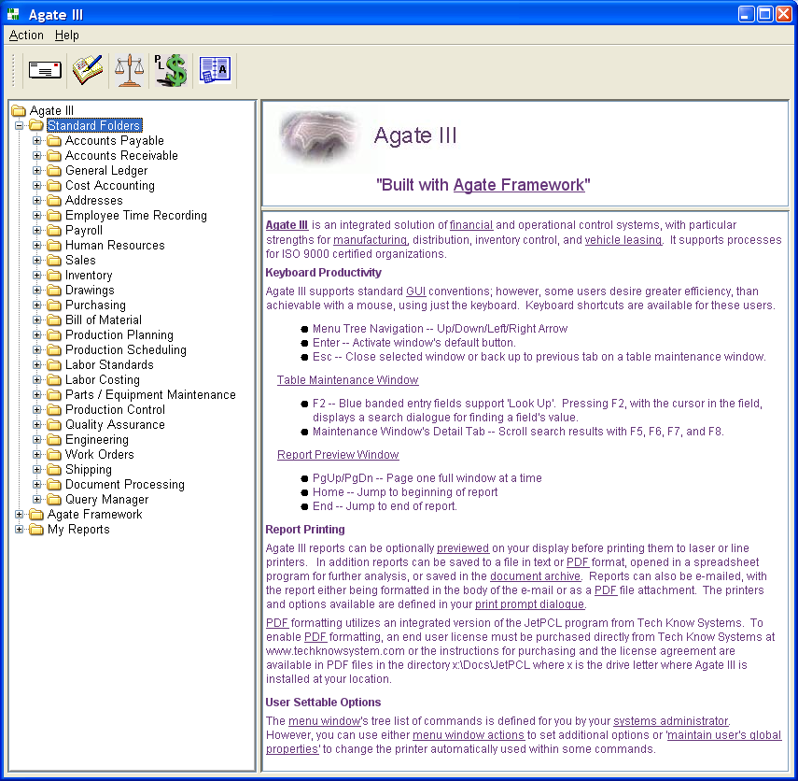
3.3 Agate III for Vehicle Leasing
Agate III, configured for a vehicle leasing business, consists of a Vehicle Management system integrated with Agate III’s General Ledger, Accounts Receivable, and Accounts Payable systems. This menu window is expanded to show some of the menu commands unique for vehicle leasing.
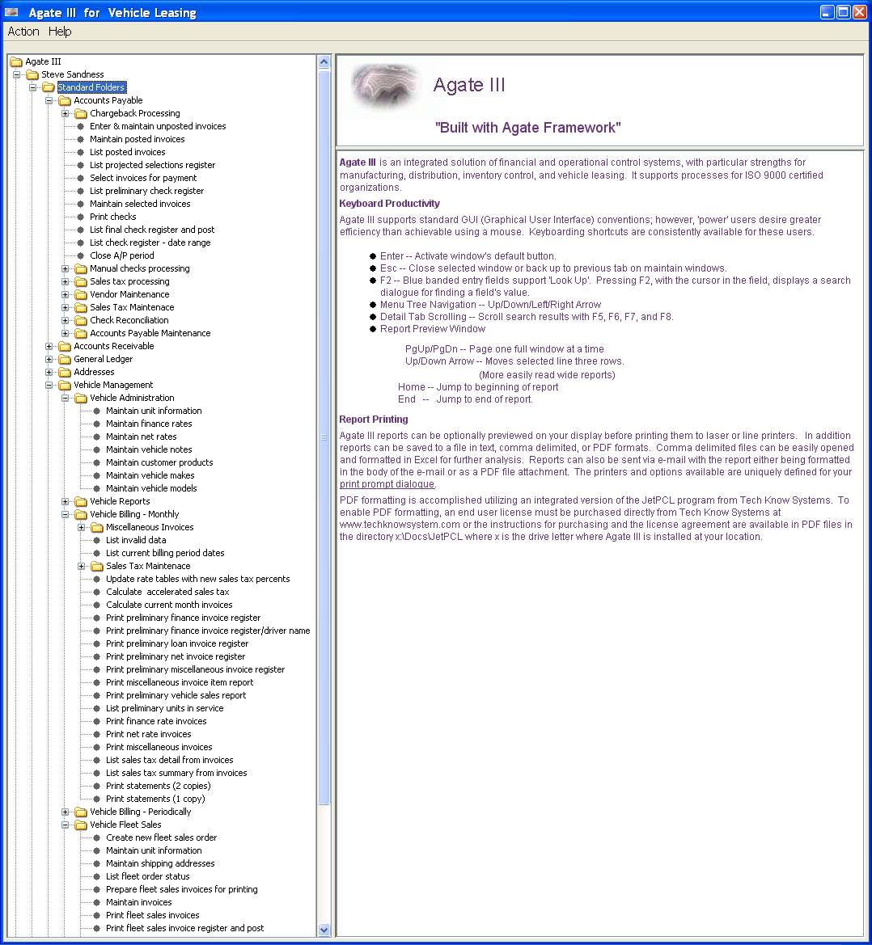
3.4 Integrated Document Image Archiving
Agate III supports archiving scanned document images and displaying them from previewed report print lines. How? Scanned documents are coded with Agate III based search keys as they are stored into the database. In addition, Agate III generated documents (invoices, checks, purchase orders, etc) can be either automatically or by user request archived into the database. 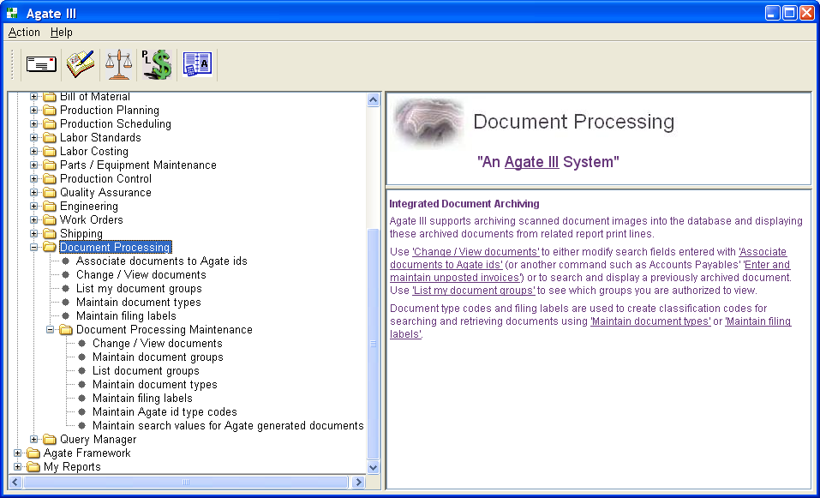
Agate III supports previewing a report before printing. The 'Display Document' button is enabled whenever a report line is selected that is supported by an archived document. Double clicking the line or pressing the 'Display Document' button displays the archived document.
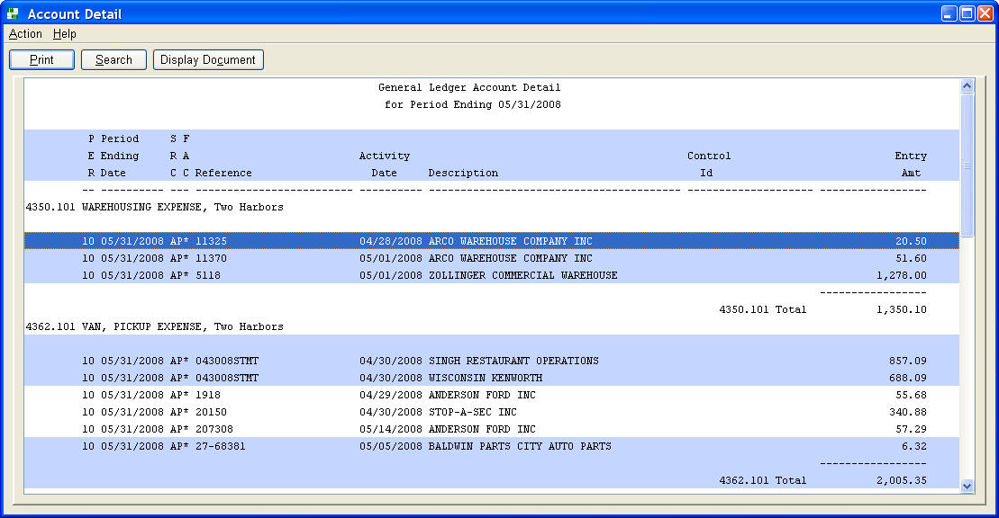
Previewed Report Example
Note: An asterisk (*) in the FACsimile column indicates a supporting document image can be displayed by either double clicking the line or pressing the 'Display Document' button.
Agate III windows, such as customer, inventory, and vendor information, contain a ‘Documents’ button for listing archived documents for the displayed customer, item or vendor. On a previewed bill of material, the engineering drawing for any item or component of the bill can be displayed by double clicking on that line of the bill. See examples of these in Section 4.
Finally, the display document command can search for and display documents one is authorized to view.
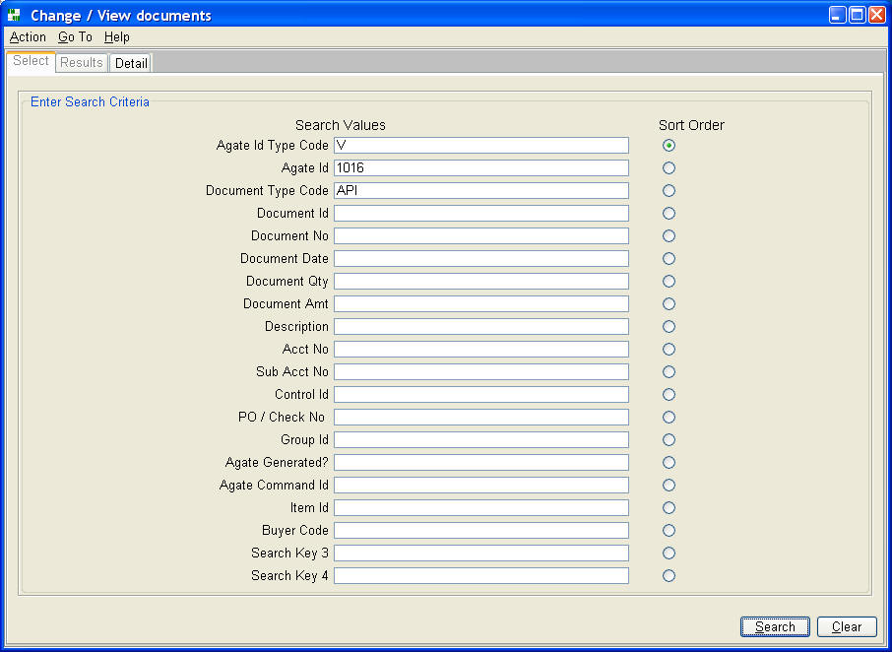
3.5 Agate Framework
Agate Framework supports rapid application development of Java applications. The resulting solution is a high quality, professional result, even though it is quickly developed.
The Framework creates a consistent environment for developers to achieve high productivity by utilizing "re-use" of software parts. Junior developers are exposed to the full power and potential of object technology while using the Framework.
Developer Productivity
The Framework provides software parts for the creation of business solutions, such as data maintenance frames, business objects, reports, menus, processing procedures, and user prompts. An array of supporting parts and widgets are available for use within these major parts. Parts are extended using the object technology technique of sub-classing and overriding methods.
End User Productivity
The Framework presents a consistent user interface for all portions of an application. Extensive keyboard shortcuts, tool tip help, and HTML help enhance the user experience.
An interactive report writer is available for users to create and run their own reports, for either ad hoc analysis or to extend the functionality of Framework built applications. Commands for these reports are placed in a user's 'My Reports' folder for easy, repetitive use. If a user written report needs to be made available to multiple users, a command may be placed into a folder that is accessible to these users.
Commands
Commands, built with the framework, are used to:
- Set up users.
- Set up programs.
- Set up printers.
- Reference framework and database properties.
- Build and run reports interactively.
4. Examples
This section provides a sampling of Agate III menu windows, maintenance windows, and reports.
4.1 General Ledger
Agate III's General Ledger System supports standard, CPA accepted, accounting practices.
The system process mirrors manual accounting procedures, making it easy to learn and use.
- Journal entries are manually entered and recorded into journals.
- Journals are posted to ledgers and a trial balance is prepared. (Journal entries are also automatically posted from other Agate III systems.)
- Accounts are analyzed and reconciled.
- A balance sheet, profit and loss statement, and other financial reports are prepared.
- The accounting period is closed, including closing revenue and expense account balances to retained earnings at year end.
The general ledger's chart of accounts, financial reports, profit centers, accounting periods, journals, and organization structure are customized to fit an organization's requirements. The system easily adapts to evolving business requirements.
Accounts can be scheduled by control id, a unique Agate III process that retains and reports journal entry activity supporting an account balance.
Cash accounts can be reconciled with bank statements.
Recurring journal entries can be entered once, and used each accounting period.
Drill down to journal detail from financial statements.
Drill down to supporting source document images from all journal detail reports, creating a truly paperless environment.
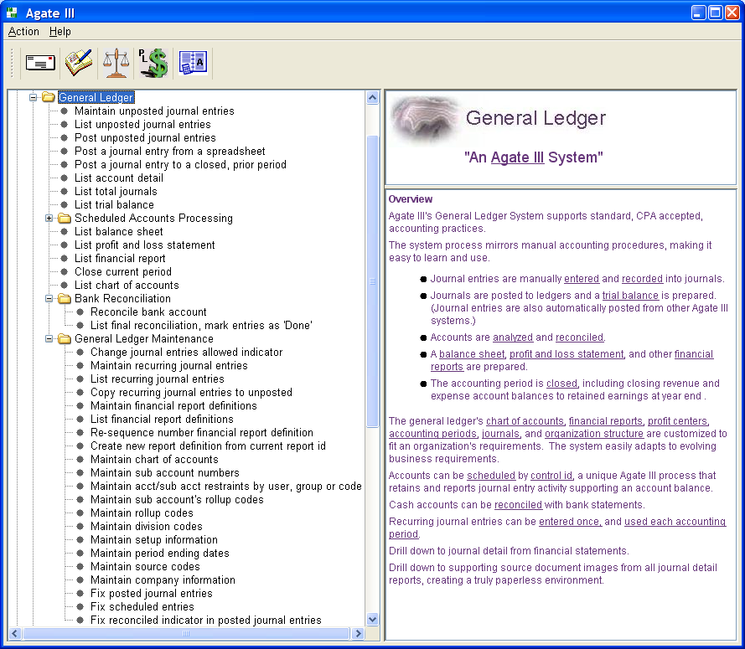
Maintain Unposted Journal Entries
Journal entries are entered in a header / detail format or can be posted from a spreadsheet.
The journal entry header is coded with company number, period number, source code, reference, activity date and description. Checking 'Detail Line Description?' allows entering a unique description on each detail line, rather than one description on the header.
Each detail line is coded with account number, sub account number, and either a debit or credit amount. If checked in the user's general ledger global properties, a control id entry field is included in the detail dialogue.
Checking 'Auto. Reverse?' generates a reversing journal entry for the next accounting period when the current period is closed.
Check 'Statistical accounts only?' to enter non monetary values into accounts checked as such in the chart of accounts. These values can be used for calculations on financial reports.
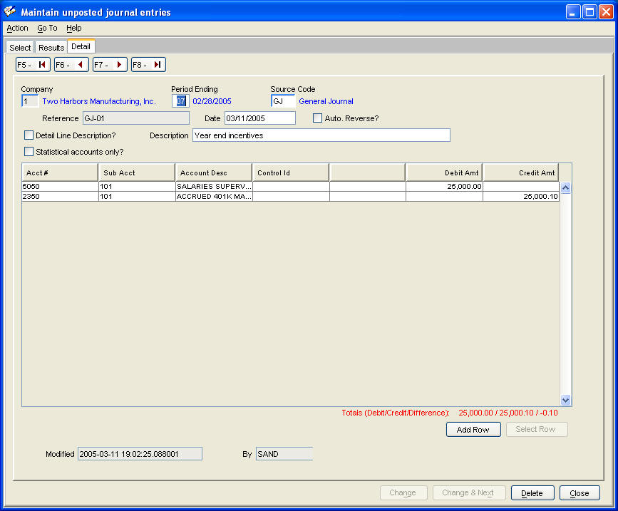
Pressing 'Add Row' or 'Select Row' displays the dialogue for adding, changing, or deleting account coding lines.
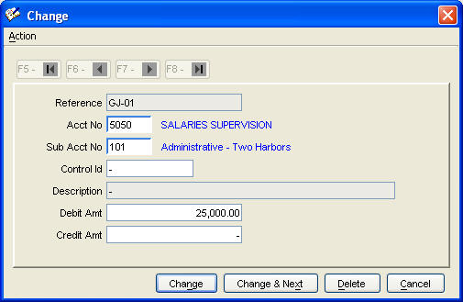
Financial Statements in CPA Format
The CPA format is prepared using the user created report definition . Drill down to journal entry detail supporting an amount by either double clicking the selected line or pressing the 'Display Detail' button.
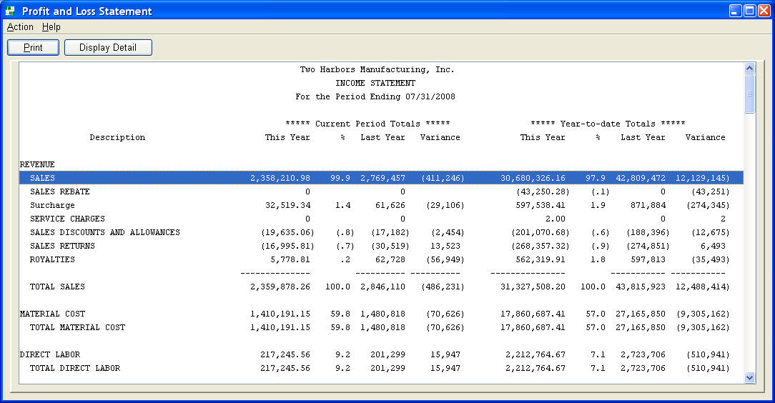

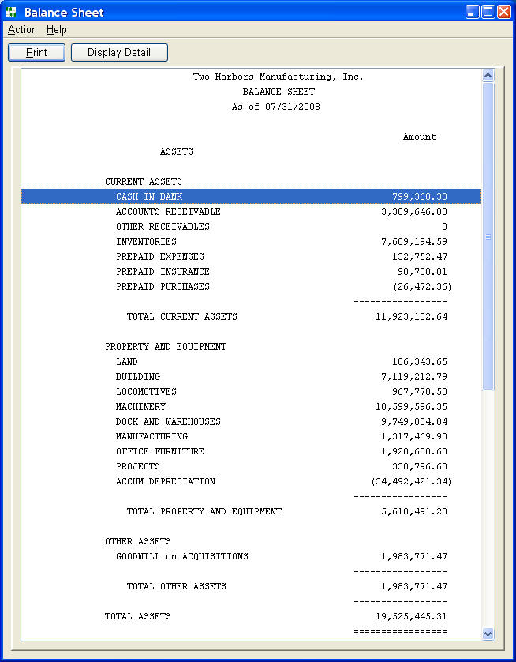
4.2 Accounts Payable
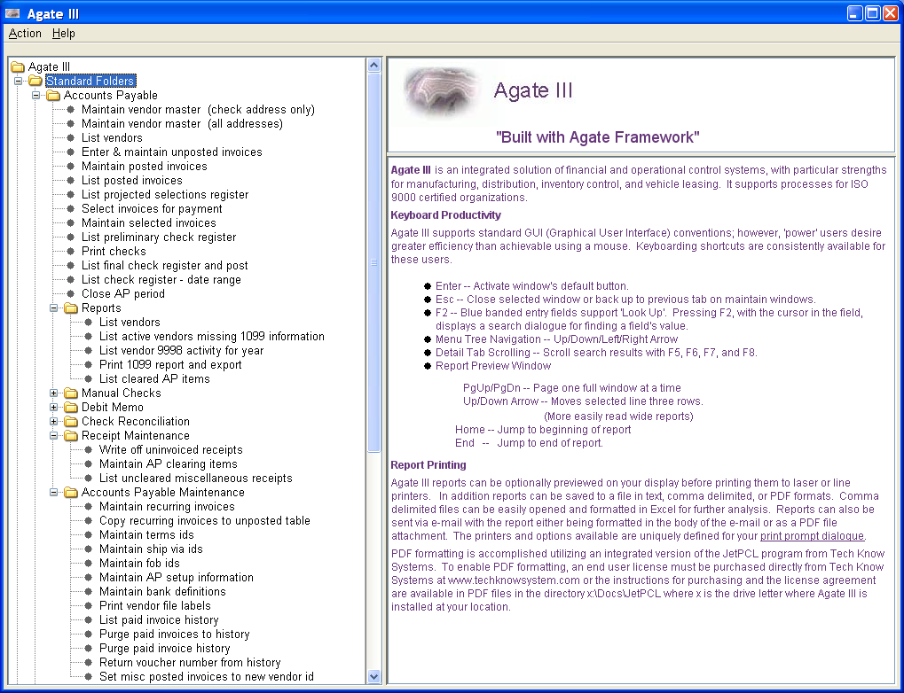
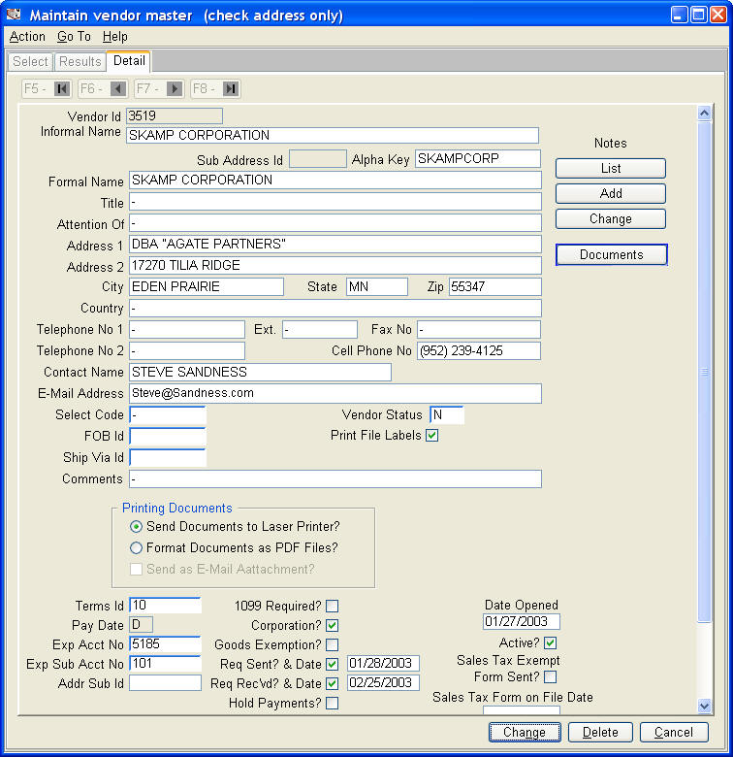
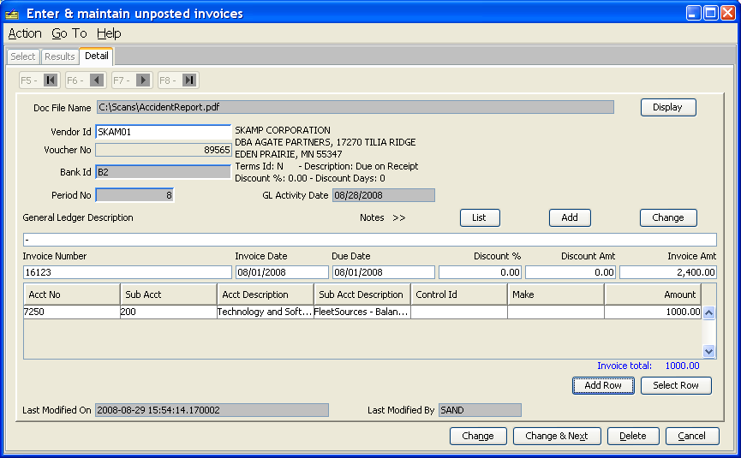
Use the 'Display' button to verify that you are coding values for the correct invoice image.
4.3 Accounts Receivable
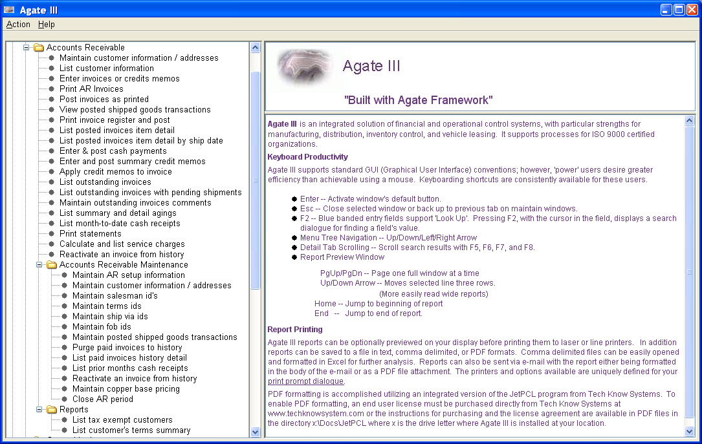
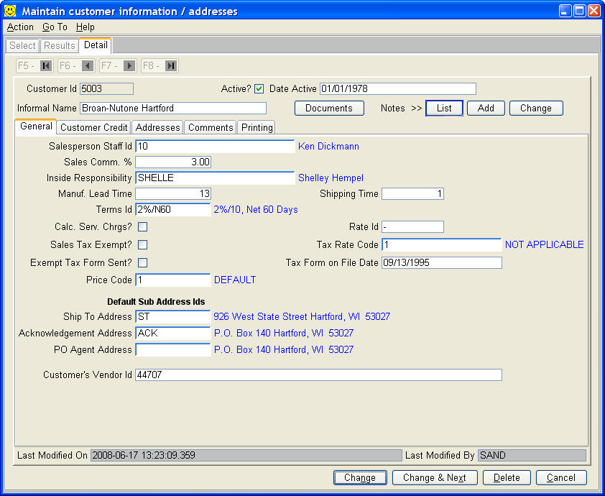
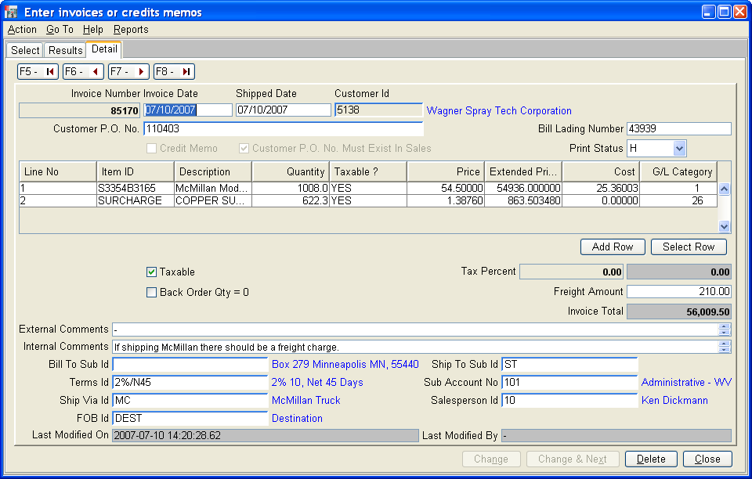
4.4 Addresses
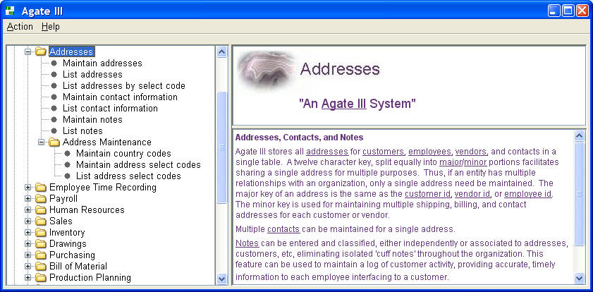
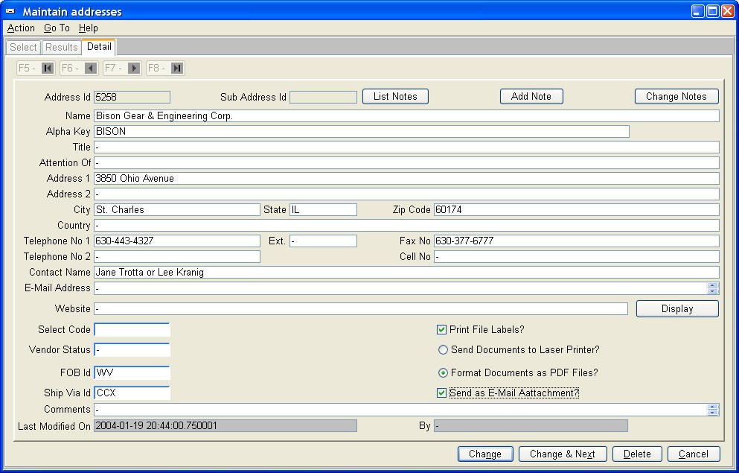
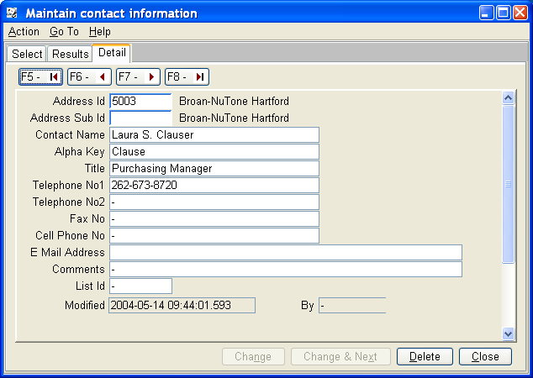
4.5 Inventory
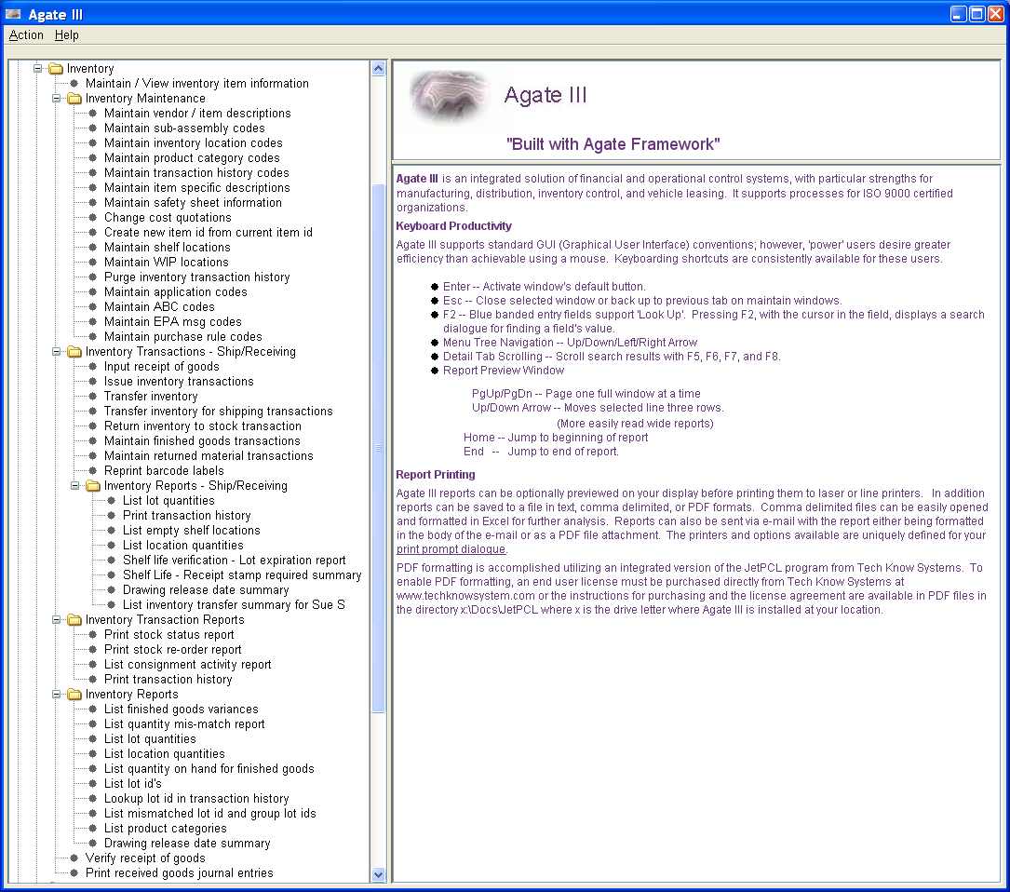
Agate III supports multi-location inventory, with optional lot based inventory by item id.
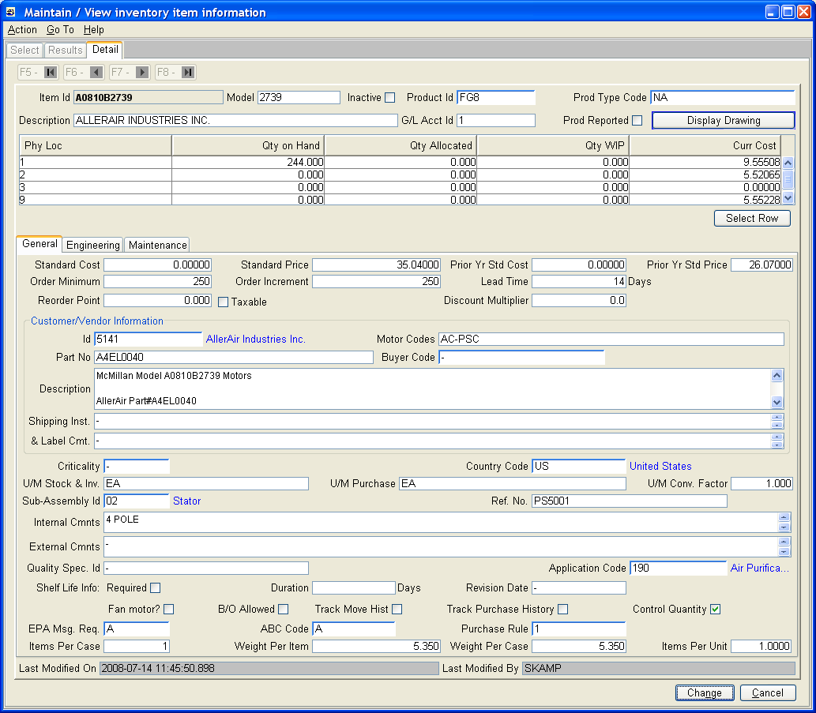
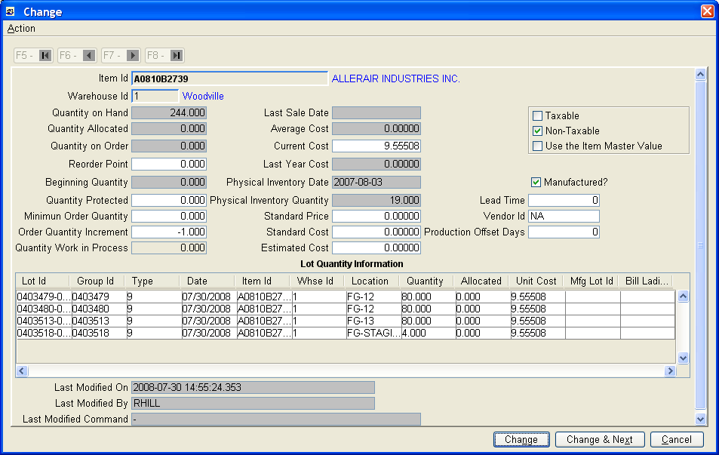
4.6 Sales Order Processing
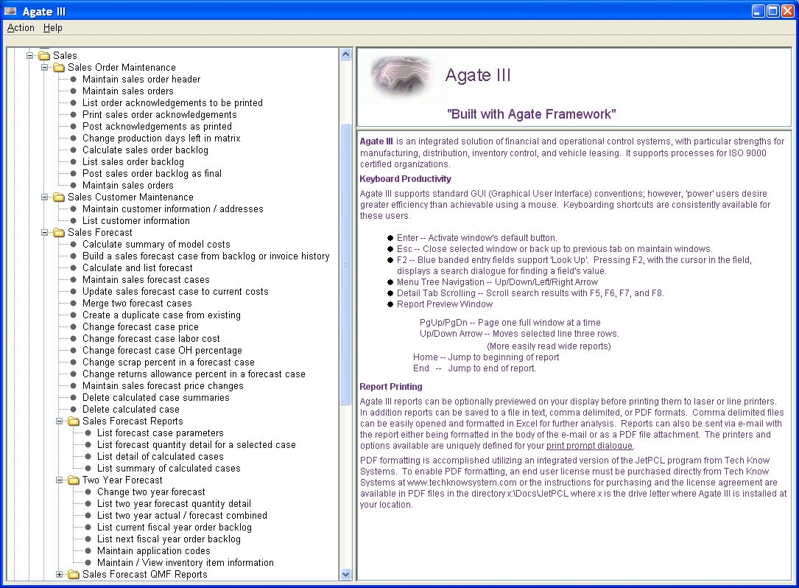
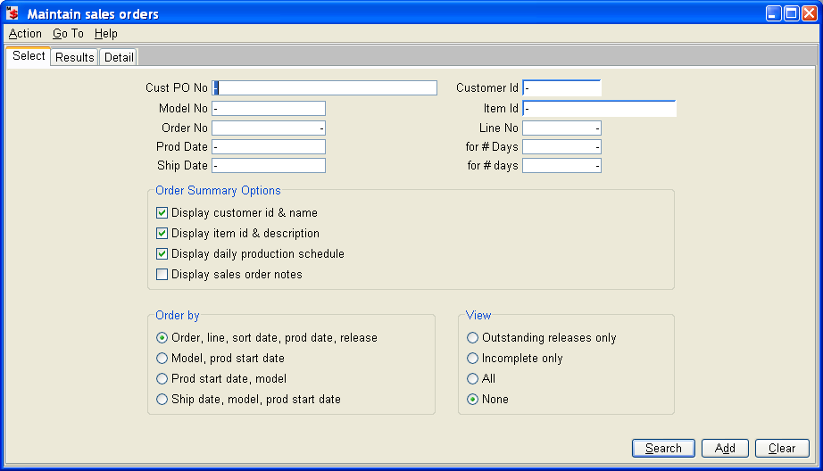
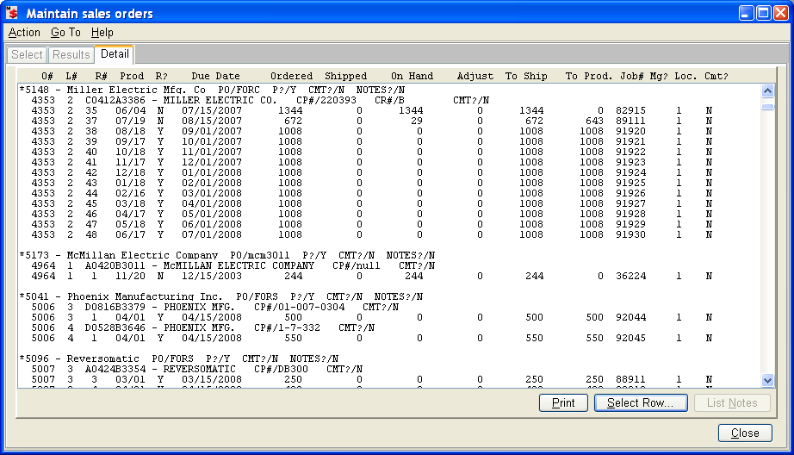
4.7 Bill of Material
